PC11 Doc. 10.1.2
CONVENTION ON INTERNATIONAL TRADE IN ENDANGERED SPECIES
OF WILD FAUNA AND FLORA
____________
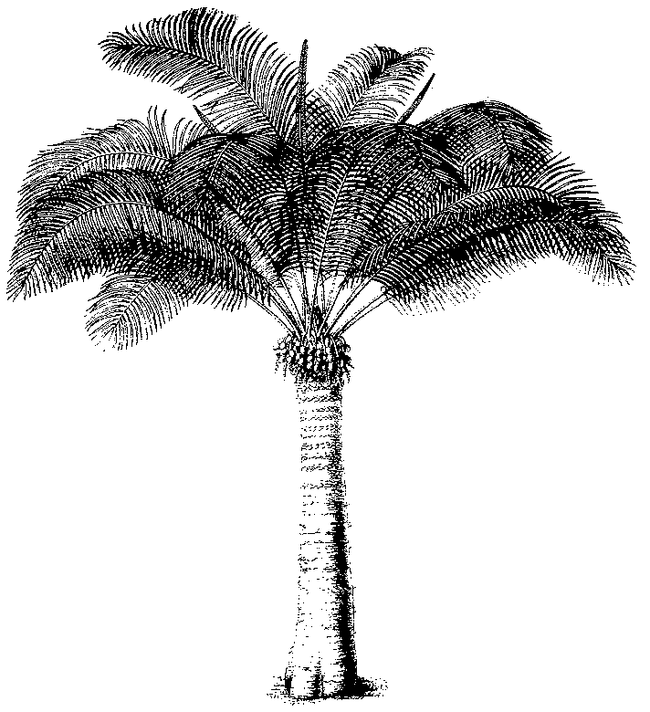
Eleventh meeting of the Plants Committee
Langkawi (Malaysia), 3-7 September 2001
Species proposals for the 12th meeting of the Conference of the Parties
Delisting of leaf-bearing cacti (Pereskioid and Opuntioid Cactaceae)
Comments by Mexico on Document PC11 Doc. 10.1.1
1. This document has been prepared by the Scientific Authority of Mexico.
2. The proposal to delete cactaceae of the “Pereskioide” and “Opuntioide” group from Appendix II covers three genera, namely Opuntia, Pereskia, and Pereskiopsis. In total this proposal means the delisting of approximately 141 species, 134 of them belonging to Opuntia, one to Pereskia and six to Pereskiopsis. This quantity of species represents 19.7 per cent of the number of species reported for Mexico.
3. Of the 134 species of the genus Opuntia, 88 are endemic to Mexico. Likewise, five of the six species of Pereskiopsis are also endemic to Mexico. Thus, of the species which it is envisaged to delete from Appendix II, 93 (in other words 69 per cent) are considered endemic to Mexico. In consequence, potentially easing trade in these endemic species represents a grave threat to the populations of them and a high risk of their decline and/or disappearance, especially when there are no solid data on their population situation.
4. For these species, there is taxonomic information, but no populational information, about the genus Pereskiopsis (Arias, 1996). The taxonomic information with regard to the genus Opuntia is fairly sparse, and knowledge about its populational status is virtually zero. This is a matter for concern, since owing to its wide diversity, high rates of reproduction and hybridization processes, identification of its species, even for the experts, is complicated.
5. The fact that the species are not listed in the IUCN Red List of Threatened Plants does not mean that they are not endangered. In fact, there are a considerable number of Mexican plants which ought to be on the list, and are not because no one has proposed to add them. It is possible that the reason no one has made the proposal is that there is no clear information, taxonomic or ecological, which would allow the proposal to be made.
6. The proposal to delete these species from Appendix II asserts that there is no significant trade in them. This is explained, at least in the case of Mexico, by the fact that trade in them has been banned since 1934. That situation makes it quite clear why there are no data giving evidence of any trade in these 141 species. However, our researches on the Internet allow us to state with certainty that there are indications of an international market for at least 14 species of Opuntia and one species of Pereskiopsis. Additionally, it may well be the case that the very lack of information about trade in these species is simply due to the fact the CITES regulations are working.
7. On the basis of the arguments above, Mexico does not support the proposal put forward for delisting of species of Cactaceae from Appendix II, until the taxonomic knowledge and the knowledge about their population status are reasonably satisfactory.
8. In this context, and with funding provided by the Comisión Nacional para el Conocimiento y Uso de la Biodiversidad (CONABIO, National Commission on Knowledge and Use of Biodiversity), Mexico is working on producing taxonomic and ecological information on the following species: Mammillaria pectinifera, M. carmenae, M. solisioides, Strombocactus disciformis, Turbinocarpus pseudomacrochele, T. shmiedickeanus, the six species of the genus Pereskiopsis, Ariocarpus trigonus, and A. agavoides. Additionally, important data on the alpha and beta diversity of Mexico’s columnar cacti are being generated. A summary of the knowledge gathered about these species will be presented at the meeting in Malaysia.

