PC11 Doc. 9.5
CONVENTION ON INTERNATIONAL TRADE IN ENDANGERED SPECIES
OF WILD FAUNA AND FLORA
____________
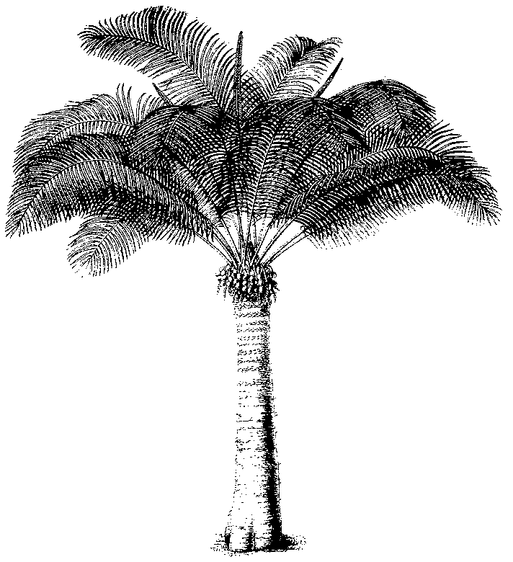
Eleventh meeting of the Plants Committee
Langkawi (Malaysia), 3-7 September 2001
Technical proposals for the 12th meeting of the Conference of the Parties
Exemptions for flasked seedlings
1. This document has been prepared by the CITES Secretariat.
2. The current annotation related to the exemption of flasked seedlings in sterile containers of species included in Appendix II reads as follows:
seedling or tissue cultures obtained in vitro, in solid or liquid media, transported in sterile containers
3. The comparable exemption for orchid species included in Appendix I is:
seedling or tissue cultures obtained in vitro, in solid or liquid media, transported in sterile containers are not subject to the provisions of the Convention
4. It has been brought to the attention of the Secretariat that some nurserymen have been removing the seedlings from their sterile flasks, cleaning off the media they have been grown in, and shipping them in other ‘sterile’ containers. This to save costs on the weight when shipping these seedlings by air. Since these seedlings are no longer in ‘solid or liquid media’, the exemption does not apply to these, and CITES documents are required for international trade.
5. Cuttings of a number of plant species or hybrids not included in the CITES Appendicesare also shipped in sterile containers without media.
6. It has been suggested that the words ‘in solid or liquid media’ should be removed from the text, to accommodate the practice referred to above. With regard to this, the Secretariat would like to make the following observations:
a) When considering this amendment, one has to evaluate the trade in flasked seedlings worldwide. The practice concerned seems to be restricted to the Northern Hemisphere, and is used for CITES specimens on a limited scale only.
b) Enforcement officers are now familiar with the exemption as described in paragraphs 2. and 3. above, and can easily recognize these because of the presence of the solid or liquid media. However, without these media, enforcement problems will arise when ‘mini orchids’ (e.g. Ornithocephalus or certain species of Pleurothallis) are, illegally, shipped in the same manner. Inspectors will have problems differentiating these from seedlings.
c) International trade in cleaned seedlings in sterile containers will in any case require the issuance of a phytosanitary certificate. Since the latter may be used as a certificate of artificial propagation (cf. Resolution Conf. 11.2, section VI) by the countries that have decided to do so, there should be no additional problems in document issuance if the current text is not amended.
7. The adoption of the exemption referred to under paragraph 3. above, only followed after lengthy discussions. The text in Resolution Conf. 11.11 in the paragraph under ‘Regarding flasked seedlings’ was a compromise that not all Parties could agree upon. It was adopted by a vote.
8. In view of the above, the Secretariat is of the opinion that there is no urgent need to change the text of the current exemption. If the Plants Committee believes that there is a need to further pursue this issue, the Secretariat strongly recommends that it only be done in relation to Appendix-II to taxa and not in relation to Appendix-I orchids.

