PC11 Doc. 9.2
CONVENTION ON INTERNATIONAL TRADE IN ENDANGERED SPECIES
OF WILD FAUNA AND FLORA
____________
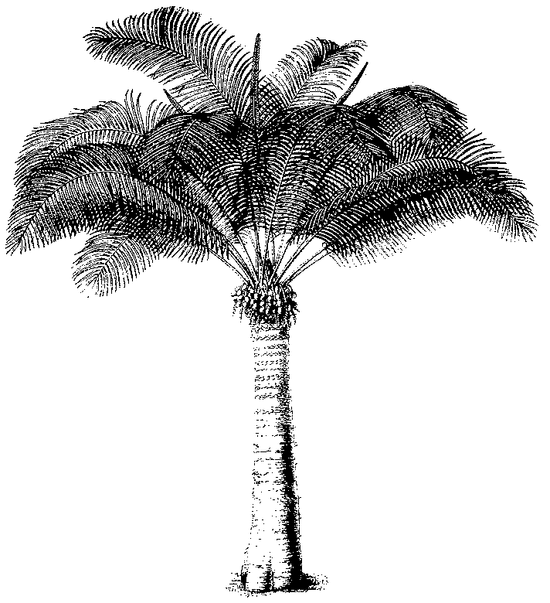
Eleventh meeting of the Plants Committee
Langkawi (Malaysia), 3-7 September 2001
Technical proposals for the 12th meeting of the Conference of the Parties
decision 11.155
1. This document has been prepared by the Secretariat.
2. At its 10th meeting, the Plants Committee discussed document Doc. PC.10.8.1, prepared by the Secretariat in relation to Decision 11.155. The Plants Committee agreed that timber coming from managed natural forests should be regarded as ‘wild’, because the current definition of “artificially propagated” could not be applied, owing to the absence of ‘controlled conditions’.
3. It also agreed that the Secretariat should further explore the subject and consider the possibility of creating a special source code for silviculturally managed.
4. Silviculture is frequently aimed at selected species and not at the full range of taxa occurring in the ecosystems under consideration, and it does not necessarily guarantee sustainable exploitation.
5. When considering whether or not exports of timber or timber products are detrimental to the survival of the species concerned, the Scientific Authority has to primarily consider the status of the individual species. However, as outlined in paragraph 3 of Article IV of the Convention, it also has to consider the role of the species in the ecosystem.
6. Various international organizations are more and more encouraging sustainable forestry management [e.g. United Nations Forum on Forests (UNFF), Center for International Forestry Research (CIFOR), ITTO, FAO, Forest Stewardship Council (FSC)] and contributing to the development of criteria and indicators for such management.
7. When issued in accordance with the provisions of Article IV, the CITES export permit is the best guarantee for sustainably produced timber. However, the work of the Scientific Authorities is greatly assisted by knowing that the specimens originate from operations that have independently been certified as having used sustainable management systems or sustainable silvicultural management.
8. It may therefore be useful to determine if any current certification or eco-labelling system is compatible with the provisions of Article IV, and if any such system should be recognized by CITES in one way or another.
9. The Secretariat believes that sustainable management of ecosystems is essential, not only for the timber species being utilized, but for all species of flora and fauna living in it. Therefore it intends to make an evaluation of the current certification or eco-labelling procedures or codes of conduct, and to enter into dialogue with the organizations concerned to ensure adequate synergies in the interest of the exploitation of sustainable resources.
10. It will report to the Plants Committee or the Conference of the Parties, as appropriate, on the result of these activities, after which the issue of a specific source code for specimens produced through silviculture or certified forest management practice should be considered.

In this context it is interesting to note that Indonesia, after having established a zero quota for the export of timber products of Gonystylus spp. and requested the inclusion of the taxon in Appendix III, will now only allow exports of specimens originating in one concession which has been granted a certificate of Sustainable Forest Management.

