PC11 Doc. 9.1b
CONVENTION ON INTERNATIONAL TRADE IN ENDANGERED SPECIES
OF WILD FAUNA AND FLORA
____________
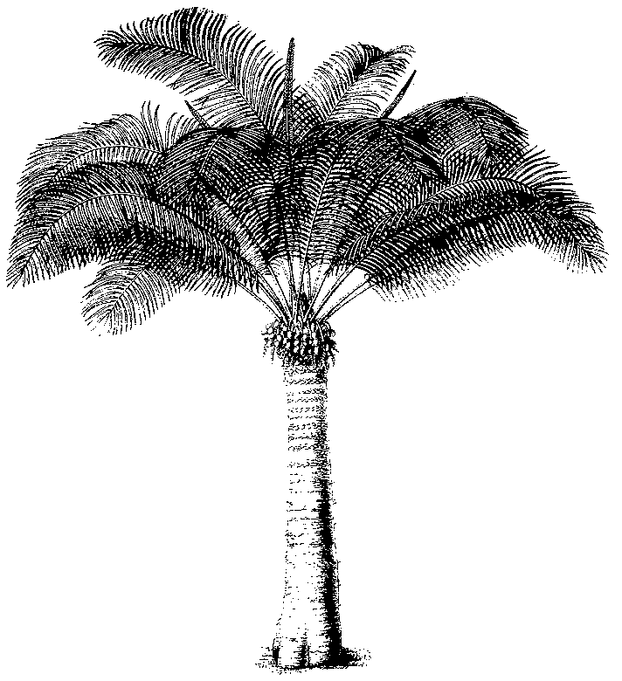
Eleventh meeting of the Plants Committee
Langkawi (Malaysia), 3-7 September 2001
Technical proposals for the 12th meeting of the Conference of the Parties
Harvesting techniques of Galanthus in Georgia
1. This document has been prepared by the Scientific Authority of Germany.

Cultivation of Galanthus woronowii in Georgia
Preliminary report of a fact finding mission of the
CITES Scientific Authority of Germany
Introduction
In 1999, a group of botanists from Scientific Authorities of some EU countries undertook a two-days informal trip to Georgia. In the same year, under contract from the CITES Secretariat by Fauna and Flora International and the World Wide Fund for Nature Georgia, a survey was carried out as part of the CITES Significant Trade Review. Both groups agreed in independent statements on the necessity to conduct additional research on the distribution and abundance of the wild populations of Galanthus to establish sustainable harvest quota.
In 2001, taking into account the findings and the recommendations of both groups, the German CITES Scientific Authority has carried out a bulb project in Georgia. The project aims at
- evaluating distribution, abundance and threat data of wild Galanthus populations, especially in the region of southwest Georgia, namely in the Ajara Autonomous Republic;
- assessing farm field material, harvest management, harvest amounts, cultivation methods;
- understanding the scientific basis on which the quota system for export was set and what mechanism are used to control monitoring and export.
The studies have been arranged in contact with the Georgian Ministry of Environment and in close cooperation with local Georgian botanists. To gather scientific data on wild populations fieldwork in the flowering season has been done by Georgian botanists. Additionally, literature research was carried out, some important herbariums were evaluated, and national experts were questioned.
From 2-16 May 2001, a group of German bulb experts and local Georgian botanists undertook a field expedition in the Ajara and Guria regions as part of the study, visiting areas of wild populations as well as collection/production areas of Galanthus species.
The members of the group had the opportunity for intensive discussions with the Georgian Minister of Environment, staff of the Georgian CITES Management Authority, members of a botanical commission (constituting the CITES Scientific Authority of Georgia) and traders.
This report briefly reflects the summarized impressions of the fortnight journey. Focussing on cultivation, not on wild populations, it may provide additional information in the discussion about the use of the term “Ranching” in connection with bulb propagation. A final report including a detailed analysis of the field data will hopefully be finished at the end of 2001.

Observations
1. Wild populations of Galanthus woronowii are to be found in areas far away from cultivation fields but also right next to them. In the run-up to the journey numerous wild populations of G. woronowii, most of them in a healthy condition, have been inspected and recorded in maps. Some of these populations have been visited, too, in the course of the excursion.
2. It is most likely that many cultivated fields have been laid out in areas of natural distribution of Galanthus species (this could explain why rarer species like Galanthus krasnovii have been found in shipments and in farmfields). Although collecting bulbs from natural wild plant communities is strictly prohibited by Georgian federal law it should be stressed that a kind of shifting cultivation is spread around the mountains in the Ajara region. Consequently, clearing of forests for the purpose of agriculture is allowed and seems to be usual, which poses an additional threat to rarer species of Galanthus. Therefore, first the bulbs are growing in the forest, later they may grow on farmfields. This seems to be a clear link between wild populations of Galanthus species and material in cultivation.
3. After spreading out into wild areas the cultivated fields can consist of remaining stocks of wild plants as well as stocks of transplanted bulbs, building up stable populations on secondary areas. Long tearm research is needed to say how these populations have been formed and if they will be long-lasting.
4. Other fields are clearly situated outside areas of natural distribution and Galanthus found there is from replanted material of uncertain origin, most probably undersized bulbs from previous harvests.
5. Some of the fields were cultivated in a manner that bulbs were harvested after capsular ripening of the plants and seed was actively worked into the soil of the same fields (natural seed regeneration). This could nearly be considered as “artificial propagation”. Other fields were replanted with small bulbs which remained after bulb selection. To our knowledge, at no time seed has been harvested selectively to plant it in separate beds. Furthermore it is unlikely that at the bulb delivery station in Gonio seeds are strained out and added to the soil. It is only the small bulbs which are filled in sacks and taken to the farmers in the mountains.
6. Neither a standardized cultivation practice applied to all fields exists nor specified criteria for bulb propagation. Some of the cultivated areas were planted with corn, others served as pasture. Some fields showed high productivity, others did not. Furthermore, it seems to be doubtful, if harvesting is carried out on a systematic rotational basis.
7. Some contradictory statements exist on the question at what time cultivation practice have been established in Georgia at all. We consider it most likely that this practice started in 1998, not much earlier.
8. The methods used by the Georgian CITES Scientific Authority to evaluate the total productivity of the Galanthus bulbs are suffering from some scientific deficiencies and led to a high total number of about 80 mill. bulbs. We consider the methods as not being suitable to serve as a scientific basis for the fixing of export quotas.
9. In most cases the production plots are situated isolated in the Ajara mountains region and difficult to reach. Visiting the plots and carrying out scientific spot checks requires personal, technical and financial resources and needs much time. Additionally, investigations may depend on what kind of information traders want to give and what fields they want to show. On the other side, the Georgian Scientific Authority lacks to a considerable amount of financial and technical resources (e.g. maps, new scientific literature). Unfortunately, Georgian botanists have only few possibilities to carry out scientific research on distribution and abundance of wild populations of Galanthus species within the country. Therefore, we have to express concern, that the Georgian SA, despite their considerable knowledge, efforts and willingness, presently is hardly able to assess possible detrimental impacts on wild populations, to assess the farm field stocks adequately and to set quotas on a scientific basis.

Recommendations
1. Although a system which ensures that exploitation of bulbs is truly sustainable has not been established yet, there are clear indications that Georgia has the potential for high and sustainable productivity in the existing Galanthus fields under certain standardized conditions. This potential can be developed in a sustainable manner only, if the cultivation system is monitored adequately and independently, and unlimited bulb trade can be avoided.
2. A system of proper artificial propagation according to the relevant CITES Resolution should be established on a long term basis. To achieve this it is necessary to develop and to discuss detailed criteria for artificial bulb propagation first.
3. A standard is needed to evaluate the present bulb productivity of Galanthus woronowii on the fields. The German CITES Scientific Authority is willing to assist the Georgian CITES Scientific Authority in this regard.
4. The members of the botanical commission have considerable knowledge and capacity. To act as Georgian Scientific Authority they urgently need financial and technical help to fulfil their tasks under CITES provisions adequately and independently.
5. The Georgian CITES Management Authority needs technical assistance and support when establishing a system to monitor steps from collection to export.
6. The export of Galanthus bulbs other than G. woronowii should be prohibited and prohibition should be well observed.
7. If suggested export quotas are based on a more conservative estimation we presently consider such a level to be not detrimental to wild populations of G. woronowii. However, it should be ensured that quota should not increase too rapidly.

