PC11 Doc. 8.3
CONVENTION ON INTERNATIONAL TRADE IN ENDANGERED SPECIES
OF WILD FAUNA AND FLORA
____________
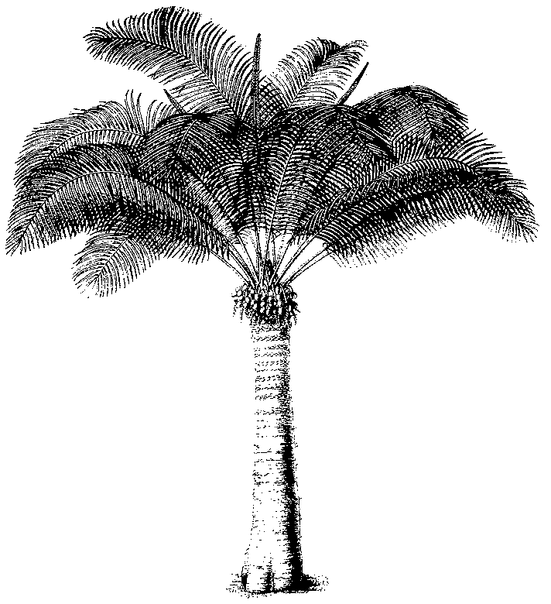
Eleventh meeting of the Plants Committee
Langkawi (Malaysia), 3-7 September 2001
Follow-up of CoP11 Decisions
Aquilaria spp.
1. Decisions 11.112 and 11.113, directed to the Plants Committee, read as follows:
11.112 The Plants Committee shall continue its review of the genus Aquilaria, in order to:
a) determine how species within the genus may be distinguished from each other when in trade, particularly when traded as agarwood;
b) determine measures, other than improved identification, that might improve accurate reporting of trade in specimens of Aquilaria malaccensis; and
c) determine whether additional species in the genus should be included in Appendix II of the Convention, either because of similarity of appearance or because their biological and trade status qualify them for inclusion in Appendix II.
11.113 If it is determined, as a result of this review, that additional species should be included in Appendix II, the Plants Committee shall specify which species should be included in Appendix II under the provisions of Article II, paragraph 2(a), and which species should be included in Appendix II under the provisions of Article II, paragraph 2(b).
2. TRAFFIC has provided the Secretariat with an outline of the work that needs to be done for the implementation of Decisions 11.112 and 11.113 (included in the Annex).
3. In consultation with the Chairman it was agreed to use USD 10,000 of the funds of the United States of America for plant Plants Committee projects for this work. The Secretariat is in the process of establishing a MoU with TRAFFIC-Oceania for their share of the work on Aquilaria.
4. With regard to a) above, it was evident that it was not possible to distinguish the various species on the basis of wood anatomical characteristics. The Secretariat therefore considered the option of using DNA markers for species identification. Through a Memorandum of Understanding with the National Herbarium in the Netherlands a pilot project was established to investigate the feasibility of using this technique. The project is funded from funds available for the Identification Manual.
5. For aspects related to the taxonomy of this genus see document PC11 Doc. 14.2.
6. The Plants Committee is requested to establish priorities for the allocation of possible additional funds.
PC11 Doc. 8.3
Annex
PROJECT PROPOSAL
Support for implementation of CITES Decisions 11.112 and 11.113 for Aquilaria species
Submitted by: TRAFFIC International
Executants: TRAFFIC East Asia, TRAFFIC India, TRAFFIC Oceania, TRAFFIC Southeast Asia, TRAFFIC International and IUCN
Objectives:
a) To compile, synthesize and present to the CITES Plants Committee up-to-date information on the status of and trade in Aquilaria spp. in order to facilitate their consideration of the merits of including additional Aquilaria species in the CITES appendices.
b) To identify measures to improve reporting accuracy of trade in specimens of A. malaccensis
c) To facilitate the CITES Secretariat’s process of obtaining samples of agarwood of Aquilaria species in the process of establishing identification methods
Background and Justification:
Aquilaria malaccensis was included in CITES Appendix II by the Ninth meeting of the Conference of the Parties to CITES (Fort Lauderdale, 1994), the listing taking effect 16 February 1995. The listing proposal, which was submitted by India, was prompted by concern regarding overexploitation of this tropical tree species for ‘agarwood’, a valuable fragrant resinous wood produced by this and other members of the genus Aquilaria. Agarwood is primarily used as an incense, in perfumery, and in Ayurvedic, Tibetan and traditional East Asian medicine. It is traded in a variety of forms, including wood, wood chips, powder, oil, and finished products such as medicine and incense.
Aquilaria species have a broad distribution in Indomalesia. For example, according to Oldfield et al. (1998), the range of A. malaccensis includes 10 countries (Bangladesh, Bhutan, India, Indonesia, Iran, Malaysia, Myanmar, Philippines, Singapore, Thailand). Other Aquilaria species are known to occur in countries such as the People’s Republic of China, Lao PDR and Viet Nam (Oldfield et al., 1998), but the complete distribution of the genus remains undocumented. Eight species in the genus are listed as threatened according to the 1994 IUCN Red List Criteria (Oldfield et al., 1998): A. banaensae (Vulnerable); A. beccariana (Vulnerable); A. crassna (Critically Endangered); A. cumingiana (Vulnerable); A. hirta (Vulnerable); A. malaccensis (Vulnerable); A. microcarpa (Vulnerable); and A. sinensis (Vulnerable). Six of these species are considered at risk from over-exploitation for agarwood. An additional species, A. rostrata, is considered Data Deficient. There is little information as to the current global status of Aquilaria species and baseline data upon which to base sustainable harvesting regimes are lacking.
The external signs of agarwood formation are not always obvious and it is unclear what percentage of the population is likely to produce agarwood, although this is believed to be low. Efforts to cultivate Aquilaria spp. have been successful, however artificial stimulation of agarwood formation has not yet been viable on a commercial scale.
More than one agarwood-producing species of the genus Aquilaria occur and are harvested in several key exporting range States, e.g. Indonesia and Malaysia. Research has shown that the distinguishing characteristics of agarwood in trade are not linked to individual species but rather to the quantity and type of resin content which complicates the analysis of trade in individual species. Identification of agarwood to the species level is beyond the abilities of most enforcement staff, with the result that agarwood declared as A. malaccensis could be composed of other Aquilaria species, and agarwood declared as not being A. malaccensis could involve this species.
Trade in agarwood is widespread, with 20 countries from Asia, Europe and North America trading in A. malaccensis in 1998 according to CITES annual report data. CITES-reported exports and re-exports of A. malaccensis totaled approximately 768 t in 1995, 638 t in 1996, 719 t in 1997 and 1074 t in 1998. There is evidence of illegal harvest and trade in many range States of A. malaccensis and other Aquilaria species.
Review of the implementation of the CITES listing for A. malaccensis was identified by the CITES Plants Committee as a priority under the CITES significant trade process for plants during 1998-2000. The CITES Secretariat contracted TRAFFIC to review CITES implementation in key range States. An interim report of TRAFFIC's findings was submitted to the ninth meeting of the CITES Plants Committee, with the full report being distributed by the CITES Secretariat to CITES Management Authorities of all known A. malaccensis range States in September 1999. The results of this study together with those of additional research are also reported in the TRAFFIC Network report Heart of the Matter: Agarwood Use and Trade and CITES Implementation for Aquilaria malaccensis (Barden et al., 2000).
Analysis of CITES data and other research show that the main consumers of agarwood are located in the Middle East and East Asia, with the use of agarwood having important cultural and religious significance. Understanding the trade in these two main consuming regions will be key to efforts to achieve the sustainable trade and utilisation of A. malaccenis and other Aquilaria species.
At the Eleventh meeting of the Conference of the Parties to CITES (Nairobi, April 2000), the Parties expressed concern about the findings of the CITES implementation study regarding inconsistent or lack of CITES implementation for A. malaccensis and over-exploitation of other species in the genus. As a result they adopted Decisions 11.112 and 11.113 (attached). Decision 11.112 directed the Plants Committee to continue its review of the genus, and in so doing to determine whether additional Aquilaria species merit inclusion in CITES Appendix II. If additional CITES listings are deemed appropriate, Decision 11.113 directs the Plants Committee to specify which species should be included in Appendix II under the provisions of either Article II, paragraph 2 (a) or Article II, paragraph 2 (b). Under Decision 11.112, the Plants Committee is also responsible for determining how Aquilaria species may be distinguished from each other in trade, and to determine other measures that could improve accurate reporting of trade in A. malaccensis.
This project is designed to support the Plants Committee’s implementation of Decisions 11.112 and 11.113. It will be implemented in coordination with other Aquilaria projects being undertaken by the TRAFFIC Network. Information obtained may be published in other forms by TRAFFIC/IUCN independently of the final report submitted to the CITES Secretariat.
Activities:
The following activities are proposed:
a) In consultation and collaboration with the CITES Secretariat and CITES Management and Scientific Authorities (or their equivalent in non-Parties) of known Aquilaria range and key consuming States, compile information on the biology, status, distribution, threats, cultivation, harvest, trade, trade reporting, management of and regulatory measures for Aquilaria species. Specific research activities to include:
b) Literature review, identification of and consultation with individuals and institutions with information relevant to Aquilaria
c) Undertake in-country research to compile information regarding the status and trade in five key Aquilaria range States (Indonesia, Malaysia, Papua New Guinea, Thailand, Viet Nam).
d) Undertake in-country research to compile information within six key consuming countries in the Middle East and East Asia to better quantify species and country of origin selectivity and market trends (China, Japan, Republic of Korea, Saudi Arabia, UAE, Singapore)
e) Compilation and analysis of CITES and Customs data, and, if available, information contained on CITES permits
f) Review of web-based advertising
g) Re-evaluate all species in the genus Aquilaria according to the 2000 IUCN Red List Criteria
h) In consultation and collaboration with CITES Management and Scientific Authorities of A. malaccensis range States and other organisations, facilitate the acquisition of agarwood samples of Aquilaria species on behalf of the CITES Secretariat
i) Synthesize and analyse information collected into individual species sheets and an overall analysis.

Project timing
April 2001-February 2002
Expected Outputs/Results:
a) Interim report on the project’s progress for submission to the 11th meeting of the CITES Plants Committee
b) Aquilaria species sheets and overall analysis detailing the study's findings, for submission to the CITES Secretariat and the twelfth meeting of the CITES Plants Committee
c) Re-evaluation of all Aquilaria species against the 2000 IUCN Red List Criteria
Project Budget (GBP):
Staff and Consultants: 40,800
Travel and Subsistence: 14,450
Communications: 2,860

Total: 58,110

