PC11 Doc. 8.2
CONVENTION ON INTERNATIONAL TRADE IN ENDANGERED SPECIES
OF WILD FAUNA AND FLORA
____________
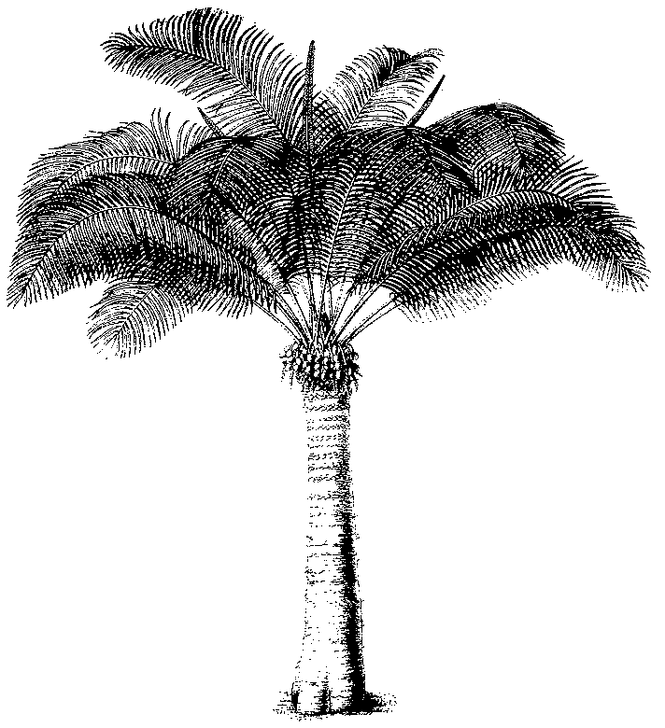
Eleventh meeting of the Plants Committee
Langkawi (Malaysia), 3-7 September 2001
Follow-up of CoP11 Decisions
Guaiacum sanctum
1. The annex to this document has been prepared by Shelly Grow and Ed Schwartzman under contract with the Secretariat.
2. The opinions expressed by the authors do not necessarily reflect the position of the Secretariat.

A Review of the Taxonomy and Distribution of the Genus Guaiacum in Mexico
Shelly Grow and Ed Schwartzman
Program in Sustainable Development and Conservation Biology
University of Maryland, College Park, MD, USA

Abstract
In response to uncertainty regarding the species of Mexican Guaiacum that are currently in trade, a phenetic analysis was carried out to clarify the nomenclature and distribution of the genus and its distribution in Mexico. The analysis was based on a review of 91 species descriptions, extensive viewing of herbarium specimens, and field observations in Mexico. Analyses reveal that three species and a distinct varietal form occur in Mexico. The results show that Guaiacum sanctum, G. coulteri, G. coulteri var. palmeri and G. unijugum are distinguishable based on morphological features, such as foliage and floral structure, and tree height. Though the species are not possible to distinguish in trade by their wood, morphological features and distribution information can be useful for monitoring trade before harvesting and processing takes place.

Introduction
Proper management of economically important plants is dependent on an understanding of the taxonomy and distribution of the species involved. However, despite centuries of commercial trade, the nomenclature of the genus Guaiacum (Zygophyllaceae) commonly referred to as Lignum vitae, still remains unclear. A proposal by the U.S. Office of Scientific Authority to uplist G. sanctum to Appendix I at the 11th CITES Conference of the Parties (2000) met with opposition due, in part, to confusion regarding the identity of the principal Guaiacum species in trade. Subsequent research indicated that G. sanctum, of Mexican origin, is the principal species in trade. However, due to uncertainty regarding the taxonomic and distribution differences among species, particularly between G. sanctum and G. coulteri, the status of Guaiacum species in trade, the viability of its populations, and threats facing the genus remain unclear. In order to properly monitor and manage this genus in Mexico, the CITES Plant Committee commissioned this study of the taxonomy of Guaiacum, focusing on those Mexican species currently in trade or that could potentially be traded.

Nomenclature and Taxonomic Treatment
The literature regarding Guaiacum contains many references to uncertainty as to the difference between the species (see Gray, 1852 for G. verticale Orteg and G. sanctum L.; Standley, 1920 for G. coulteri A. Gray and G. planchoni Gray ex. Vail and Rydberg; and Hemsley, 1879 for G. coulteri, and G. guatemalense Planch. ex Vail & Rydberg). A review of herbarium specimens uncovered several misidentifications, further indicating uncertainty as to the differences between the species. Attempts to accurately describe the taxonomy of the genus have resulted in a profusion of different names for the species. Further confounding the taxonomy, plants of other genera and even separate families have been included within Guaiacum. Figure 1 shows a list of 21 binomials for the genus from a search of the International Plant Names Index (1999). However, most experts in Zygophyllaceae consider there to be only four to six true species: G. sanctum L., G. coulteri A. Gray, G. officinale L., G. unijugum Brandegee, and perhaps G. angustifolia Engelm., and G. guatemalense (Vail & Rydberg, 1910; Porter, 1972).
Commonly accepted species | Notes
G. angustifolia Englem. | Commonly considered to be Porlieria angustifolia Engelm.
G. coulteri A. Gray
G. officinale L.
G. sanctum L.
G. unijugum T.S. Brandegee
Synonyms | Notes
G. abilo Blanco | Actually Garuga pinnata (Buseraceae)
Guaiacum afrum L. | Actually Schotia speciosa Jacq. (Leguminoseae)
G. arboreum DC | Actually Bulnesia arborea Engl.
G. bijugum Stokes | Synonym for G. officinale (Stokes, 1812)
G. breynii Spreng | No information obtained
G. dubium Forst f. | No information obtained
G. guatemalense Planch. ex Vail & Rydberg | Synonym for G. sanctum, or a hybrid between G. sanctum and G. coulteri (Porter, 1972)
G. hygrometricum Ruiz & Pavon | Actually Porlieria hygrometricum (Descole et al, 1940)
G. mexicanum Baill. | Synonym for L. divaricata Ses & Moc Ex DC Cov
G. microphyllum (Baill.) Desc. | Actually Porlieria microphyllum (Descole et al, 1940)
G. multijugum Stokes | Synonym for G. sanctum (Stokes, 1812)
G. palmeri Vail | Treated as G. coulteri var. palmeri (Vail) I.M. Johnston (Johnston, 1924)
G. parvifolium Planch. ex A. Gray | Most likely a synonym for G. coulteri (Gray 1897 and Vail and Ryderg, 1910)
G. planchoni Gray ex. Vail and Rydberg | Synonym for G. coulteri (Standley, 1920)
G. sloanei Shuttl. ex A. Gray | Synonym for G. sanctum (Gray, 1897; Vail and Rydberg, 1910)
G. verticale Orteg. | Synonym for G. sanctum (Gray, 1897; Vail and Rydberg, 1910)
Figure 1: Species of the genus Guaiacum according to the International Index of Plant Names (1999).
Of the 21 listed binomials pertaining to Guaiacum, at least seven refer to species belonging to distinct families or other genera within the family Zygophyllaceae. Authors have described various species of the closely related genus Porlieria (Zygophyllaceae) as belonging to Guaiacum. For example, P. angustifolia Engelm., has been referred to as belonging to both genera at different times. Gray (1852) placed this species within Porlieria, basing his determination on the squamulate filaments and tetramerous flowers. Porter (1974) points out that P. angustifolia accords more with Guaiacum coulteri than Porlieria and mentions the possibility of the latter genus being submerged within Guaiacum. P. angustifolia is principally distinguished from Guaiacum species by the scaly basal appendages on the filaments. Dense pubescence on the ovary, small leaflets rarely >2.5 mm wide, and terminal leaflets larger than others are features that may differentiate this species from Guaiacum species (personal observation).
Several names have been introduced as synonyms for the commonly recognized species. Synonyms for Guaiacum sanctum L. include G. sloanei Shuttl. ex A. Gray and G. verticale Orteg. (Gray, 1897; Vail and Rydberg, 1910). Linnaeus (1753) described G. sanctum as bearing pinnate leaves with several pairs of obovate, entire leaflets. It produces blue flowers and a fruit with 4 (5 sic) capsules. Vail and Rydberg (1910) describe G. sanctum as bearing 4-10 leaflets, 2-3.5 cm in length.
Though several synonyms have been applied to Guaiacum species of wide morphological and ecological variation distributed from Sonora to Oaxaca, Mexico, G. coulteri as described by Asa Gray is the accepted name for this species (Porter, 1972). Gray (1852 and 1897) described it as a shrub bearing 3-5 pairs of linear, oblong, mucronate leaflets with uneven bases. The fruit is a capsule with 5-keeled cells. Vail and Rydberg (1910) reported a new species, Guaiacum planchoni Gray ex. Vail, distributed in Oaxaca, Mexico. Standley (1920) did not consider G. planchoni to be a distinct species and found that Guaiacum specimens from Oaxaca fall within the normal range of variation for G. coulteri. G. planchoni is now treated as a synonym of G. coulteri.
Guaiacum palmeri Vail is considered by some authors as a synonym for G. coulteri (Record & Hess, 1943). Others differentiate G. palmeri from G. coulteri by having a pubescent ovary and smaller leaflet size (Vail and Rydberg, 1910; Ortega, 1927; Martinez, 1959). Currently G. palmeri is treated as a variety, G. coulteri var. palmeri (Vail and Rydberg) I.M. Johnston (Johnston, 1924). The ovary of this varietal form is covered all or in part with dense pubescence, thus making G. coulteri var. palmeri easily recognizable. Its distribution is centered around Guaymas, Sonora and extends north to Hermosillo and south into Sinaloa (Shreve and Wiggins, 1964).
Guaiacum guatemalense Planch. ex Vail & Rydberg was described by several authors and correctly published by Vail and Rydberg (1910). Specimens from as far as Oaxaca, Mexico and Nicaragua have been described as G. guatemalense (personal observation), though the type specimen originated from the plains of Zacapa, Guatemala (Hemsley, 1879). Vail and Rydberg (1910) distinguish the species from G. coulteri as having oblong-obovate petals and leaflets strigose beneath. Standley (1946) considered G. guatemalense to be a synonym of G. sanctum and more recent flora collections have identified all Guaiacum species in Central America as G. sanctum (Honduras – Molina, 1975; Nicaragua – Seymour, 1980, Guatemala – Chickering, 1973 and Wendelken, 1987 but see Aguilar, 1958). Porter considers G. guatemalense to be the result of hybridization and introgression between G. sanctum and G. coulteri based on the morphological variation and lower seed set found in specimens (Porter, 1972).
Both Guaiacum officinale L. and Guaiacum unijugum T.S. Brandegee are distinctly recognized species. Though G. officinale has occasionally been misidentified it appears quite different from other species, bearing non-apiculate leaflets and a two-celled ovary. G. officinale is found in northern South America, the Caribbean, and Panama. Its distribution overlaps with that of G. sanctum in the Caribbean but does not overlap in Florida, Mexico, or Central America (Record and Hess, 1943). G. unijugum has a single pair of leaflets and is restricted in its range to the southeastern cape of Baja California (Brandegee, 1915; Wiggins, 1980).
By reviewing the literature, utilizing statistical and Geographic Information System (GIS) analysis of herbarium samples, and conducting field observations, some areas of uncertainty have been clarified, while other questions have arisen. Phenetic analysis has been conducted to elucidate the morphological characters that can most successfully distinguish the species from each other and provide a practical tool to help manage the conservation and trade of the genus. Genetic analysis was not included in this study. Though DNA sequencing may clarify differences among the species, it may not be feasible for identification for trade purposes.

Methods
Five hundred and twenty four herbarium specimens of Guaiacum were studied for a preliminary review of herbarium specimens and character evaluation. The following herbaria provided loans of material for this study: the University of Arizona (ARIZ), Arizona State University (ASU), the Florida Museum of Natural History (FLAS), and Rancho Santa Ana Botanical Garden (RSA). Visits were made to the Herbario Nacional de México (MEXU), the United States National Herbarium (US), and to the United States National Arboretum (NA). The following species were selected for an initial review: G. coulteri, G. coulteri var. palmeri, G. guatemalense, G. sanctum, G. verticale, G. officinale, G. unijugum, and Porlieria angustifolia. Of these specimens, 113 were selected for the final phenetic analysis.
Specimens were selected based on the completeness of their foliage and flowering material. Though the principal area of study was Mexico, specimens were selected from a wide geographical area in order to examine the variation of the species throughout their range and particularly in areas where Guaiacum taxonomy is most unclear, i.e. southern Mexico and Central America. All specimens described as G. palmeri and specimens of G. coulteri bearing a pubescent ovary were treated as G. coulteri var. palmeri in accordance with the latest nomenclature (Johnston, 1924). Specimens described as Guaiacum / Porlieria angustifolia and G. officinale were observed but were not included within the analysis. These species possess discreet characters, e.g. basal staminal appendages in the case of P. angustifolia and non-apiculate leaves in the case of G.officinale, that readily distinguish them from other Guaiacum specimens. G. unijugum was not included due to insufficient sample size of specimens (n=2).
An initial literature review of 91 descriptions of Guaiacum was conducted to identify relevant characters for analysis. Table 1 shows the 38 selected leaf, flower, and general morphological characters chosen. Some characters were identified from the literature as useful for distinguishing the species, e.g. leaflet length and width, leaflet shape, and petal length (Vail and Rydberg, 1910; Standley, 1920). Other characters, such as leaflet internode length, were selected for use in the analysis after numerous observations. External morphological measurements were obtained using a metric ruler and were rounded to the nearest 0.5 mm. Floral and pubescence characters were observed using a standard dissecting microscope. Tree height measurements were obtained from the collection notes of each herbarium specimen when available.
 | Character | State
1 | Mean tree height | (m)
2 | Mean number of leaflets per leaf | 3 - 12
3 | Leaf length | (mm)
4 | Leaf width | (mm)
5 | Ratio of leaf length to width
6 | Leaflet length | (mm)
7 | Leaflet width at base | (mm)
8 | Leaflet width at middle | (mm)
9 | Leaflet width apex | (mm)
10 | Ratio of leaflet length to width at middle
11 | Ratio of leaflet width at middle to width at base
12 | Ratio of leaflet width at middel to width at apex
13 | Petiole length | (mm)
14 | Rachis length | (mm)
15 | Ratio of rachis to petiole length
16 | Leaflet internode length | (mm)
17 | Leaflet pubescence | 0 = absent, 1 = slight, 2 = moderate,  3 = dense
18 | Petiole pubescence | 0 = absent, 1 = slight, 2 = moderate,  3 = dense
19 | Pedicel length | (mm)
20 | Ratio of pedicel length to petal length
21 | Petal length | (mm)
22 | Petal width | (mm)
23 | Ratio of petal length to width
24 | Sepal length | (mm)
25 | Sepal width | (mm)
26 | Ratio of sepal length to width
27 | Total ovary length | (mm)
28 | Stipe length | (mm)
29 | Ratio of total ovary length to stipe length
30 | Total stamen length | (mm)
31 | Filament length | (mm)
32 | Anther length | (mm)
33 | Ovary pubescence | 0 = absent, 1 = present
34 | Inner sepal pubescence | 0 = absent, 1 = slight, 2 = moderate,  3 = dense
35 | Outer sepal pubescence | 0 = absent, 1 = slight, 2 = moderate,  3 = dense
36 | Receptacle pubsecence | 0 = absent, 1 = slight, 2 = moderate,  3 = dense
37 | Pedicel pubescence | 0 = absent, 1 = slight, 2 = moderate,  3 = dense
38 | Petal pubescence | 0 = absent, 1 = slight, 2 = moderate,  3 = dense
Table 1: 38 Characters and corresponding states used in phenetic analysis of the genus Guaiacum
All analyses were computed using NTSYSpc (Applied Biostatistics Inc. 1998). Each specimen selected for analysis was treated as a separate organizational taxonomic unit (OTU). The values of the resulting 113 X 38 data matrix were standardized by column to reduce the effects of differential scaling of character states. Character values were standardized by subtracting the mean of the variable and by dividing with the standard deviation (Sokal and Sneath, 1963).
Cluster analysis and ordinate analysis were used to interpret the data matrix. For the cluster analysis average taxonomic distance coefficients were computed for OTU’s. The unweighted paired arithmetic average method (UPGMA) was used to cluster the distance coefficients and construct a phenogram that displays the grouping of the OTU’s (Sokal and Sneath, 1963).
Principal components analysis (PCA) was carried out to interpret the variance of the OTU’s along orthogonal axes and determine which variables explain the greatest variance along these axes. A correlation matrix of the characters was used to calculate eigenvectors. These eigenvectors were multiplied by the standardized values of the original data matrix in order to project the OTU’s as points in a character space. The eigenvalues and the amount of variance explained by each component were obtained as well.
Taxonomic data was geographically analyzed using Arc View GIS. The latitude and longitude of the OTU’s were obtained from the notes accompanying herbarium specimens whenever possible. When not provided, coordinates were estimated from the description of the collecting locale. Thirteen older specimens (9% of all specimens) did not list the state of origin for collecting locale, and were placed in the center of their country of origin. Character variation is plotted for several variables including: ovary pubescence, anther length, leaflet width, and petiole pubescence. Pubescence scales were modified for GIS to reflect trends indicated in the clustering and principle components analysis.
Field visits were conducted in Mexico in order to observe two species, Guaiacum coulteri and G. sanctum, in their natural habitat and various growth forms. Nine trees and shrubs were observed in Campeche (G. sanctum), 13 in Oaxaca, and 3 in Puebla (G. coulteri). Several habitat and growth characteristics were considered and recorded when observable for the individuals encountered. Tree height and diameter at breast height (dbh) were measured for the individuals observed and means and standard error were calculated and plotted using Microsoft Excel 2000. Field observations also provided valuable qualitative data regarding tree growth form and habitat.

Results

Clustering and phenogram
Figure 2 (see the Annex to this document) displays the results of the cluster analysis. The position of the OTU’s is for the most part consistent with the conventional nomenclature of the genus. Guaiacum sanctum and G. coulteri are separated into 2 distinct groups at a distance coefficient of approximately 1.5. Three outliers, Coax14, Cpueb2, and Pson 105 [bottom of Figure 2 (see the Annex to this document)] are separated from both of these groups. Clusters of G. sanctum and G. coulteri show groupings of OTU’s within clusters. G. coulteri var. palmeri is grouped together within the lower portion of the G. coulteri cluster. All of the former OTU’s are from the states of Sonora and Sinaloa in northern Mexico. Only two similar OTU’s, Psin 102 and Pson 105, fall outside of the G. coulteri var. palmeri grouping. Though both have the pubescent ovary that is characteristic of the group, these OTU’s lack other character states that conform to the “palmeri” type, e.g. short rachis and leaflet internode length.
The large cluster of Guaiacum coulteri in Figure 2 (see the Annex to this document) is mostly comprised of OTU’s from Oaxaca and to a lesser degree from the states of Jalisco, Guerrero, Nayarit, Michoacan, Colima and Sinaloa. Two OTU’s determined as G. sanctum from Oaxaca fall within this group, Soax66 and Soax61. These more closely resemble G. coulteri, and likely represent misidentifications. Snica53 and Snica64, were determined as G. sanctum but were grouped within the G. coulteri cluster. Both have features characteristic of G. coulteri, e.g. long stamens and shorter petioles.
Within the Guaiacum sanctum cluster several groups form corresponding to the species distribution in Florida and the Caribbean, Central America, and the Yucatan Peninsula of Mexico. Several outliers are separated from the rest of the G. sanctum cluster. A group of specimens from Guatemala and Central America are separated from the main cluster at a distance coefficient of 1.25. Both species from Guatemala, G. sanctum and G. guatemalense, are lumped together within this cluster. Two OTU’s determined as G. coulteri, Coax27 and Cchia7, resemble G. sanctum and are clustered within the Guatemala group. Coax27 is a tall tree and bears the smaller stamens typical of G. sanctum. Cchia7 possesses the shorter ovary and stipe length common of G. sanctum.
The main cluster of Guaiacum sanctum is further divided into two groups, one group of OTU’s solely from the Yucatan and another representing Florida and the Caribbean and several from the Yucatan. OTU’s from Nicaragua, Honduras, and Costa Rica are scattered throughout the G.sanctum cluster. One OTU described as G. coulteri, Cjal5, was included in this cluster presumably due to its long leaf length and smaller floral structure.

Principal Components Analysis
The results of the PCA are consistent with the cluster analysis. Figure 3 (see the Annex to this document) shows that the first principle component effectively separates Guaiacum sanctum from the Yucatan, Florida and the Caribbean from G. coulteri and G. coulteri var. palmeri. G. sanctum and G. guatemalense from Guatemala are not clearly discriminated from G. coulteri by the first principle component. The first principle component does, however, discriminate OTU’s from Guatemala from other OTU’s described as G. sanctum, thus indicating that these two groups may be distinct. G. sanctum from Florida, the Caribbean, and the Yucatan are not effectively separated by the first principle component. The second component discriminates OTU’s with a pubescent ovary, those described as G. palmeri, G. coulteri var. palmeri, and some G. coulteri, from G. coulteri with glabrous ovaries.
Table 2 indicates the first three principal components that account for 51% of the variance among OTU’s and the 5 characters with the highest factor loadings for each of the three principal components. The characters that act most strongly to group the OTU’s principally relate to leaf and floral characteristics. OTU’s determined as Guaiacum sanctum can be characterized by their wider leaflets, shorter stamens and less pubescent petioles. OTU’s determined as G. palmeri / G. coulteri var. palmeri are distinguished from G. coulteri and G. guatemalense by having shorter leaf and rachis length and a pubescent ovary. Though grouped with G. sanctum by the cluster analysis, OTU’s from Guatemala are difficult to discriminate based on the PCA and share some characteristics with both G. sanctum and G. coulteri.
Component | Eigenvalue | Variance explained (%) | Cummulative (%) | 5 characters with highest loadings | Factor  Loadings
I | 11.86 | 0.31 | 0.31 | Mid-leaflet width | 0.8876
 |  |  |  | Terminal leaflet width | 0.8452
 |  |  |  | Total Stamen Length | -0.7927
 |  |  |  | Basal leaflet width | 0.7737
 |  |  |  | Ratio of pedicel to petal length | 0.7685
II | 4.35 | 0.11 | 0.43 | Leaf length | 0.5967
 |  |  |  | Rachis length | 0.5814
 |  |  |  | Ovary pubescence | -0.532
 |  |  |  | Pedicel pubescence | -0.5054
 |  |  |  | Leaflet length | 0.5005
III | 3.24 | 0.09 | 0.51 | Rachis length | 0.5664
 |  |  |  | Sepal width | 0.5657
 |  |  |  | Outer sepal pubescence | 0.5501
 |  |  |  | Pedicel pubescence | 0.5156
 |  |  |  | Ratio of sepal length to width | -0.4868
Table 2. Variance explained by first three principle components and the 5 characters with the highest factor loadings for each component.
The GIS analysis demonstrates some of the trends in the data. Figure 4a displays ovary pubescence and clearly delineates the area of Guaiacum coulteri var. palmeri distribution in Sonora in northwest Mexico. Figures 4b-4d show anther length, leaflet width, and petiole pubescence respectively. All maps clearly show the character variation between OTU’s from the Pacific Coast of Mexico (G. coulteri and G. coulteri var. palmeri) and the Yucatan Peninsula (G. sanctum). All OTU’s corresponding to G. sanctum from Florida, the Caribbean, and Central America are distinguished from OTU’s from the Pacific Coast of Mexico, except those from Guatemala, which can only be distinguished by anther length (Figure 4b).

Field Observations
Observations of Guaiacum in the field yielded valuable information not available from herbarium specimens [Table 3, (see the Annex to this document)]. Figure 5 shows that measured individuals of Guaiacum sanctum from Campeche were taller on average than G. coulteri in Oaxaca and Puebla. G. sanctum occupied the canopy at the observation sites in Campeche at heights > 20-m, whereas G. coulteri individuals were shorter in height. Individuals of G. coulteri observed had greater dbh than G. sanctum. Though tree age was not quantitatively measured, some G. coulteri individuals of large girth appeared quite old. The bark of both species was gray in color, though the bark of G. coulteri seemed lighter than that of G. sanctum. Most trees had bark that flaked from the trunk in thick pieces of approximately 2-20 cm².
The habitats of the two species studied differed as well. Guaiacum sanctum was observed in the medium semi-evergreen forests of the Calakmul Biosphere Reserve. G. coulteri was found in more open low semi-deciduous forests of Oaxaca and Puebla as well as in developed areas, near homes and along roadsides. G. sanctum was found only on limestone soils whereas G.coulteri was found in a variety of sandy, often disturbed soils. Both species were observed in predominantly rocky soils. Several sites sampled in Oaxaca and Puebla had been impacted by land use practices, such as burning and grazing, and suffered moderate to severe soil erosion. In more impacted sites some individuals of G. coulteri appeared stressed and presented a much-branched habit and very small sessile leaves borne along the branches. Seedlings and saplings of both species were found surrounding larger trees in areas not subject to heavy grazing, thus providing evidence of Guaiacum’s healthy ability to regenerate from seed when not disturbed.

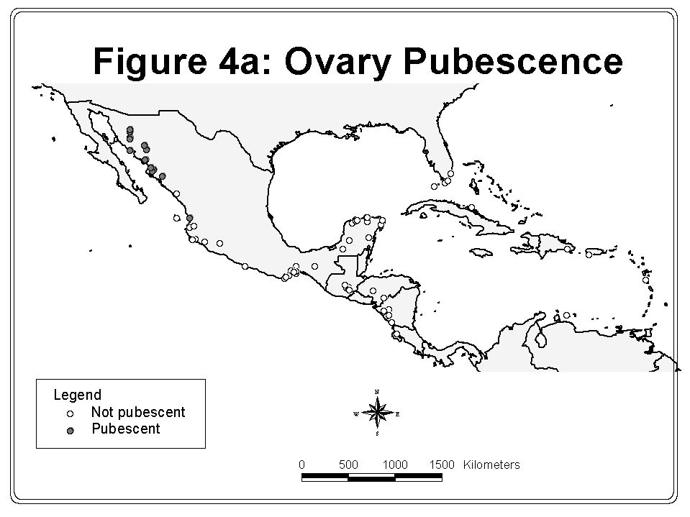

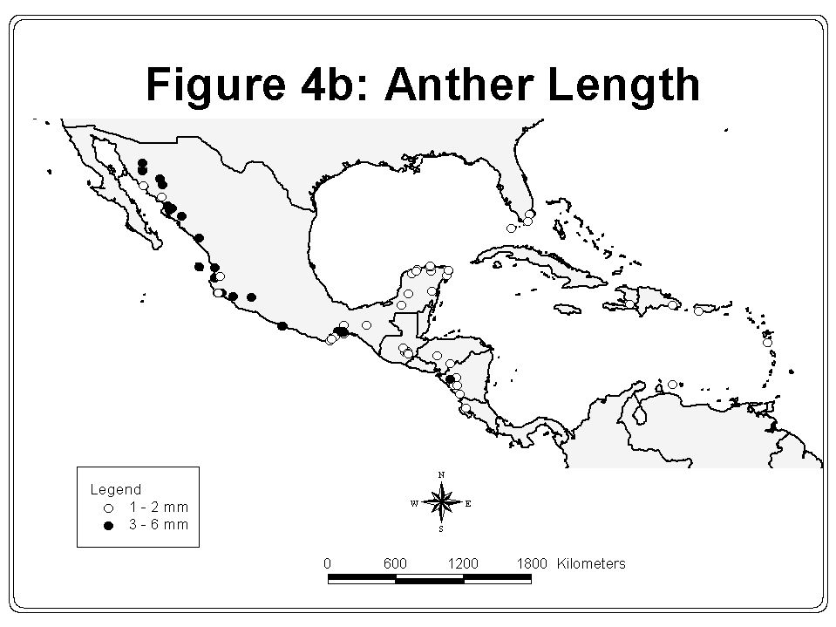

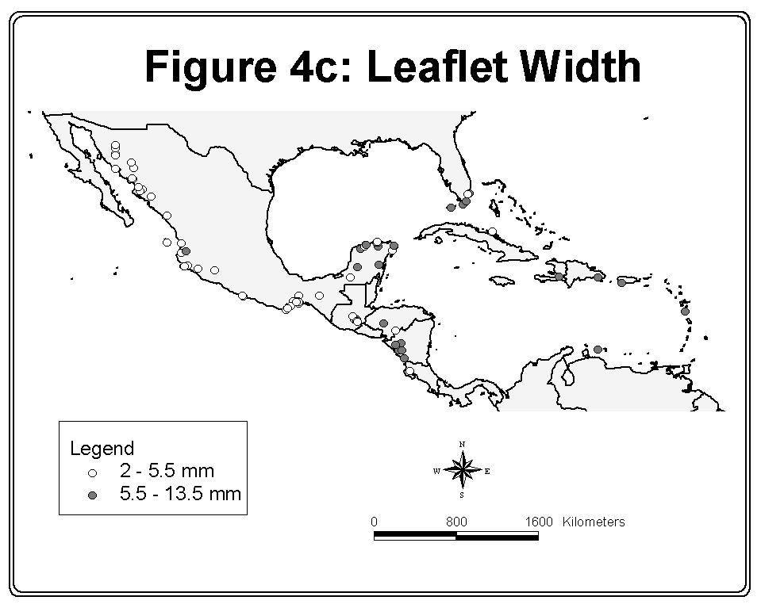

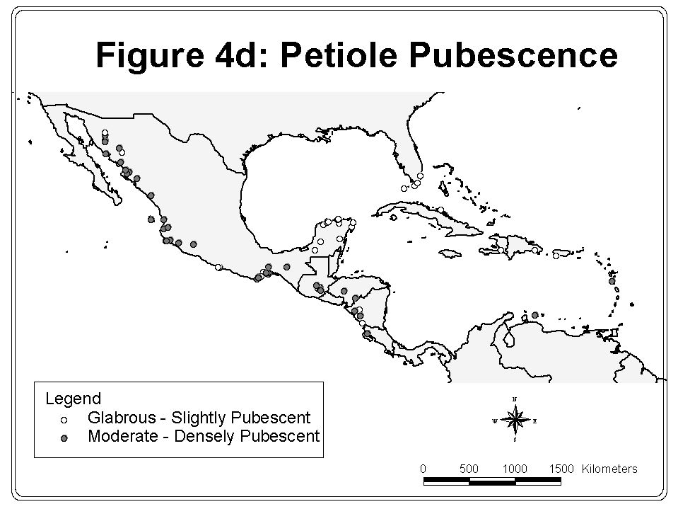

n = 9
n = 16

Figure 5: Mean tree height and standard error of Guaiacum sanctum and G. coulteri individuals observed in the field in Mexico.
Discussion
Based on the herbarium analysis, field data, and personal observation Guaiacum sanctum, G. coulteri, and G. coulteri var. palmeri can be distinguished from each other. G. sanctum is characterized by having petioles glabrous or slightly pubescent, wider leaflets and smaller floral structures than the other two species. G. sanctum is limited to the Yucatan Peninsula in its Mexican distribution and tends to be a taller tree, up to 20-m tall. G. coulteri is distinguished from G. sanctum by possessing narrower leaflets, larger floral structures, and petioles moderate to densely pubescent. G. coulteri var. palmeri can be clearly discerned from both G. coulteri and G. sanctum by its pubescent ovary.
There are, however, some inconsistencies that do not fit with the conclusion of clear delineation between species. Based on both personal observation and the analyses, specimens from Guatemala do not conform entirely to the characteristics of either G. sanctum or G. coulteri. The cluster analysis successfully groups them with G. sanctum, whereas ordination analysis groups many specimens from Guatemala with G. coulteri. This result lends support to Porter’s suggestion (1972) that G. guatemalense represents a hybrid between G. sanctum and G. coulteri.
Specimens from areas such as Honduras, Nicaragua, Costa Rica, and Oaxaca, Mexico presented difficulties for analysis as well. Though specimens from Honduras, Nicaragua, and Costa Rica are generally classified as G. sanctum, they present a wide range of variation and share some characteristics with G. coulteri such as a high leaflet length to width ratio. According to the analyses, G. coulteri from the southern and central Pacific coast of Mexico sometimes falls within the range of variation of G. sanctum. The clustering and PCA could not clearly differentiate all specimens of G. coulteri from Oaxaca, Jalisco, and Chiapas from G. sanctum, thus demonstrating the overlapping range of variation among these taxa and the difficulty in discriminating among them.
The morphological variation observed in Guaiacum species may be a reflection of the influence of environmental factors on specimens. Data such as elevation, precipitation, and soil type were often absent from herbarium specimens and were prevented from inclusion in the analysis. Other factors not available for analysis, such as the age of the trees and growing conditions, may affect the morphology of the plants. Foliage characteristics, though determined to be most useful for discriminating G. sanctum and G. coulteri, are not considered conserved traits for plants and may possibly exhibit variation due to environmental conditions. Furthermore, the analysis relied on herbarium collections for distribution data and therefore risks introducing the bias of the original collectors. The original collectors may have overemphasized some areas for collection and ignored others completely.
Questions for Further Studies
Future Guaiacum research should explore different approaches to more definitively assess the relationships in the genus. Though not practical for monitoring purposes, analysis of molecular evidence could prove to be the simplest way of identifying the species. Though the phylogenetics of the Zygophyllaceae has been examined previously (Sheahan and Cutler, 2000), the phylogeny of the genus Guaiacum remains unexplored. Such a study may provide explanations for the morphological variation of Guaiacum in areas such as Oaxaca, Mexico and Guatemala.
Recent studies have provided data on the distribution of G. sanctum in the Yucatan Peninsula. Galindo-Leal et al. (2000) indicate that approximately 1000 km² of dry tropical forest on the edge of the Calkmul Biosphere Reserve, Campeche is dominated by G. sanctum. Mexico’s largest exporter of G. sanctum timber reports an average density of 8 trees > 20 cm per hectare in the area around Pich in northern Campeche (Salmón, 2000). Compilation of studies such as these can provide needed data regarding the population status of G. sanctum. This type of information is needed for other Guaiacum species and for other areas of Guaiacum distribution within Mexico, Central America and the Caribbean.
Furthermore, relatively little empirical data is available regarding the life history of Guaiacum species. While some aspects of the phenology and ecology of Guaiacum have been addressed by previous workers (Wendelken, 1987), much remains to be learned about the biology of this genus. Information regarding reproduction rates, growth rates and genetic variation of the species may prove essential for estimating the viability of their populations.
Relevance for Trade Management
The need for systematic review and clarification of the distribution of the genus is principally driven by concerns about population threats due to trade in the species. Despite reports that G. coulteri is not considered commercially valuable, specimens were observed in Mexico with more than sufficient girth to fabricate propeller shafts, the main industrial use of Guaiacum timber. Recent reports that G. coulteri may be traded as G. sanctum (Curiel, 2000) and reports from Canadian Customs that G. coulteri was imported from Mexico (Gerson, 2000) have raised concern over this latter species and heightened the need for a clear understanding of the taxonomy of the genus.
The ability to distinguish G. sanctum from G. coulteri can enable CITES and custom officials to monitor trade in these species separately and detect harvesting trends for both species. The main form of the tree in commerce is timber however, and some experts have suggested that the wood of the two species is indistinguishable (Schippman, 2001; Porter, 2001). Though foliage and flowering material may be sufficient for identification, lacking these features, the two species may be impossible to differentiate. The most effective way to identify the species in trade may be to inspect stands of Guaiacum before harvesting for identification purposes or determine the place of origin of the timber.
Literature Cited
Aguilar G., J.I. 1958. Relación de Unos Aspectos de la Flora Util de Guatemala. VI Reunion de la Comisión Forestal Latinoamericana, Guatemala, November, 1958.
Applied Biostatistics Inc. 1998. NTSYSpc. Numerical taxonomy and multivariate analysis system. Version 2.02i.
Bentham, G. and J.D. Hooker. Genera Plantarum. 1862. Reprinted 1965. Wheldon & Wesley, LTD. and Verlag J. Cramer. Germany.
Brandegee, T.S. 1915. Plantae Mexicanae Purpusianae VII, 6(8):183, University of California Press, Berkeley.
Chickering, C.R. 1973. Flowers of Guatemala. University of Oklahoma Press, Norman.
CITES. 2000. Consideration of Proposals for Amendment of Apendices I and II, Prop. 11.62. Nairobi, April, 2000.
Curiel, G. 2000. Personal communication to Ed Schwartzman by telephone. October 23, 2000.
Descole, H.R., C.A. O’Donnell, & A. Louteig. 1940. Revisión de las Zigofiláceas argentines. Lilloa V: 257-352.
Galindo-Leal, C., J.P. Fay, S. Weiss, and B. Sandler. Conservation priorities in the greater Calakmul Region, Mexico: Correcting the consequences of a congenital illness. Natural Areas Journal. 20(4): 376-380
Gerson, H., Canada Customs and Revenue Agency. 2000. E-mail communication with Christopher Robbins. November 15, 2000.
Gray, A. 1852. Plantae Wrightianae Texano -- Neo-Mexicanae, part 1. Smithsonian Contributions to Knowledge, Smithsonian Institute, Washington, D.C.
Gray, A. 1897. Synoptical Flora of North America: Vol. I. - Part I. American Book Company, New York.
Hemsley, W.B. 1879-1888. Biologia Centralis-Americana; or Contributions to the Knowledge of the Fauna and Flora of Mexico and Central America. F.D. Godman and O. Salvin, eds. Botany, volume 1. R.H. Porter, publisher, London.
Instituto Nacional de Ecología. 2000. http://www.ine.gob.mx/ucanp/index.html
International Plant Names Index. 1999. http://www.ipni.org/index.html.
Johnston, I.M. 1924. Expedition of the California Academy of Sciences to the Gulf of California. Proceedings of the California Academy of Sciences 12 (30): 951-1218.
Linnaeus, Carol. 1753. Species Plantarum. Acad. Imper. Monspel. Berol. Tolos. Stockholm, Sweden.
Martinez, M. 1959. Plantas Utiles de la Flora Mexicana. Ediciones Botas. Mexico.
Molina R., A. 1975. Enumeración de las Plantas de Honduras. Ceiba 19 (1): 1-118.
Ortega, J.G. 1927. Guayacán. México Forestal 5 (11-12): 139-140.
Porter, D.M. 1963. The Taxonomy and Distribution of the Zygophyllaceae of Baja California, Mexico. Contributions from the Gray Herbarium 192: 99-135.
Porter, D.M. 1972. The Genera of the Zygophyllaceae in the Southeastern United States. Journal of the Arnold Arboretum 53: 531-532.
Porter, D.M. 1974. Disjunct distributions in the New World Zygophyllaceae. Taxon 23: 339-346.
Porter, D.M. 2001. E-mail communication to Ed Schwartzman. March 16, 2001.
Record, S.J. and R.W. Hess. 1943. Timbers of the New World. Yale University Press, New Haven.
Salmón, M. 2000. E-mail communication to Shelly Grow. December 20, 2000.
Schippmann, U. 2001. E-mail communication to Julie Lyke. June 6, 2001.
Seymour, F.C. 1980. A Check List of the Vascular Plants of Nicaragua. Phytologia Memoirs I, New Jersey.
Sheahan, M.C. and D.F. Cutler. 2000. Phylogenetic relationships within Zygophyllaceae based on DAN sequences of three plastid regions, with special emphasis on the Zygophylloideae. Systematic Botany 25(2): 371-384
Shreve, F. and I.L. Wiggins. 1964. Vegetation and Flora of the Sonoran Desert. Stanford University Press. Stanford, California.
Sokal, R.R. and P.H.A. Sneath. 1963. Principles of Numerical Taxonomy. W.H. Freeman and Company. San Francisco and London.
Sprengel, C. 1825. Systema Vegetabilium. Sumtibus Librariae Dieterichianae, Gottingae.
Standley, P.C. 1920. Trees and Shrubs of Mexico (Gleicheniaceae-Betulaceae), volume 23, part 1. Contributions from the National Herbarium, Smithsonian Institution, United States.
Standley, P.C. and J.A. Steyermark. 1946. Flora of Guatemala. Fieldiana: Botany volume 24, part 4. Chicago Natural History Museum.
Stokes, J. 1812. Botanical Materia Medica ii: Consisting of the generic and specific characters of the plants used in medicine and diet. J. Johnson. London.
Vail, A.M. and R.A. Rydberg. 1910. North American Flora, 25(2)103-107.
Wendelken, P.W. and R.F. Martin. Avian consumption of Guaiacum sanctum fruit in the arid interior of Guatemala. Biotropica 19(2): 116-121.
Wiggins, I.L. 1980. Flora of Baja California. Stanford University Press, California.
Identification Key and Descriptions of Mexican Guaiacum Species
Dichotomous key and species descriptions based on the works of Bentham and Hooker, 1862; Porter 1963 and 1972; Shreve and Wiggins, 1964; Standley, 1920; Vail and Rydberg, 1910; and personal observations of herbarium specimens.
GUAIACUM L. Sp. Pl. 381. 1753.
Trees or shrubs of strong, resinous wood, often with swollen nodes. Leaves petiolate, oppositely arranged and even-pinnate with 2-14 pairs of entire, mucronate - apiculate leaflets. Flowers borne individually or in clusters on peduncles arising from a pair of deciduous bracts. Sepals 5 (4), imbricate and of unequal size. Petals blue – purple obovate. Stamens 8 – 10 inserted on a disk and without appendages. Anthers versatile and oblong. Ovary of 5 (2 - 5) locules, obovate, and extending into a pointed style. Fruits 2-5 winged, obovate on a short stalk, dehiscent. Seeds solitary in each carpel, covered by a red, fleshy aril.
Leaflets elliptic - broadly obovate, 7 – 18 mm wide. 1. G. sanctum
Leaflets linear oblong – slightly obovate, 3 – 11 mm in wide.
Ovary glabrous. 2. G. coulteri
Ovary partly – entirely pubescent or tomentose.
Number of leaflets 6 – 10. 3. G. coulteri var. palmeri
Number of leaflets usually 2. 4. G. unijugum
1. Guaiacum sanctum L. Sp. Pl. 382. 1753
Guaiacum sloanei Shuttl. ex A. Gray, Pl. Wright. i. 29. 1852
Guaiacum verticale Ortega, Hort. Matr. Dec. 93. 1798.
Guaiacum mutlijugum Stokes, Bot. Mat. Med. ii. 488. 1812.
Yucatan Peninsula; also reported in Veracruz and Tabasco. Central America, the West Indies and Florida Keys.
Medium to small tree, 10-m (15 - 20) in height; trunk with dark gray bark flaking in small to medium pieces; thicker branches slightly sinewy; leaves 2.4 – 5.8 cm long; leaflets 4 – 8, elliptic to broadly obovate, unequal, 18 – 32 mm long, 7 - 18 mm wide, essentially glabrous, leaflets spaced 6 –11 mm apart along rachis; petioles glabrous to slightly ciliate, 3 – 9 mm long; stipules 3 mm, deciduous; flowers borne terminally or from upper leaf axils on peduncles; sepals 5, 4 - 6 mm long , 2 - 4 mm wide, ciliate inside, slightly pubescent outside; petals 5, blue or purple, obovate and clawed, 8 – 10 mm long, 4 –7 mm wide; ovary obovate, 5- angled, glabrous, 4 –9 mm total length, with a style 1 – 3 mm long; stamens 4 – 7 mm long; anthers 1 - 2 mm long; fruit obovate, 5-winged, 11 – 17 mm long, 4 - 11 mm wide; borne on slightly ciliate pedicels, 11 – 29 mm long; seeds black, elliptic, 10 –11 mm long, covered by fleshy red aril.
Typically found on rocky, calcareous soil. Habitat dry, medium semi-evergreen and low semi-deciduous forests as well as coastal areas. Distributed within protected areas including Sian Ka’an and Calakmul Biosphere Reserve (Instituto Nacional de Ecología, 2000).
2. Guaiacum coulteri A. Gray, Mem. Am. Acad. II. 5: 312
Guaiacum planchoni Gray ex. Vail and Rydberg
Guaiacum parvifolium Planch. ex A. Gray
Sonora to Oaxaca, along Pacific Coast of Mexico.
Shrub or small tree 1 – 8 (12) m in height; trunk with gray bark flaking in medium to large pieces; thicker branches slightly sinewy; leaves 2 – 6.2 cm long; leaflets 6 - 12, oblong linear – elliptic (slightly obovate), slightly unequal, 11 – 23 (29) mm long, 4 - 11 mm wide, essentially glabrous, leaflets spaced 3 - 9 mm apart along rachis; petioles moderate – densely ciliate, 1 – 5 (1- 9) mm long; stipules subulate, deciduous; flowers axillary; sepals 5, 5 – 8 mm long, 2 - 6 mm wide, ciliate inside, slightly pubescent outside; petals 5, blue or purple, distinctly clawed, 11 – 16 (11 - 20) mm long, 6 - 15 mm wide; ovary obovate, 5-angled, glabrous, 9 – 15 mm total length, style 2 – 6 mm long; stamens 7 - 12 mm long; anthers 2 –3 mm long; fruit obovate, 5-winged, 12 – 18 mm long, 7 - 14 mm wide; borne on slightly ciliate pedicels, 11 – 29 mm long; seeds black, ellipsoid, 10 –12 mm long, covered by fleshy yellow – red aril.
Found on a variety of dry rocky, sandy and clay soils. Habitat dry, low semi-deciduous forest, thorny scrub, and roadsides. This species is also used as an ornamental and found planted in patios in Oaxaca.
3. G. coulteri var. palmeri (Vail) I.M. Johnston, Proc. Calif. Acad. IV, 12: 1053, 1924
Guaiacum palmeri Vail
In the vicinity of Guaymas, Sonora, north to Hermosillo, Sonora and south into Sinaloa.
Shrub or small tree 1 – 4 m in height with corky bark; leaves 1.5 – 6 cm long; leaflets 6 - 10, oblong linear, 7 – 24 mm long, 3 - 6 mm wide, slightly pubescent on underside, leaflets spaced 3 – 6 (3 - 9) mm apart along rachis; petioles densely ciliate, 2 – 5 mm long; stipules minute, deciduous; flowers in axils of leaves at end of branches; sepals 5, 5 – 8 mm long, 3 - 6 mm wide, ciliate inside, slightly pubescent outside; petals 5, blue or purple, distinctly clawed, 11 – 16 (11 - 20) mm long, 6 - 15 mm wide; ovary obovate, 5- angled, partly to entirely covered with dense pubescence or tomentum, 5 – 11 mm total length, style 2– 5 (1 – 5) mm long; stamens 8 - 11 mm long; anthers 2 –4 mm long; fruit obovate, 5-winged, 10 – 15 mm long, 10 - 15 mm wide; borne on a moderate to densely pubescent pedicel, 6 - 14 mm long; seeds black, ellipsoid, 7 – 8 mm long, covered by fleshy, red aril.
Found on sandy, rocky soils. Habitat chaparral, low semi-deciduous forest, and roadsides.
There has some been some question as to whether this form of G. coulteri constitutes a separate species or is even worth recognition as a variety (Johnston, 1920).
4. G. unijugum Brandegee, Univ. of Calif. Pub. Bot. 6: 183, 1915
Endemic to southeast Cape Region of Baja California Sur.
Shrub 1 – 2 m in height with brownish gray bark; leaves composed of 2 (4) leaflets, unequal, ovoid 6 – 13 mm long, 3 - 10 mm wide, glabrate to puberulent; petioles densely pubescent, 3 – 5 mm long; stipules puberulent, deciduous; flowers usually solitary on short spurs; sepals 5, 3 –6 mm long, 2 - 4 mm wide, moderately puberulent; petals 5, blue or purple, distinctly clawed, 9 - 12 mm long, 6 mm wide; ovary obovate, 5- angled, tomentose, style 1 – 1.5 mm long; stamens 5 – 8 mm long; anthers curved, 2 mm long; fruit tomentose, 15 – 20 mm long, slightly wider than long; borne on pedicels, 7 - 16 mm long; seeds rarely more than one per fruit.
Habitat on dunes and hills near coast.

PC11 Doc. 8.2
Annex

G. palmeri
cluster

Guatemala
cluster

G. sanctum cluster
G. coulteri cluster
Outliers
Figure 2: Phenogram of UPGMA clustering based on average taxonomic distance of 113 OTU’s of the genus Guaiacum. OTU clusters are indicated in brackets. OTU’s are coded for interpretation of species and locale information. The first letter of each OTU refers to its species description (C = G. coulteri, S = G. sanctum, G = G. guatemalense, and P = G. coulteri var. palmeri). The last 3 - 4 letters represents the first letters of the state of origin of Mexican OTU’s and general locale of others, e.g. son = Sonora, car = Caribbean, and hond = Honduras. All OTU’s were sequentially numbered to differentiate specimens of the same species and locale.
Figure 3: Projection of 113 OTU’s of the genus Guaiacum onto a character space defined by two principle components. The first letter of each OTU refers to its species description (C = G. coulteri, S = G. sanctum, G = G. guatemalense, and P = G. coulteri var. palmeri). The last 3 - 4 letters represents the first letters of the state of origin of Mexican OTU’s and general locale of others, e.g. son = Sonora, car = Caribbean, and hond = Honduras. All OTU’s were sequentially numbered to differentiate specimens of the same species and locale.

Tree # | Species | Latitude | Longitude | Elevation (m) | Municipio, Estado | Height (m) | DBH (cm) | Height to first branching | Bark color | Bark flaking? | Soil type
1 | Guaiacum sanctum | 182497 | 895328 | 70 | Calakmul, Campeche | 20 | 60 | 8 | dark grey | yes | limestone, rocky
2 | Guaiacum sanctum | 182497 | 895328 | 70 | Calakmul, Campeche | 15 | 20 | 3 | grey | yes | limestone, rocky
3 | Guaiacum sanctum | 182497 | 895328 | 70 | Calakmul, Campeche |  |  | 2.5 |  | yes | limestone, rocky
4 | Guaiacum sanctum | 182497 | 895328 | 70 | Calakmul, Campeche | 12 | 15 | 1 | dark grey | yes | limestone, rocky
5 | Guaiacum sanctum | 182047 | 895248 | 70 | Calakmul, Campeche | 12 | 20 |  |  |  | limestone, rocky
6 | Guaiacum sanctum | 182047 | 895248 | 70 | Calakmul, Campeche | 8 | 13 |  |  |  | limestone, rocky
7 | Guaiacum sanctum | 182047 | 895248 | 70 | Calakmul, Campeche | 15 | 20 |  |  |  | limestone, rocky
8 | Guaiacum sanctum | 182047 | 895248 | 70 | Calakmul, Campeche | 18 | 18 |  |  |  | limestone, rocky
9 | Guaiacum sanctum | 182047 | 895248 | 70 | Calakmul, Campeche | 4.5 | 10 |  |  |  | limestone, rocky
10 | Guaiacum coulteri | 161392 | 951045 | 20 | San Pedro Huilotepec, Oaxaca | 5.5 | 26 | 0.5 | light grey | no | sandy
11 | Guaiacum coulteri | 161392 | 951045 | 20 | San Pedro Huilotepec, Oaxaca | 7.5 | 54 | 2.5 |  | yes | sandy
12 | Guaiacum coulteri | 161549 | 951335 | 35 | Tehuantepec, Oaxaca | 7 | 61 | 2.5 |  | yes | sandy, disturbed
13 | Guaiacum coulteri | 161549 | 951335 | 35 | Tehuantepec, Oaxaca | 6.5 | 54 |  |  | no | sandy, disturbed
14 | Guaiacum coulteri | 155860 | 953187 | 90 | Santiago de Astata, Oaxaca | 7 | 70 |  | light grey | yes | sandy, disturbed
15 | Guaiacum coulteri | 155860 | 953187 | 90 | Santiago de Astata, Oaxaca | 7 | 36 |  |  |  | sandy, disturbed
16 | Guaiacum coulteri | 155860 | 953187 | 90 | Santiago de Astata, Oaxaca | 6 | 40 |  |  |  | sandy, disturbed
17 | Guaiacum coulteri | 155979 | 954018 |  | San Pedro de Huamelula, Oaxaca | 6 | 20 |  |  | no | limestone, eroding
18 | Guaiacum coulteri | 160086 | 953986 |  | San Pedro de Huamelula, Oaxaca | 4.5 | 20 | 0.5 | grey | yes | sandy, rocky
19 | Guaiacum coulteri | 160086 | 953986 |  | San Pedro de Huamelula, Oaxaca | 2 | 8 | 0.5 |  | no | sandy, rocky
20 | Guaiacum coulteri | 155826 | 954307 |  | San Pedro de Huamelula, Oaxaca | 4 | 50 | 1 | light grey
21 | Guaiacum coulteri | 175149 | 980740 | 925 | Mariscala, Oaxaca | 5.5 | 78 | 1.5 | light grey | yes | rocky, sandy
22 | Guaiacum coulteri | 175361 | 982722 | 935 | Mariscala, Oaxaca | 5.5 | 40 | 1 | light grey |  | rocky, sandy
23 | Guaiacum coulteri | 180281 | 980810 | 950 | Guadalupe de Santa Ana, Puebla | 6 | 51 | 2 | light grey | yes | rocky, sandy, eroded
24 | Guaiacum coulteri | 182100 | 981771 | 940 | Teuhitzingo, Puebla | 2.5 | 8 | 0.5 |  | no | clay, disturbed
25 | Guaiacum coulteri | 182100 | 981771 | 940 | Teuhitzingo, Puebla | 3 | 10 | 0.5 |  | no | clay, disturbed
Table 3. Field observations of Guaiacum spp. in Mexico.

