PC11 Doc. 7.3
CONVENTION ON INTERNATIONAL TRADE IN ENDANGERED SPECIES
OF WILD FAUNA AND FLORA
____________
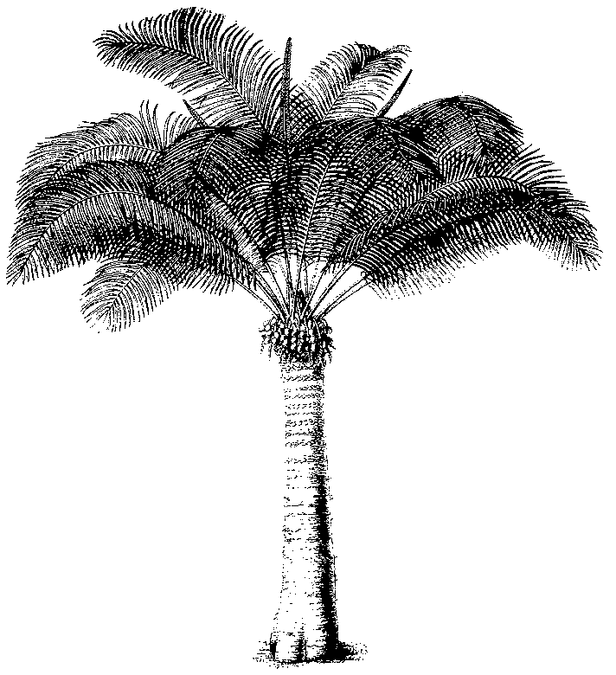
Eleventh meeting of the Plants Committee
Langkawi (Malaysia), 3-7 September 2001
Review of Resolution Conf. 9.24
Report of the Standing Committee meeting (plants issues)
1. The attached document [SC45 Doc. 17 (Rev. 1)] was presented to the Standing Committee at its 45th meeting, in Paris, (France), 19-22 June 2001.

