PC11 Doc. 4
CONVENTION ON INTERNATIONAL TRADE IN ENDANGERED SPECIES
OF WILD FAUNA AND FLORA
____________
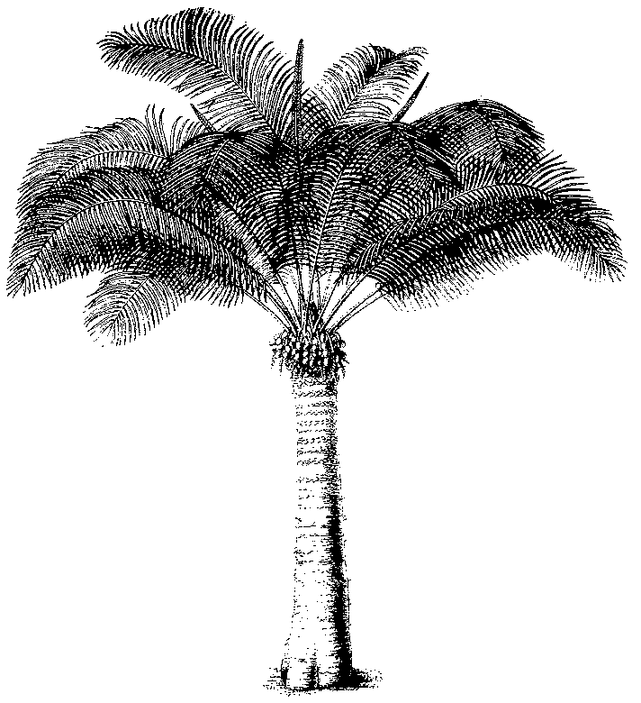
Eleventh meeting of the Plants Committee
Langkawi (Malaysia), 3-7 September 2001
ADMISSION OF OBSERVERS
1. The present document lists all organizations that had informed the Chairman of their desire to be represented at the 11th meeting of the Plants Committee by observers. This list is submitted to the Plants Committee for the purpose of considering the admission of observers.
2. UNEP
UNEP-World Conservation Monitoring Centre
3. Intergovernmental organizations
IUCN-The World Conservation Union
4. Non-governmental organizations
International Wood Products Association (IWPA)
American Orchid Society
COMURNAT
Environmental Investigation Agency
SYNKEM
TRAFFIC Network
TELEPAK Indonesia
WWF Malaysia

