PC11 Doc. 3.2
CONVENTION ON INTERNATIONAL TRADE IN ENDANGERED SPECIES
OF WILD FAUNA AND FLORA
____________
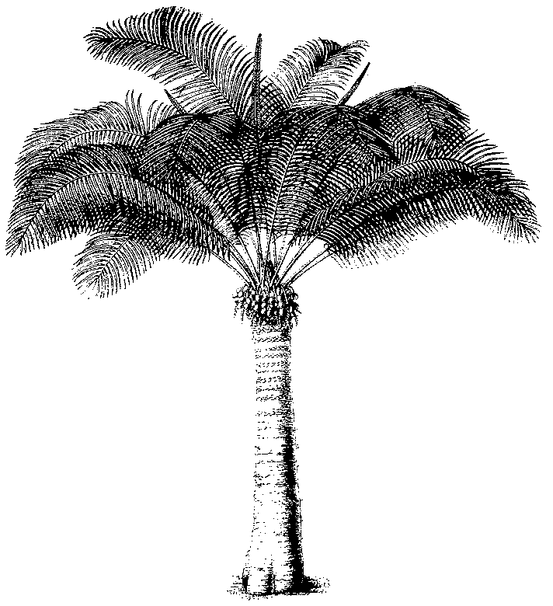
Eleventh meeting of the Plants Committee
Langkawi (Malaysia), 3-7 September 2001
Adoption of the agenda and the Working programme
Working programme

Sunday 2 September
20h00 Welcome reception

Monday 3 September
09h00 – 09h45 Closed session (Committee members and Parties only)
10h00 – 10h45 Official opening of the meeting
10h45 – 11h15 Coffee break
11h15 – 12h30 Working session
12h30 – 14h00 Lunch
14h00 – 15h30 Working session
15h30 – 16h00 Tea break
16h00 – 17h30 Working session

Tuesday 4 September
09h00 – 10h30 Working session
10h30 – 11h00 Coffee break
11h00 – 12h30 Working session
12h30 – 14h00 Lunch
14h00 – 15h30 Working session
15h30 – 16h00 Tea break
16h00 – 17h30 Working session

Wednesday 5 September
Excursion

Thursday 6 September
09h00 – 10h30 Working session
10h30 – 11h00 Coffee break
11h00 – 12h30 Working session
12h30 – 14h00 Lunch
14h00 – 15h30 Working session
15h30 – 16h00 Tea break
16h00 – 17h30 Working session

Friday 7 September
09h00 – 10h30 Working session
10h30 – 11h00 Coffee break
11h00 – 12h30 Working session
12h30 – 14h00 Lunch
14h00 – 15h30 Working session
15h30 – 16h00 Tea break
16h00- Closing ceremony

