AC18 Inf. 9

CONVENTION ON INTERNATIONAL TRADE IN ENDANGERED SPECIES
OF WILD FAUNA AND FLORA

___________________
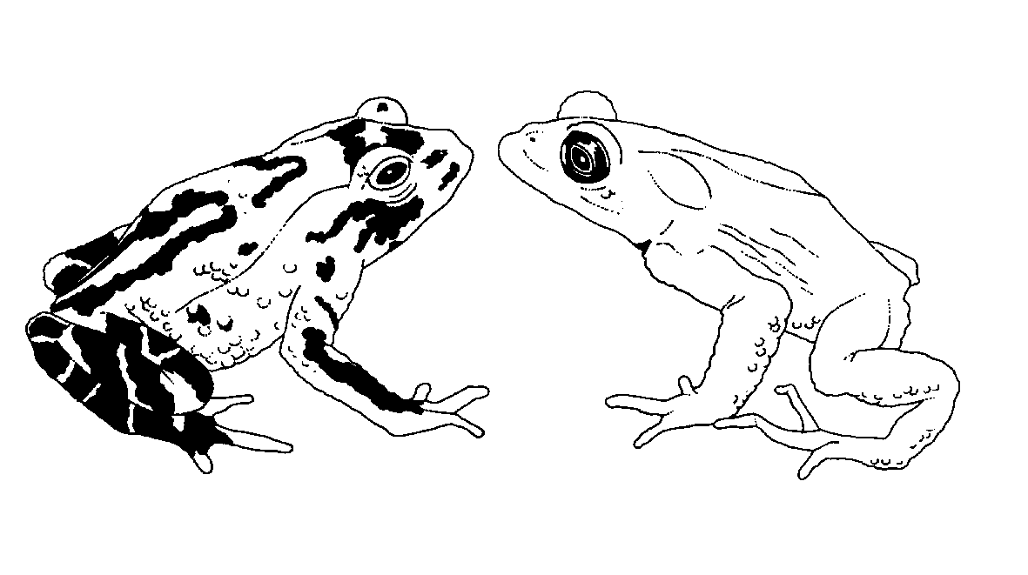

Eighteenth meeting of the Animals Committee
San José (Costa Rica), 8-12 April 2002

Identification Manual

progress report
1. In accordance with Resolution Conf. 11.19, paragraph g) the Secretariat herewith provides a report on the progress made with the production of the Identification Manual.
2. A list of the sheets that have been distributed since 30 June 2001, and of those being printed edited, formatted, translated, or prepared, is included in the Annex.
3. The source of the sheets is indicated under the original language in which they were provided.
4. The Secretariat has contracted the former editor of the Identification Manual, Dr J.-P. Biber, to convert all the published sheets into electronic format, for updating and inclusion on its website.

Annex
Identification Manual sheets sent to the Parties since 30 June 2001
Fauna
English
Accipitridae: 1 species (provided by Switzerland)
Cetorhinus maximus: 5 pages (provided by the United Kingdom)
French
Accipitridae: 42 species
Cetorhinus maximus: 5 pages
Flora
French
Timber identification: Introduction (24 pages) plus 6 species
Identification Manual sheets, currently with the printers, to be sent in April-May 2002
Fauna
English
Accipitridae: 1 species
Elapidae: 1 species (Management Authority of Australia)
Myobatrachidae: 2 species (Management Authority of Australia)
French
Cercopithecidae: general remarks: 2 pages
Procyonidae: general remarks (2 pages) plus 1 species
Equidae: general remarks (2 pages) plus 2 species
Artiodactyla: 16 species
Pittidae: 2 species
Fringillidae: 3 species
Accipitridae: 58 species
Flora
English
Appendix-I Cactaceae (Management Authority of Switzerland)
Identification of Cactaceae based on morphological characteristics (ca. 40 pages) in English (prepared under contract with the Secretariat)
Identification of cycads based on leaf characteristics (ca. 20 pages, including colour illustrations) in English and Spanish (provided by the Management Authority of Switzerland)

Identification Manual sheets requiring editing and/or formatting
Fauna
Chamaeleonidae: about 120 sheets (English and French) (Management Authority of Germany)
Accipitridae and other bird families: 57 species (French)
Chaetophractus nationi
Phelsuma spp.: 35 species (French)
Cordylidae: 23 species (French)
Cuora spp.: key plus six species (English and French) (Management Authority of Switzerland)
Carcharodon carcharias (Management Authority of Australia)
Flora
Timber identification: Introduction (24 pages) plus 15 species (Spanish) (provided by the Scientific Authority of Spain in Spanish); 9 species in English and French
Identification of Cactaceae based on morphological characteristics (ca. 40 pages) in French and Spanish (prepared under contract with the Secretariat)
Identification of Cycads based on leaf characteristics (ca. 20 pages, including colour illustrations) in Spanish (provided by the Management Authority of Switzerland)
Medicinal plants: 18 species (17 from the Scientific Authority of Germany, one from the Management Authority of China)
Gonystylus spp. and Cedrela odorata (National Herbarium Netherlands, under contract with the Secretariat)

In preparation
Fauna
English
29 parrot species (Management Authority of Switzerland)
Flora
English
22 species of Aloe (Management Authority of Switzerland)
11 sheets on various species (Scientific Authority of the United States of America)

