AC18 Doc. 20.1

CONVENTION ON INTERNATIONAL TRADE IN ENDANGERED SPECIES
OF WILD FAUNA AND FLORA

___________________
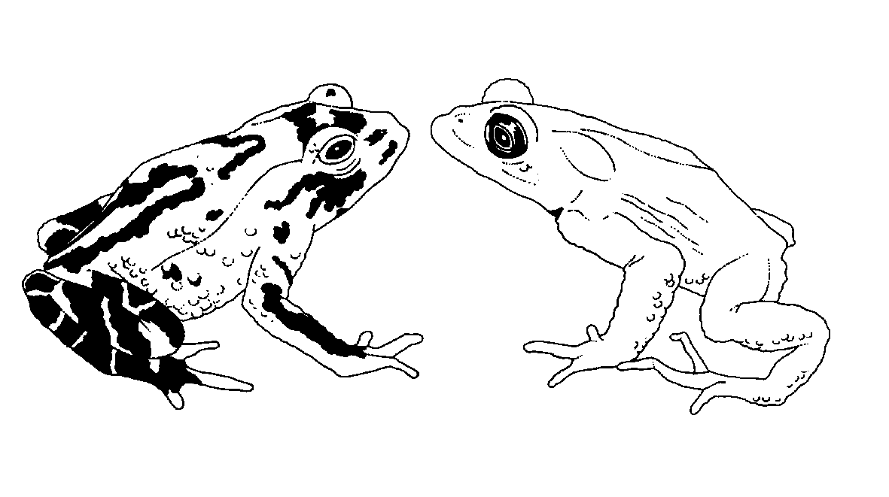

Eighteenth meeting of the Animals Committee
San José (Costa Rica), 8-12 April 2002

Implementation of Decision 11.100 regarding trade in alien species

REPORT OF THE WORKING GROUP
This document has been prepared by the Chairman of the working group on trade in alien species
Introduction
1. Notwithstanding the threatened status of most species under CITES regulation, trade in alien species can represent a threat to the biodiversity of countries receiving them. Some CITES-listed species, such as macaques in Mauritius and rosellas and deer species in New Zealand, may be pests in their countries of introduction. In addition, the trade regulation and monitoring mechanisms of CITES provide very useful experience in the development of protocols for invasive species under the Convention on Biological Diversity.
Members of the working group
2. The members of the working group are Rod Hay, Regional Representative for Oceania (chairman), Sixto Inchaustegui, Regional Representative of Central and South America and the Caribbean, Michael Griffin, Regional Representative of Africa and representatives from Israel (Simon Nemtzov), Italy (Marco Apollonio – rapporteur), United States of America (Pamela Hall), Spain (Carlos Ibero Solana) and IUCN (Alison Rosser). The International Wildlife Coalition was invited to participate in the working group intersessionally.
Activities agreed to at AC17
3. The working group agreed at AC17 that the priority activity was the production of a list of actual and potential invasive species included in the CITES-Appendices. It was further agreed that the purpose of such a list would be to provide Parties with information on examples of CITES species that have become invasive. This would give suggestions for management and scientific authorities when considering the overall impacts of trade in these or similar species.
Activity since AC17
4. The working group has not been as active as hoped. However, all CITES animal species has been screened and a candidate list of “CITES invasive animals” has been prepared for circulation at or prior to AC18.
5. In addition, liaison with IUCN/SSC Invasive Species Specialist Group (ISSG) has continued through the chairman of the working group. The ISSG has agreed to provide input into the development of the list of invasive species included in the CITES-Appendices. The ISSG Invasive Species Database is under active development and is available for searching at http://www.issg.org/database/welcome/
Issues to be resolved
6. Lower priority issues discussed by the AC17 working group included:
a) continuing liaison with other bodies, including the IUCN/SSC/ISSG and the Convention on Biological Diversity;
b) the risks to biodiversity from organisms transported with CITES species imported for trade; and
c) the impacts of other invasive species on CITES-listed species in their natural range.
7. It is recommended that the group concentrate on the production of the list of CITES-listed invasive species, in conjunction with the Plants Committee.

