AC18 Doc. 15.2

CONVENTION ON INTERNATIONAL TRADE IN ENDANGERED SPECIES
OF WILD FAUNA AND FLORA

___________________
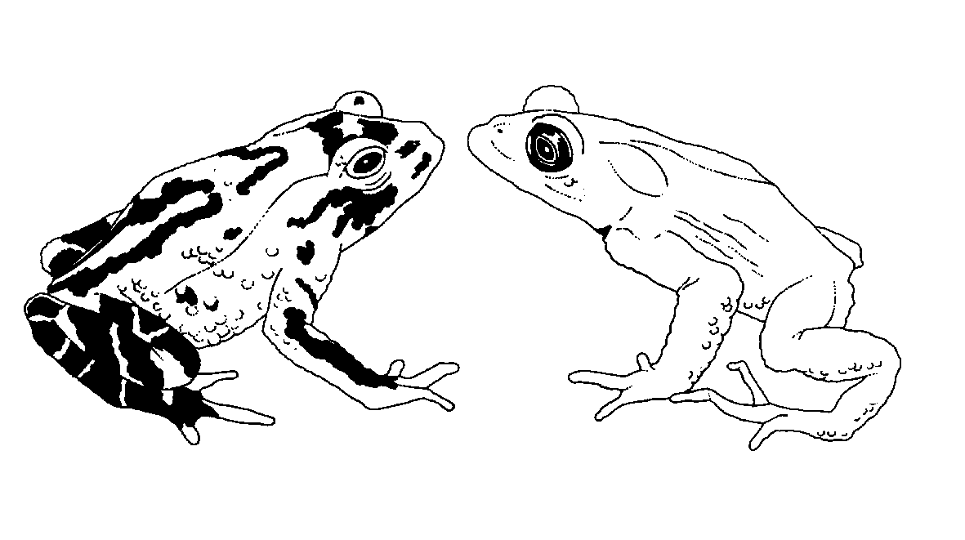

Eighteenth meeting of the Animals Committee
San José (Costa Rica), 8-12 April 2002

Universal labelling system for the identification of caviar

proposed amendements to resolution Conf. 11.13
This document has been prepared by the Secretariat.
1. Resolution Conf. 11.13 on universal labelling of caviar is meant to apply particularly to commercial shipments of caviar that are exported from the country of origin to the initial country of import. At the 17th meeting of the Animals Committee (Hanoi, August 2001), the Committee’s working group on the universal labelling of caviar was tasked to assess the need to revise Resolution Conf. 11.13 to extend the scope of the Resolution to include labelling of caviar that is re-exported, to improve clarity and consistency of certain recommendations, and to complete or update its provisions as necessary.
2. The working group worked intersessionally, and an informal technical sub-group of the working group drafted a revision of resolution Conf. 11.13 for further discussion at AC18. The resulting document is presented in the Annex to this document. Proposed additional text appears in bold. Proposed deletions appear in strikethrough. The working group should provide justifications for each of the proposed changes.
3. The Secretariat suggests that the labelling requirements should not be extended to meat of Acipenseriformes at this stage. It further notes that some of the proposed new text requires review and editing, and that text for certain new definitions and codes has not yet been provided. Noting that inadequate controls of domestic markets for caviar remain a matter of great concern, the Secretariat recommends that all containers of caviar be labelled, including those traded domestically, in order to improve monitoring of the trade. If there were a truly universal labelling system for caviar, this could be used as a certification scheme, providing customers with greater assurances regarding the source and quality of caviar.

Annex

Universal labelling system for the identification of caviar

Proposed amendments to Resolution Conf. 11.13
AWARE that all living species of sturgeon and paddlefish (Acipenseriformes) are listed in Appendix I or II of CITES, but concerned that certain parts and derivatives of some sturgeon species may be subject to some illegal trade;
RECOGNIZING that illegal trade has in the past threatened the survival of certain populations of sturgeons and has undermined the efforts of producer countries to manage their sturgeon resources on a sustainable basis;
RECOGNIZING that Resolution Conf. 10.12 (Rev.), adopted by the Conference of the Parties at its 10th meeting (Harare, 1997) and amended at its 11th meeting (Gigiri, 2000), directs the Secretariat in consultation with the Animals Committee to explore the development of a uniform marking system for sturgeon parts and derivatives to assist in subsequent identification of the species;
RECALLING that Article VI, paragraph 7, of the Convention provides that specimens of species listed in the Appendices may be marked to assist in identifying them;
NOTING that, in order to assist the Parties in identifying legal caviar in trade, marking should be standardized and that particular specifications for the design of labels and utilisation thereof are fundamental and should be generally applied;
CONSIDERING that the labelling of all caviar in international trade would be a fundamental step towards the effective regulation of trade in sturgeons and sturgeon products;
RECOGNIZING, however, that the Animals Committee, at its 15th meeting (Antananarivo, 1999), decided to recommend only, at this stage, the adoption of a universal marking system for the export of caviar from producing countries to the initial country of import;
RECOGNIZING, that the Animals Committee, at its 17th meeting (Hanoi, 2001), recommended that the universal marking system for the export of caviar from producing countries to the initial country of import should be expanded to caviar for re-export;
NOTING, that the Standing Committee at its 45th meeting raised concerns about domestic markets of caviar and the need to enhance systems that facilitate trade control;
NOTING that strategies for the uniform marking of caviar should take into account marking systems currently in place and should not prevent producer countries and legitimate processing and trading industries from marking the caviar in trade in a further developed way;
THE CONFERENCE OF THE PARTIES TO THE CONVENTION
RECOMMENDS:
- That the following definitions apply in relation to trade in sturgeon caviar and meat:
Primary container: [definition to be provided]
Secondary container: [definition to be provided]
Aquaculture: sturgeon and paddlefish farmed in compliance with CITES provisions defining captive breeding;
Processing plant: the facility, or parent company, responsible for the original placing of the caviar into the container that is in contact with the caviar.
Lot identification number: a number relating to the point in time when the processing occurred. This should be no longer than one day but the date itself need not be quoted but can be represented as a series of letters and numbers.
"Pressed" caviar: the eggs of more than one sturgeon or paddlefish species remaining after the processing and preparation of other, higher quality, caviar products.
a) the introduction of a uniform marking system for any primary container (tin, jar, or box into which caviar is directly packed) of more than 249 grams of caviar entering international trade from the countries of origin, based on the application of non-reusable labels on each primary container;
- the introduction of a uniform marking system for any primary container (tin, jar, or box) that is in direct contact with the caviar produced for commercial or non-commercial purpose and whether in domestic or international trade, based on the application of a non-reusable label on each container;
b) that for export of primary containers containing less than 250 grams of caviar, the non-reusable labels referred to in paragraph a) above be affixed only to the secondary containers, which should also include a description of the content;
- that, when the caviar is exported or re-exported, its secondary container should, in addition to the description of the content in accordance with international customs regulations, mention the exact quantity of caviar per species and per CITES permit or certificate in accordance with the information included in the related CITES permit or certificate;
c) d) that the non-reusable label affixed on all containers of caviar produced in countries of origin include, as a minimum: grade of the caviar (beluga, sevruga, or ossetra); a standard species code as provided in the Annex 1; the source code of the specimen as provided in Annex 2 (e.g. wild, aquaculture); and a unique serial number for the shipment, consisting of the ISO two-letter code for the country of origin, the year of harvest; the official registration code of the processing plant (xxxx); and a unique number for the primary container that corresponds to the processing plant and the lot identification number for the caviar (yyy):
Beluga/HUS/WIL/RU/2000/xxxx/yyyy
d) that the information, referred to in paragraph c) above be clearly marked on all secondary containers containing one or more primary containers of caviar;
e) that the non-reusable label referred to in paragraph d) above remains on the container as long as the caviar it contains is not re-packaged. Where repackaging does not take place, the label referred to suffice for re-exports;
f) that all containers in which caviar is repackaged are re-labelled with a non-reusable label that includes as a minimum: a standard species code as provided in the Annex 1, the source of the specimen as provided in Annex 2 (e.g. wild or aquaculture), the ISO two-letter code for the country of origin, the year of repackaging, the official registration code of the repackaging facility (wwww) and the number of the previous CITES permit or certificate (zzzz):
PER/WIL/IR/2001/wwww/zzzz
e) g) that, in order to facilitate tracking and monitoring of caviar exports and re-exports, the same information that is on the label affixed to the secondary caviar container be given mentioned on the export permit and re-export certificate under box “9. Description” or described in an annex attached to the CITES permit or certificate;
f) h) that, in the event of mismatches of information between a label and a permit or certificate, the Management Authority of the importing Party immediately contact its counterpart in the exporting or re-exporting Party to establish whether this was a genuine error arising from the volume of information required by this Resolution, and that, if this is the case, every effort be made to avoid penalising those involved in such transactions;
i) that Parties establish a system of registration for processing and re-packaging facilities of caviar and that the Management Authority of exporting, re-exporting and importing Parties provide to the Secretariat the list of registration codes of processing plants and repackaging facilities officially registered in their country. An updated list is to be provided annually before 15 March of the year of concern;
g) j) that the Management Authority of the exporting, re-exporting, and importing Parties provide to the Secretariat, as when directed by the Standing Committee or agreed to between the range State and the CITES Secretariat, a copy of each export permit for caviar immediately after issuance or upon receipt for verification and confirmation to importing Parties, as appropriate;
h) that Parties accept shipments of caviar imported directly from countries of origin and re-export only if they are accompanied by appropriate documents containing the information referred to in paragraph c), d) or e), f) or g) and if the related processed products are labelled as directed in this Resolution; and
i) that Parties establish, where legally possible, a system of registration or licensing or both for importers and exporters of caviar;
RECOMMENDS that the preceding set of procedures take effect as soon as possible for export quotas for the year 2001 caviar produced and repackaged in the year 2004; and
URGES all Parties that trade (export, import or re-export) in caviar to report promptly to the Secretariat the volumes involved each year.

Annex 1

Codes for identification of Acipenseriformes species,
hybrids and several species
Species | Code
Acipenser baerii | BAE
Acipenser baerii baicalensis | BAI
Acipenser brevirostrum | BVI
Acipenser dabryanus | DAB
Acipenser fulvescens | FUL
Acipenser gueldenstaedtii | GUE
Acipenser medirostris | MED
Acipenser mikadoi | MIK
Acipenser naccarii | NAC
Acipenser nudiventris | NUD
Acipenser oxyrhynchus | OXY
Acipenser oxyrhynchus desotoi | DES
Acipenser persicus | PER
Acipenser ruthenus | RUT
Acipenser schrencki | SCH
Acipenser sinensis | SIN
Acipenser stellatus | STE
Acipenser sturio | STU
Acipenser transmontanus | TRA
Huso dauricus | DAU
Huso huso | HUS
Polyodon spathula | SPA
Psephurus gladius | GLA
Pseudoscaphirhynchus fedtschenkoi | FED
Pseudoscaphirhynchus hermanni | HER
Pseudoscaphirhynchus kaufmanni | KAU
Scaphirhynchus platorynchus | PLA
Scaphirhynchus albus | ALB
Scaphirhynchus suttkusi | SUS
Mixed species (for “Pressed” caviar exclusively) | MIX
Hybrid specimens: code for the species of the male x code for the species of the female | YYYxXXX

Annex 2

Codes for sources of specimens of Acipenseriformes
Wild | WIL
Aquaculture | AQC
Ranched | [code to be provided]
Farmed (grown in ponds” for a few month) | [code to be provided]

