AC18 Doc. 15.1

CONVENTION ON INTERNATIONAL TRADE IN ENDANGERED SPECIES
OF WILD FAUNA AND FLORA

___________________
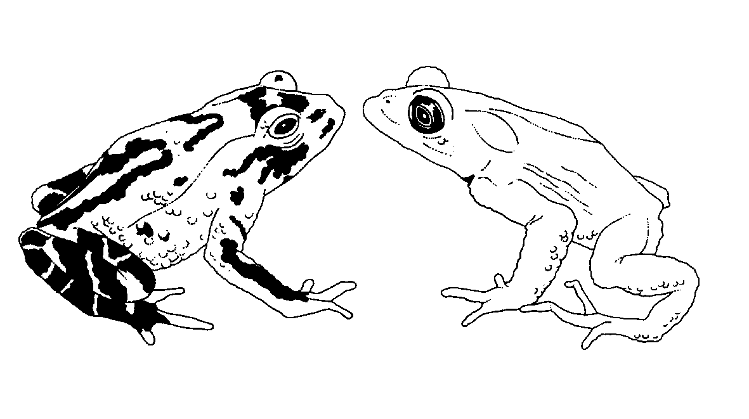

Eighteenth meeting of the Animals Committee
San José (Costa Rica), 8-12 April 2002

Universal labelling system for the identification of caviar (Resolution Conf. 11.13)

report of the working group
This report has been prepared by the Chairman of the working group on the universal labelling of caviar.
Background
1. Following the adoption of Resolution Conf. 11.13 concerning a universal labelling system for the identification of caviar, and the monitoring, in collaboration with the Animals Committee, by the Secretariat of the implementation of the system as required under Decision 11.162, it became apparent that certain recommendations in this Resolution required clarification. This was referred to the Animals Committee, which established a working group at its 16th meeting (Shepherdstown, December 2000) that included representatives of several range States of Acipenseriformes. The working group reconvened at the 17th meeting of the Animals Committee (Hanoi, July 2001). It formulated recommendations and clarifications regarding the implementation of Resolution Conf. 11.13 that were approved by the Animals Committee.
Membership of the working group
2. Participants in the working group at AC17 comprised the Regional Representative for Oceania (Chairman), the Secretariat, the Regional Representative for Europe, and representatives from China, France, Islamic Republic of Iran, the Russian Federation, Ukraine, United States of America, with NGO participation by IWMC and TRAFFIC Europe.
3. Subsequent to AC17, the working group also included participation by representatives of Petrossian Inc. and Caviar House.
Activities since AC17
4. This first draft of Notification to the Parties No. 2001/075 was developed during AC17, and amended by the Secretariat in consultation with the working group. The final draft of the notification was circulated to working group members for comments prior to being sent to Parties on 5 November 2001.
5. Notification to the Parties No. 2001/075 outlined the elements of the agreed universal labelling system and also invited Parties to apply a comparable system for the labelling of re-exported containers of caviar.
6. Since that Notification was issued, the CITES Management Authorities of the People’s Republic of China and the Russian Federation have communicated their labelling systems to the Secretariat and details of these have been issued to Parties (Notifications to the Parties Nos. 2001/087 and 2001/088 of 19 December 2001).
7. A further notification was issued by the Secretariat (Notification to the Parties No. 2001/089 of 19 December 2001) encouraging all caviar exporting countries that had not already done so to provide details of their labelling systems for exports of caviar and examples of the labels.
8. In the light of the fact that the system is not mandatory for re-export, an informal technical sub-group of the working group met in Geneva (hosted by the Secretariat) on 8 October 2001. This group canvassed the issues involved in drafting a resolution to apply the system to re-exports. The results of these discussions culminated in a draft resolution for discussion at AC18.
Issues remaining to be resolved
9. Extending the scope of Resolution Conf. 11.13 to cover re-export remains the major item for the working group. It is suggested that a draft resolution for CoP12 can be prepared at AC18 for submission at CoP12.

