AC18 Doc. 13.2

CONVENTION ON INTERNATIONAL TRADE IN ENDANGERED SPECIES
OF WILD FAUNA AND FLORA

____________
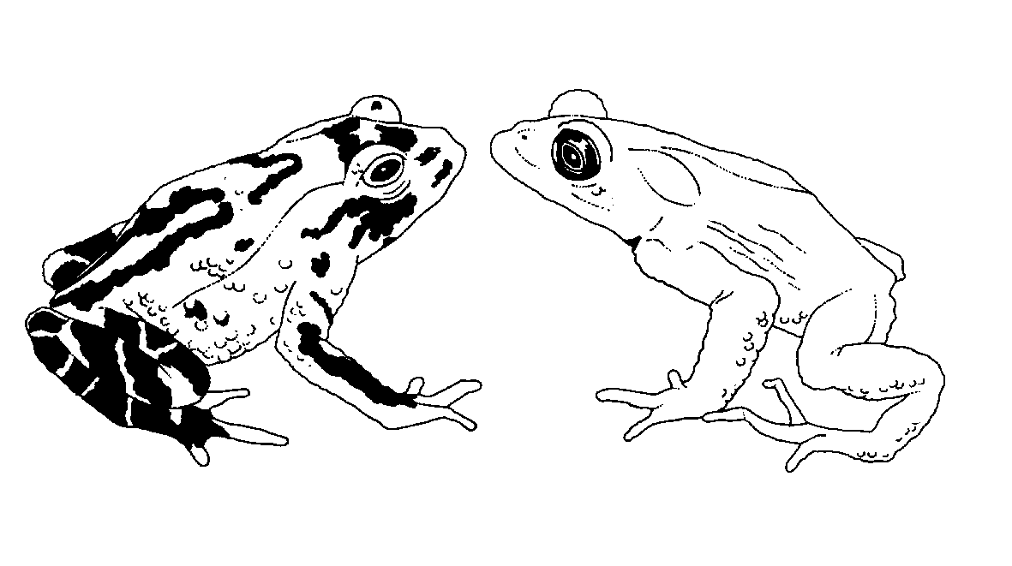

Eighteenth meeting of the Animals Committee
San José (Costa Rica), 8-12 April 2002

Implementation of Decision 11.165 on trade in traditional medicines

inventory of operations where captive breeding of cites species
is conducted for medicinal purposes
1. Paragraph a) of Decision 11.165 states that:
The Secretariat shall, in consultation with the Animals and Plants Committees:
a) compile an inventory of operations where artificial propagation or captive breeding of CITES species is conducted for medicinal purposes.
2. No further information is provided concerning the intended purpose of the inventory nor the criteria to be used for its compilation. The Secretariat is aware that not all countries in their national legislation provide for the registration of operations conducting artificial propagation or captive breeding, and expects that many countries will not have the means to conduct such a registration.
3. The Animals Committee is therefore requested to advise the Secretariat on this issue, in particular to indicate what the conservation benefits of such an inventory may be and any criteria that may be considered in its compilation. A similar request will be made to the Plants Committee. The Secretariat is concerned that there may be a large number of small operations that occasionally breed or propagate CITES-listed species that may be occasionally used for medicinal purposes, and may not involve international trade. Compiling (and updating) an inventory including such operations will be a huge undertaking, with little apparent conservation benefit.
4. If a clear conservation benefit were to be identified, the Secretariat would request the Committee to consider two alternative approaches, i.e. to recommend to the Conference of the Parties that the recommendation concerning an inventory of such operations be directed to the Parties to be implemented at national level; or to recommend to the Conference of the Parties to incorporate this element in the registration of operations pursuant to Resolution Conf. 11.14, on Guidelines for a procedure to register and monitor operations that breed Appendix-I animal species for commercial purposes.
5. The Secretariat wishes to note that no provision has been made by the Conference of the Parties in the budget of the Secretariat to implement Decision 11.165 and that the Secretariat is not able to recommend to the Standing Committee to assign a high priority to the implementation of this Decision at the cost of other priorities. The Secretariat will therefore recommend at the next meeting of the Conference of the Parties to delete this Decision unless a compelling argument can be put forward by either one of the technical committees in favour of the compilation and use of an inventory of the type specified in paragraph a) of the Decision.

