AC18 Doc. 10

CONVENTION ON INTERNATIONAL TRADE IN ENDANGERED SPECIES
OF WILD FAUNA AND FLORA

___________________
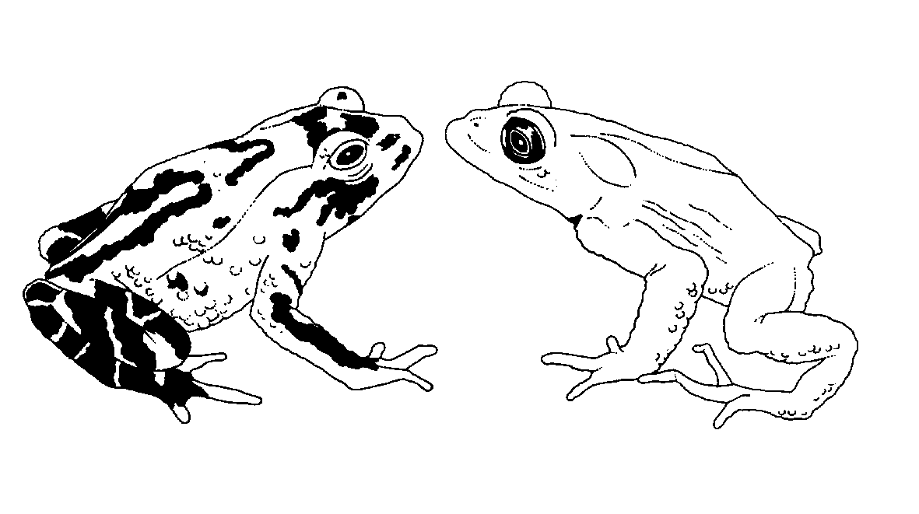

Eighteenth meeting of the Animals Committee
San José (Costa Rica), 8-12 April 2002

Relationship between ex situ production and in situ conservation
This document has been prepared by the Secretariat.
1. Decision 11.102 directs the Animals Committee, regarding operations that breed Appendix-I animal species for commercial purposes, to “examine the complex issues related to the origin of founder breeding stock and the relationship between ex situ breeding operations and in situ conservation of the species and, in collaboration with interested organizations, identify possible strategies and other mechanisms by which registered ex situ breeding operations may contribute to enhancing the recovery and/or conservation of the species within the countries of origin, and report its findings at the 12th meeting of the Conference of the Parties”.
2. With Notification to the Parties No. 2001/091 of 19 December 2001 (see Annex 1), the Secretariat invited all Parties and organizations to provide any information on the relationship between ex situ production systems and in situ conservation programmes for any CITES-listed species. At the time of preparing this document, no response has been received.
3. The Secretariat participated in a workshop organized by IUCN on the impact of commercial captive production and artificial propagation on wild species conservation in December 2001, White Oaks, Florida, United States of America, and the executive summary of this workshop is provided as Annex 2. Elements of this workshop are highly relevant to the task before the Animals Committee, and it may be useful to ask IUCN how it intends to follow-up on this workshop. One of the recommendations of the workshop refers to the assessment of the potential consequences of commercial captive-breeding operations on the conservation of wild populations, following an approach similar to the checklist developed by IUCN regarding the making of non-detriment findings for CITES-listed species (document Inf. 11.6). This approach may prove to be of value in the context of CITES as well.
4. The Secretariat is concerned that the Animals Committee may not be able to comply with Decision 11.102, on the basis of information provided by Parties and interested organizations. The issue is nevertheless, in the opinion of the Secretariat, of considerable importance, and should be explored further, also in the context of developments in the Convention on Biological Diversity concerning access to genetic resources.
5. The Secretariat requests that the Committee recommend to the Conference of the Parties that work should continue on this subject after CoP12.

Annex 1
No. 2001/091 Geneva, 19 December 2001
CONCERNING:
Relationship between ex situ production and in situ conservation
1. Decision 11.102 directs the Animals Committee, regarding operations that breed Appendix-I animal species for commercial purposes, to “examine the complex issues related to the origin of founder breeding stock and the relationship between ex situ breeding operations and in situ conservation of the species and, in collaboration with interested organizations, identify possible strategies and other mechanisms by which registered ex situ breeding operations may contribute to enhancing the recovery and/or conservation of the species within the countries of origin, and report its findings at the 12th meeting of the Conference of the Parties”.
2. The Secretariat has been aware of a range of critical views or contradictory perspectives on this issue. Such opinions may derive from situations that do not characterize most ex situ production systems (i.e. captive breeding operations, artificial propagation operations) even though ex situ breeding operations need not be synonymous with conservation programmes. Examples of such views are that:
i) establishing ex situ production systems may have unintended consequences such as the risk of creating disincentives for habitat protection and in situ conservation, for example by requiring less strict controls over trade in specimens from captive breeding than from other production systems (and thus making it easier and cheaper to produce specimens for trade through captive breeding than maintaining wild populations and their habitat for a controlled offtake);
ii) ex situ production for commercial trade may result in a shift in production and trade from range States to non-range countries to the possible detriment of in situ conservation and/or socio-economic development in range States. This raises the question of ownership of genetic resources (i.e. the extent to which the countries of origin should benefit from trade in CITES-listed species) and whether CITES can contribute to the handling of this issue in the forum of the Convention on Biological Diversity;
iii) it may be wrongly assumed that ex situ production systems such as captive-breeding operations, in the general understanding of the term, have no negative conservation impacts (and even worse, the assumption that captive-breeding operations by definition contribute to the conservation of species in the wild), when indeed captive-breeding operations may have considerable negative impacts, e.g. captive-breeding operations for Appendix-I animal species that do not meet the criteria for registration;
iv) there is a continuing use of ex situ production systems to launder unauthorized wild-harvested or illegally traded specimens; and
v) the vulnerability of some communities to unnecessary trade controls and unpredictable access to consumer markets, as may result from regulatory policies favouring ex situ production systems, appears not to be fully appreciated.
3. At its 16th meeting, the Animals Committee endorsed a proposal from the Secretariat to:
i) request Management Authorities to provide information on the relationship between captive-breeding operations and in situ conservation programmes at national and international levels;
ii) request other appropriate organizations, and in particular the IUCN/SSC Wildlife Trade Programme, the IUCN/SSC Conservation Breeding Specialist Group and the IUCN/SSC Reintroduction Specialist Group, to inform the Committee on this subject;
iii) establish a project for which external funds should be sought, to research the resource economics (which include the relative socio-economic importance) of trade in specimens from various production systems;
iv) establish a project, for which external funds should be sought, to research the conservation impact of various production systems, focused on a number of target species; and
v) explore potential cooperation with the Convention on Biological Diversity on this subject.
4. Aspects of the potential impact of ex-situ production systems on wild populations, in the context of making non-detriment findings for specimens of Appendix-II species, and developing a classification system for the various production systems involving CITES-listed species were discussed by the Animals and Plants Committees at their latest meetings. Consensus was reached in both Committees that neither the relationships between wild populations and an increasingly complex range of ex situ production systems, nor the potential impacts of those systems on wild populations are fully understood, and that the subject should be investigated further for all CITES-listed animal and plant species.
5. All Parties and organizations are accordingly invited to provide any information that they may already have on the relationship between ex situ production systems and in situ conservation programmes for any CITES-listed species, particularly concerning the issues referred to in paragraph 2, and providing examples where possible.
6. The Secretariat intends to use the information received for the development of further actions outlined in paragraph 3, in consultation with the Animals and Plants Committees. The Secretariat would be grateful if the information requested could be submitted by 31 March 2002.
Annex 2
(English only/ Seulement en anglais/ Únicamente en inglés)

The impact of commercial captive production/ artificial propagation
in relation to wild species conservation

Results of a workshop organised by IUCN - The World Conservation Union
and hosted by the Gilman Foundation
Summary
Demand for the use of wild species is increasing as human populations grow and the poverty gap widens. As many wild species are already over-used, a number of agencies are recommending that wild species be brought into captive production or cultivation systems (CCP). However, the conservation impacts of such production systems are poorly understood, on one hand such production may reduce the harvest of wild populations, but on the other it can lead to environmental degradation, pollution and loss of genetic diversity as well as loss of incentives to conserve wild populations. To identify the conservation impacts of commercial captive breeding and begin to develop guidance to deal with these impacts, IUCN SSC convened a small workshop with three working groups. The groups dealt respectively with cultivation of plants for the medicinal and horticultural trade, aquaculture and the captive production of terrestrial fauna.
The results obtained from the three groups were remarkably complimentary as they tackled different aspects of the issue. The questions identified as important by all groups are summarised and synthesised below and formed the starting point for developing the various actions recommended by the different groups:
- How are terms used in the industry defined?
- Who benefits from CCP?
- Who approves/administrates/ regulates CCP?
- How to assess conservation benefits of a particular production system?
- What is the appropriate decision making process to develop a product from wild collection to production to marketing and permitting?
- How to deal with genetics and domestication/ GMO issues and their conservation impacts?
- Which hazards are relevant - invasive species, disease, environmental impact and how to address them?
- How to deal with the challenges associated with the market place; the difficulty for industry of dealing with increasingly complex regulation; the equitable sharing of benefits associated with product development that occurs well away from the point of origin of the original wild species?
- What is the role of the consumer in shaping demand, regulation, and pricing?
- How to ensure a balanced view of the conservation risks and benefits and recognition of the cultural aspects involved in supply and demand?
The groups developed a risk assessment framework for investigating the impacts of captive breeding and artificial propagation on the conservation of species. Currently there are no agreed definitions or descriptions of production systems so it is difficult to categorise the systems and to determine which are most likely to be beneficial to both conservation and livelihoods. Consequently, the plant group in particular felt that it will be necessary to look at the characteristics on which such systems can be grouped if generalisations about the costs and benefits of such systems are to be drawn out. For fauna, the working group demonstrated a preliminary classification methodology (based on work presented to the Animals Committee by Hank Jenkins) to characterise production systems on the basis of their dependence on the wild population coupled with the degree of management control that is exercised over captive breeding operations.
To develop a risk assessment approach, the fauna group, having categorised some production systems, were able to examine the perceived positive and negative impacts of several types of production system on conservation. They then identified the various stakeholders impacted by the production systems and examined the conservation costs and benefits to particular stakeholders. Once costs to stakeholders have been identified it is possible to go on and develop activities to mitigate these impacts. The fauna group identified some concrete activities to develop for change.
Both the plant and aquaculture groups also focussed on the need for risk assessments to identify the impacts in individual cases. The plant group developed a model of the dynamics of the commercialisation and artificial production of a newly identified product so as to be able to identify when risk assessment exercises would need to be undertaken. The aquaculture group identified socio-economic and environmental issues of concern to the conservation and business communities and began to incorporate these into a checklist to be used when undertaking risk assessments.
Results/ recommendations
The over-riding result of the workshop was agreement on the need to undertake risk assessments when considering the impacts of captive breeding or cultivation operations. Participants spent time exploring a range of tools to be used in undertaking these risks assessments and ensuring that conservation and socio-economic interests are represented, Clearly an important step will be to conduct a stakeholder analysis. In addition, analysis of the various characteristics associated with beneficial CCP systems will help to determine those systems that could be encouraged in different situations.
In terms of assessing production systems, there are two situations to deal with:
a) the initiation of new CCP operations
b) the improvement of the environment to deal with existing CCP operations. (This environment could include regulations, public awareness and consumer pressure).
In either case a risk assessment would help to identify the appropriate action and to assess the conservation impacts of established systems to identify where improvements might be made to the regulatory; market or social environment so as to benefit business and conservation interests. To predict when CCP is likely to be considered as an alternative to wild production the workshop developed tools to model the growth of market demand for a product. To ensure that the important issues are considered in risk assessments, the group dealing with aquaculture developed a draft risk assessment checklist (see Table 4). The draft needs further work, review and testing, but the group felt that the checklist could probably be easily modified to be used in assessing all forms of CCP systems and to ensure that supply and demand, social and economic factors are considered along with conservation concerns.
In addition to the tools, a number of key issues were identified for further research or for action to stimulate the adoption of appropriate regulations or strategies:
Definition: Further analytical work is required to develop definitions and a framework of categories of production in order to assess the costs and benefits of different production systems. Initial CITES work has developed a framework for animals this needs to be extended to encompass plant production systems.
Conservation risk assessments: Further analytical work is required to understand the sustainability of different production systems (wild crafting to CCP and all in between); and the impact on the environment. The workshop developed a draft Risk Assessment Template as a tool to aid such assessments.
Social: Further analytical work is required to analyse the distribution of power, assets and benefits from different production systems.
Access and benefits: Policy and legislation should be developed to promote appropriate access and benefit sharing, empowering local communities and considering livelihood issues.
Dialogue and education: Action is needed to educate all stakeholders of the need and potential for CCP to contribute to conservation and to encourage stewardship throughout the entire chain of supply. Promoting dialogue between all stakeholders will be vital to achieving any progress.
Policy development: To institute changes and improvements, policy and legislation work will be required to formalise the need for risk assessments, benefit sharing, use of economic instruments etc. in association with the development of CCP systems.
Regulation: Further analytical work is required to identify gaps and the need for change in the regulatory framework. There are a number of existing soft (certification, voluntary standards) and hard policy tools (CITES) that apply to the industry, yet there are notable gaps and a need for greater collaboration between schemes. Regulations should be more responsive to the needs of different stakeholder groups and consider the use of industry self-regulation and incentives for compliance to reduce enforcement costs.
Market dynamics and economic incentives: A review of market dynamics could help to increase the economic feasibility of the industry and market factors can be used to promote conservation and business interests, e.g. certification/ green labelling schemes.
Production: Whichever production system is chosen to supply the product should not compromise conservation of the wild resource.
Capacity Building: Tools will need to be developed to assist with risk assessments and on-going monitoring protocols, implementation of regulations, etc.
The audience for these activities will include: The Commercial Chain (industry and consumers); Policy makers and Regulatory Agencies; General Public; NGOs/scientists; Local Communities.

