AC18 Doc. 7.5

CONVENTION ON INTERNATIONAL TRADE IN ENDANGERED SPECIES
OF WILD FAUNA AND FLORA

___________________
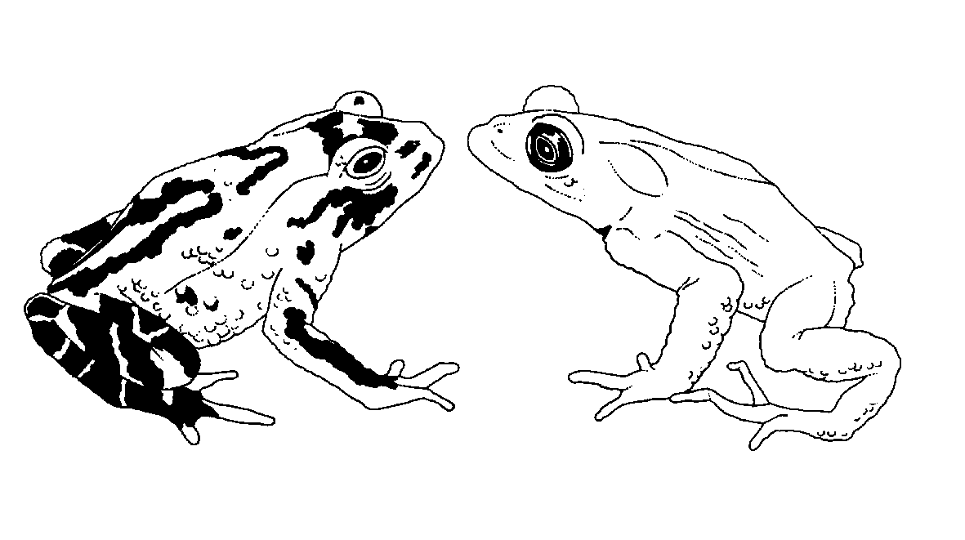

Eighteenth meeting of the Animals Committee
San José (Costa Rica), 8-12 April 2002

Implementation of Resolution Conf. 8.9 (Rev.)

significant trade field projects for animals
This document has been prepared by the Secretariat.
1. At its eighth meeting (Harare, July 1992), the Animals Committee drafted “Guidelines for the Development and Assessment of CITES Significant-Trade Field Projects for Animals”, which were approved by the Standing Committee at its 29th meeting (Washington, DC, March 1993). These guidelines, consisting of a Preamble and two Annexes, were communicated through Notification to the Parties No. 763 of 31 August 1993 (see Annex).
2. The “Guidelines for the Development and Assessment of CITES Significant Trade Projects for Animals” have been little used in the context of the Review of Significant Trade because of the revision of Resolution Conf 8.9 and the adoption of Decision 11.106. Furthermore, field studies or evaluations of threats to populations or of other relevant factors which range States of species concerned have been recommended to do pursuant to Resolution Conf. 8.9 (Rev.) do not need to follow the guidelines.
3. The Secretariat notes that the Preamble to the guidelines describes a process and sequence of events regarding the Review of Significant Trade that was modified through the adoption of Resolution Conf. 8.9 (Rev.) and Decision 11.106. The Preamble therefore for instance no longer correctly describes the role of the Animals Committee and the Standing Committee in the process. Similarly, the Diagram of Procedures for Significant Review in Annex 2 is no longer fully applicable.
4. In its Annex 1, the guidelines lay out factors that should be considered where appropriate and practicable for undertaking CITES Significant Trade Field Projects for animals. The Secretariat is of the opinion that these factors could be valid considerations when range States develop field projects or studies, particularly in the context of the implementation of recommendations pursuant to Resolution Conf.8.9 (Rev.).
5. The guidelines could therefore best be seen in the context of field projects and studies that Parties or the Animals Committee may wish to initiate. The guidelines could also be of use in developing terms of reference for projects on the status of species for which assistance from the Secretariat has been sought. The Secretariat believes however that, generally, the role of the guidelines in the implementation of Resolution Conf. 8.9 (Rev.) is no longer relevant.
6. The Animals Committee is requested to consider whether the Guidelines for the Development and Assessment of CITES Significant-Trade Field Projects for Animals should be retained and to provide recommendations for modifications if appropriate.
Annex
No. 763 Geneva, 31 August 1993

CONCERNING:
CITES Significant-Trade Field Projects for Animals
1. At its eighth meeting, held in Harare (Zimbabwe) in July 1992, the Animals Committee drafted Guidelines for the Development and Assessment of CITES Significant-Trade Field Projects for Animals.
2. The Guidelines were submitted to the Standing Committee at its 29th meeting, held in Washington, DC (USA) in March 1993. The Standing Committee approved the Guidelines, which are hereby communicated to all the Parties with a view to their implementation.
Guidelines for the Development and Assessment
of CITES Significant-Trade Field Projects for Animals
Preamble
Project outlines, stating the objectives and purpose of the proposed study together with the proposed investigators, locations, duration and cost should be forwarded to the Secretariat for consideration by the Standing Committee. The proponent(s) of projects that have been approved by the Standing Committee will be requested by the Secretariat to provide a detailed proposal in accordance with the approved Guidelines.
The attached Guidelines (Annex 1) have been developed to ensure that data collected enable assessment of the impact of trade and formulation of management policies. The major study objectives should include assessments of species' distributions, population parameters, and levels of offtake from the wild. The Guidelines provide a comprehensive set of requirements for data collection. Specific proposals will need to be tailored to suit the species under investigation and available resources. Where appropriate, proposals must include details of methodologies.
In consultation with the range Party or Parties, and drawing on appropriate expertise, the Animals Committee will review and approve the scientific content of projects approved by the Standing Committee.
Following field work, the consultant will produce a draft report that includes an executive summary and management conclusions. Where applicable, the Animals Committee will arrange to have reports reviewed, within two months of submission, by appropriate experts to ensure scientific credibility and by national government representatives of the range Party or Parties to encourage a consensual approach to any proposed management programme.
Following the review process, the consultant will produce a final report that addresses concerns raised by reviewers. The final report, together with reviewers' comments and the consultant's response to review comments will be forwarded to the Animals Committee for evaluation and consideration of the necessity for any management recommendations to be developed pursuant to Resolution Conf. 8.9.
The sequence of events in the development and conduct of CITES-approved field projects in relation to procedures required pursuant to Resolution Conf. 8.9 are set out diagrammatically in Annex 2.
Annex 1
Guidelines
Within the specific confines of each field study project, the following factors should be considered where appropriate and practicable.
A. Biological Factors
1. Minimum and maximum population estimates, using appropriate methodologies. Field surveys should be representative of different habitats and should include a comparison of exploited and unexploited populations. Comprehensive population estimates necessitate the collection of data on the following:
a) limits of distribution of the species, including, where appropriate, subspecies, populations and subpopulations;
b) population densities in different habitats and under varying environmental conditions;
c) the extent of different habitats over the range of the species; and
d) the extent of modification of populations and habitats by human activities, such as trapping, logging, fires and settlement.
2. Trends of change in population size (using field data, published data, or data from interviews of trappers, hunters and exporters).
3. Life history parameters (using either field data or, where not available, data from captive populations or from closely related species) and population parameters including:
a) age and sex structure, particularly in respect of the number of breeding adults;
b) age at first breeding, breeding seasonality, fecundity and the interval between breeding; and
c) age-specific survivorship.
4. Ecological factors, including seasonal movements and differences in habitat occupancy, and factors that limit population size, e.g. competition and predation.
B. Levels of Exploitation
Assessments of offtake from wild populations, using information on:
a) numbers harvested for international trade (as whole animals or parts) based on official statistics and on estimates of numbers harvested in excess of those recorded officially (i.e. illegal trade and legal trade amongst non-Parties);
b) numbers harvested for domestic markets;
c) offtake for other purposes, including pest control, where applicable, and subsistence hunting for meat and other products;
d) post-capture/pre-export mortality;
e) age and sex of specimens taken from the wild for any purpose; and
f) harvesting seasons and methods of capture.
C. Socio-economic Factors
Assessment of local and national factors that stimulate trade. Factors to be investigated include:
a) wages and benefits from other forms of employment as compared with earnings from harvesting;
b) price structure of the trade at local and national levels;
c) influence of cultural imperatives and traditions upon exploitation patterns; and
d) disincentives provided by law enforcement and social taboos.
Annex 2
Diagram of Proposed Procedure for Significant Trade Review
Problem identification
(through IUCN/WCMC & AC process or by the Parties)
Start of Conf. 8.9 including
initiation of studies
Preparation of project outlines
(Parties with Secretariat or independently in consultation with
range States)
SC approval for policy AC submits a list of species and trade issues for which information is needed
Project proposal development
Acquisition of funds
by Secretariat
AC review of proposal
(including review by range States and
other appropriate experts)
Field work
Preparation of draft report
Review by appropriate experts.............Optional by AC and range States
Rewrite/amend with executive summary
and management conclusions
Evaluation by AC in consultation with range States
and development of recommendations pursuant to Conf. 8.9
Transmission of relevant recommendations to
range States by Secretariat
Implementation of AC Conf. 8.9 recommendations
(including initiation of studies)

