AC18 Doc. 6.1
CONVENTION ON INTERNATIONAL TRADE IN ENDANGERED SPECIES
OF WILD FAUNA AND FLORA

___________________
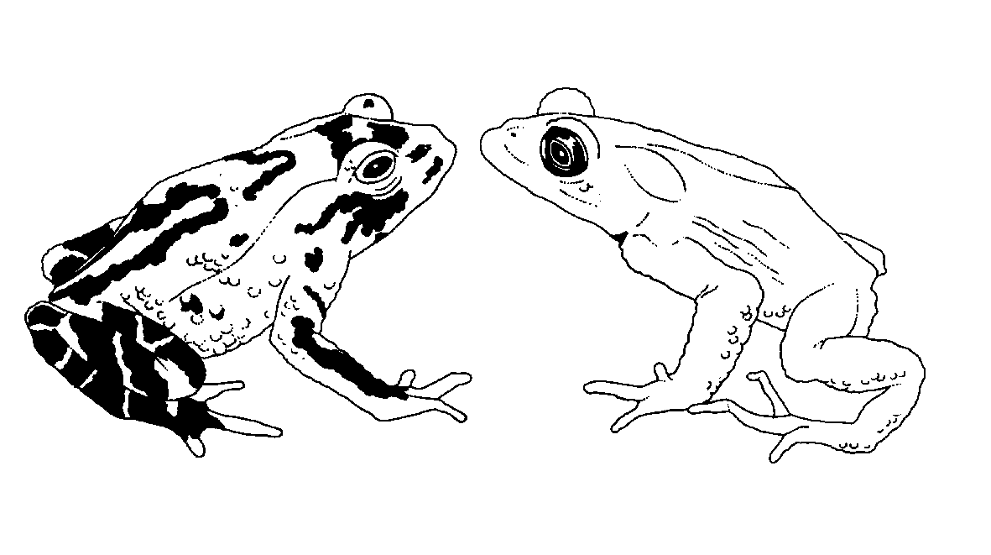

Eighteenth meeting of the Animals Committee
San José (Costa Rica), 8-12 April 2002

Report from Chairman

LIAISON WITH the STANDING Committee
The report annexed to this document was prepared by the Chairman of the Animals Committee and was presented to the Standing Committee at its 46th meeting (Geneva, 11-15 March 2002) as document SC46 Doc. 21.

Annex

Report from the Chairman of the Animals Committee to the Standing Committee
1. This report (for the period 15 April 2001 to 10 January 2002) has been prepared by the Chairman of the Animals Committee.
2. In the course of 2001, the regional representative for North America, Dr Susan Lieberman, announced that starting on August 1, 2001, she would be employed by a NGO and be based in the United Kingdom. After discussion with the Parties from the North American region, it was decided that she would be replaced by Dr Kurt Johnson of the Scientific Authority of the United States of America. Dr Johnson immediately took up his position and acted as regional representative for North America during the 17th meeting of the Animals Committee (AC17).
3. Because of the departure of Dr Lieberman (who was Vice-Chairman of the Committee), the position of Vice-Chairman became vacant and during AC17, the Animals Committee (AC) elected the representative for Central and South America and the Caribbean, Dr Marco Polo Micheletti Bain from Honduras, as the new Vice-Chairman.
4. AC17 took place from 30 July to 3 August 2001 in Hanoi, Viet Nam. The meeting evolved successfully, and I wish to express my gratitude to the Government of Viet Nam, and especially to the Management and Scientific Authority, for the great job it did in organising AC17 in a very efficient, pleasant way in nice and agreeable surroundings.
5. The attendance of NGOs was arranged in the same way as for AC16 and went smoothly. Some new NGOs that had not attended any of the previous meetings of the Committee were present for the first time.
6. The Summary Record of AC17 has been transmitted by the Secretariat to the Parties through Notification to the Parties No. 2001/095 of 19 December 2001.
7. Many items raised much interest and discussion during AC17 (cf. the reports of the working groups in the Summary Record), but some important issues merit to be especially mentioned.
a) One particular item that fuelled long debates was the definition of the term “critically endangered in the wild”, about which the AC could not reach consensus. It was finally agreed among members of the AC that the Secretariat would draw up three lists comprising Appendix-I listed species of reptiles that are difficult to keep or to breed in captivity, and that are categorised by IUCN as 1) critically endangered in the wild, 2) as critically endangered in the wild or endangered in the wild, and 3) as critically endangered in the wild, endangered in the wild or vulnerable in the wild. It was decided to limit this exercise to a pilot-project with reptiles. The four herpetologists in the AC will evaluate the three lists and the results will be discussed at AC18. It is therefore not possible to present the Standing Committee at this time with a list as mentioned in Decision 11.101. Several points would need further clarification, including differences in text between Decisions 11.101 and 11.163, and Resolution Conf. 11.14, and the need for the Standing Committee to approve any list before its submission to the meeting of the Conference of the Parties.
b) A second issue which generated extensive discussions, both in plenary and in the working group, was the agenda item on “Control of captive breeding, ranching and wild harvest production systems for Appendix II species”. There was much appreciation for the document produced by the consultant, and it was generally acknowledged that it gave a good overview of the different systems in use at the moment. Most discussion, however, was devoted to the changes in the existing source codes and the new additional ones as proposed by the consultant. For a number of participants, the advantages of more clear specifications were evident, while others perceived them as administratively cumbersome and complicated to monitor. It was suggested that a similar exercise should be done for plants and that the results should be combined. The Secretariat hired a consultant to take this matter forward. We hope to have a new document for further discussion at AC18.
c) The trade in freshwater turtles and tortoises in Southeast Asia also elicited much debate in the working group. There were some divergent views as to who should be invited to participate. The Secretariat pointed out that it had secured USD 92,500 for the technical workshop that it intended to convene in compliance with Decision 11.150, which meant that only a limited number of participants could be invited. Also, it was clarified that the workshop was not meant to be another scientific meeting, but rather a hands-on workshop where the main object of discussion would be legal frameworks and implementation. The workshop was scheduled to be held in Bogor, Indonesia from 26 to 29 November 2001, but because of events later in the year, it was decided to move the venue (at the invitation of the Chinese Government) to southern China, and to change the period to 25–28 March 2002.
d) The recommendations on sturgeons that had been made by the AC to the Standing Committee (SC) in the context of the implementation of Resolution Conf. 8.9 (Rev.) were adopted by the SC at its 45th meeting in Paris. The range States concerned agreed on the terms laid down in these recommendations. At AC17, only one additional new species (Strombus gigas) was selected for phase V of the Significant Trade Review process. Further discussions were held in a working group concerning a revision of Resolution Conf. 8.9 (Rev.). The conclusion was that the review of Significant Trade should be simplified and that most of the suggestions made by the consultant in document AC17 Doc.7.4 could be supported. The proposal of the Secretariat for the first country-based Significant Trade Review was discussed in detail, but finally the principle was approved with consensus of members of the AC, with the understanding that country-based reviews should NOT replace single species reviews, but could be organised in parallel.
Members of the AC agreed that Madagascar was a good candidate for the first country-based review, also taking into account that this Party had requested the Secretariat for such assistance. This conclusion was only relayed to the Secretariat, and not to observers at AC17. The Plants Committee came to the same conclusion at its meeting in Malaysia in September 2001, and the Secretariat therefore initiated the review process.
In the meantime the Terms of Reference for the country-based review were developed with input from the Animals Committee, and consultants have been contracted since November 2001.
Members of AC have recently advised the Secretariat on how to proceed with a number of outstanding sturgeon issues. The range States concerned will be informed by the Secretariat.
e) The periodic review of animal taxa in the Appendices gave rise to extensive, detailed discussions on biological and trade matters concerning the different taxa. It was noted that the system of voluntary contributions for animal species reviews, which had been initiated at AC 15, was not really working. There was no mechanism to compel Parties that had volunteered to undertake certain reviews to complete the work. The working group suggested to develop written guidelines that should be discussed at AC18 (the United States of America agreed to take the lead on this), and requested the Secretariat to develop a rapid assessment technique for screening multiple taxa (or higher-level taxa) to determine which should be the subject of more in-depth reviews.
f) The working group on corals presented a document on whether certain coral taxa could be identified to the generic level only, and presented a draft list of such taxa. It suggested a standard reference for corals, referring the matter to the Nomenclature Committee. The working group also assessed appropriateness of using Article IV.3 as an alternative to Article IV.2.(a) for the export of corals. No consensus could be reached on this issue, but the group agreed that a more ecosystem-based approach for managing the harvest of corals for export was desirable and that Parties should be encouraged to take this into consideration. The group will look into the possibility to insert additional text into Resolution Conf. 11.10 to address this subject. The draft text will be presented at AC18.
g) The working group on the universal labelling of caviar produced a draft text for a Notification to the Parties to be issued by the Secretariat.
h) The working group on transportation of live animals agreed to continue its cooperation with IATA. The American (AZA) and European Zoo Associations (EAZA) agreed to review the IATA live animals regulations and to provide draft recommendations to the transport working group by 31 January 2002. This matter should be taken up again and finalised at AC18. The Chair of the working group announced that the German government had hired a consultant to analyse the questionnaires on transport mortality, and that the results will be presented at AC18. The working group will examine Resolution Conf. 10.21 to determine if changes are needed.
i) The working group on Syngnathids reviewed the replies that had been received in response to Notification No. 2001/023, and considered these a good start of the information-seeking process. It further discussed logistics, content and desired outcome of the technical workshop to be held for 18 to 22 February 2002 in Cebu, Philippines.
j) The working group on trade in alien species concluded that a concise list with key examples of CITES species that are known to have become invasive should be developed. The initial analysis of details held by the ISSG should be awaited.
8. After AC17, several members of the AC (Dr Marinus S. Hoogmoed, Dr Sixto Inchaustegui, Tonny Soehartono) and Mr Tom De Meulenaer of the CITES Secretariat were invited by the Government of Viet Nam to visit some reptile and primate breeding centres in the southern part of the country, near Ho Chi Min City. Due to logistical problems, the regional representative for Africa, Mr Mike Griffin, could not take part in this trip. The trip (which lasted four days) was very useful, and the participants gained much insight in the processes and the species involved. Most reptiles were non-CITES listed species, but some crocodile (Crocodilus siamensis) farms and several breeding centres for Python molurus bivittatus were visited. The Chairman and Tom De Meulenaer prepared a trip report. We want to thank the Vietnamese Government for this generous initiative because it provided all participants with valuable information.
9. At the end of AC17, Costa Rica offered to host AC18. This offer was gratefully accepted. AC18 will be held from 8 to 12 April 2002 in San José, Costa Rica.
Revision of the Criteria
10. On 19-23 April 2001, the Chairs of AC, PC and the Criteria Review Group (CWG) met at the Secretariat in Geneva to ’finalise’ a draft of the revision of Resolution Conf. 9.24 (Rev.). This review concerned the entire Resolution with the exception of its Annex 5, which had not yet been discussed by the CWG because of time constraints and because the content would depend upon changes in the rest of the document. During the meeting, the comments received up till that date from members of the Committees, Parties and observers, as well as the discussions at the second Joint Meeting of AC and PC in Shepherdstown in December 2000 were taken into consideration.
11. On 21–23 May 2001, the CWG met in Siguënza, Spain. This meeting was entirely devoted to a discussion of Annex 5 (definitions, notes and guidelines) of Resolution Conf 9.24 (Rev.). The Secretariat circulated to the members of the CWG a draft of the proposed new text of Annex 5 for their comments. The Secretariat collated the results of this meeting and that of the Chairs of AC, PC and CWG in April 2001 into one document that was distributed with Notification to the Parties No. 2001/037 of 31 May 2001. Comments on this document could be sent to the Secretariat until 15 October 2001.
12. On 17-20 November 2001, the Chairs of AC and the CWG met at the Secretariat in Geneva to review all comments and to make a new draft document that is part of the documentation for the 46th Meeting of the SC. This document takes into account all comments that were received. Due to health and travel problems, the Chair of PC could not attend this meeting.
13. On 15–17 May 2001, the Chairman of AC participated in the First Wider Caribbean Hawksbill Turtle Dialogue in Mexico-City, Mexico. The meeting was considered useful, with countries having the opportunity to discuss in a relaxed atmosphere matters of common interest concerning hawksbill turtles (Eretmochelys imbricata). A meeting statement was issued and a second Dialogue is intended to take place in May 2002 in Grand Cayman.
14. At the request of the Secretariat, the Chairman of AC participated from 30 April to 3 May 2001 with Ms Marceil Yeater of the Secretariat in the First Meeting of the International Committee on Intellectual Property and Genetic Resources, Traditional Knowledge and Folklore, organised by the World Intellectual Property Organisation in Geneva, Switzerland. The CITES delegation made a statement explaining CITES and how CITES might fit into the process. A document was prepared (AC17 Inf.10).
15. On 14-16 November 2001, a first meeting for Scientific Authorities of the European Region on animal matters was held in Bonn, Germany at the invitation of the German government. This meeting was organised by the German government in close cooperation with the regional representative for Europe, Dr. Katalin Rodics. The German government covered all the costs of the participants from eastern European countries. The meeting was chaired by the Chairman of AC and was attended by slightly over 30 countries and about 85 persons. The meeting addressed general AC matters as well as issues pertaining specifically to Europe (including sturgeons, caviar, birds of prey, brown bear, and Black Sea Bottlenose dolphin Tursiops truncatus ponticus). The country representatives gave a short presentation about how CITES was implemented in their respective countries. It was clear that there are many ways to achieve a similar goal. The participants evaluated the meeting as very useful. Interregional (and personal) contacts significantly improved as a result of this meeting.
16. On 12 and 13 November 2001, and preceding the above mentioned meeting, the Secretariat organised a regional training seminar for European Scientific Authorities. The seminar was perceived as useful, and especially new Parties to CITES said they had benefited from it.
17. At its 45th Meeting, the SC addressed time-sensitive samples [cf. document SC45 Doc.10 (Rev.1)], and formed a working group to develop a draft resolution on this subject for consideration at SC46. Although no longer in the hands of AC, the issue regularly came up in discussions with interested parties and groups. I only could report that the matter was under consideration by the SC and would be addressed again at SC46.
18. The Secretariat has incurred expenditures amounting to CHF 137,159 in relation to the organization of the 18th meeting of the Committee, as outlined below:
 | CHF
Logistic costs of the meeting | 62,258
Translation of documents | 15,756
AC members travel and daily allowance costs | 32,791
Rapporteur | 7,958
Experts travel and daily allowance costs | 4,048
Secretariat staff travel and daily allowance costs | 14,348
TOTAL | 137,159

19. The Chairman continued to spend about 60% of his normal working time on CITES matters. As mentioned to you before, this was only possible thanks to a contractual arrangement between the Dutch Ministry of Agriculture, Nature Management and Fisheries (responsible for the implementation of CITES in the Netherlands), and the employer of the Chairman, the National Museum of Natural History in Leiden, the Netherlands. The costs for my time and for travel to and attending regular meetings of the AC and the CoP were funded from a budget that was generously provided by the Dutch Ministry of Agriculture, Nature Management and Fisheries under this contract.
20. The experience of nearly two years has shown that full governmental and institutional support (especially financial support) is a sine qua non condition to undertake effectively the work of the Chairman of the AC. Without this support, it is practically impossible to adequately assume all responsibilities. As pointed out to the SC last year, this could imply that persons from countries where such financial and other support cannot be ensured are actually prevented from taking up this position. In practice, this can be seen as unfairness against certain regions or countries. This is a matter of concern, and I would like to urge the SC to look into the possibilities to make funds available to remunerate countries for the time that the Chairman of the AC needs to devote to the assignment.
21. I would like to take this opportunity to thank my colleagues in the Secretariat: Malan Lindeque, Tom De Meulenaer and Ger van Vliet, with whom I have been working closely during the past period on several issues relating both to the AC and the Criteria Review process, for their help and cooperation and for greatly facilitating my task as a Chairman.
22. At the 45th Meeting of the SC, and at the request of the Chairman of the SC, the Chairmen of AC and PC were asked to form part of the working group on Implementation and Evaluation of the Strategic plan, chaired by South Africa. This working group will meet on February 13-15, 2002 at the Secretariat in Geneva.
23. The proposal of the AC (proposed to the 45th Meeting of the SC by the Secretariat under the item “Establishment of an implementation committee”) to look into the possibility of establishing a technical committee for implementation matters was referred to a working group by SC45. Nothing on this subject has been heard so far.
24. I also want to thank all the persons who are chairing the different working groups of the AC and all those participating in the working groups. Most of these working groups have not yet finalised their tasks, but all realise that either at, or shortly after AC18, they will have to produce documentation for presentation at CoP12.
25. Last but not least I want to thank the members and the alternate members of AC for all their input and advice.

Leiden, The Netherlands, 7 January 2002
Dr. M.S.Hoogmoed
Chairman CITES Animals Committee

