AC18 Doc. 5.6

CONVENTION ON INTERNATIONAL TRADE IN ENDANGERED SPECIES
OF WILD FAUNA AND FLORA

___________________
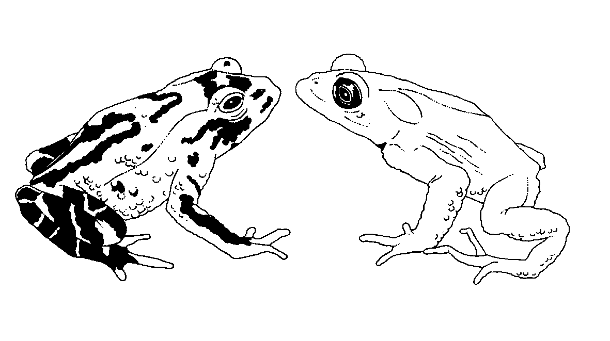

Eighteenth meeting of the Animals Committee
San José (Costa Rica), 8-12 April 2002

Regional reports

oceania
This document has been prepared by Dr Rod Hay in his capacity as Regional Representative for Oceania.
General information
1. Member: Dr Rod Hay (New Zealand).
2. Alternate: Dr Dick Watling (Fiji).
3. Both Dr Hay and Dr Watling were elected to their positions at CoP11 in Gigiri, Kenya. Dr Hay had been alternate Oceanian representative since CoP9 (1994).
4. Number of Parties in Oceania: five (Australia, Fiji, New Zealand, Papua New Guinea, Vanuatu). Note that France, the United Kingdom and the United States of America have territories in the Oceanian region.
5. Number of countries in the region not party to CITES: 11, not including Tokelau (administered by New Zealand), Commonwealth of the North Marianas (administered by United States of America), and the Territories of France, the United Kingdom and United States of America.
6. Number of parties responding to communications in 2001-2002: three.
7. Names of other institutions, NGOs contacted: IUCN Species Survival Commission – Invasive Species Specialist Group (ISSG); South Pacific Regional Environment Programme (SPREP); New Zealand delegation to the Convention on Biological Diversity – Subsidiary Body on Scientific, Technical and Technological Advice 7 and Conference of the Parties; UNEP-WCMC.
List of items
8. As follow-up to agenda items since AC17, Dr Hay continued his chairmanship of the working group on the universal labelling system for the identification of caviar.
9. Dr Hay continued chairmanship of the working group on invasive species.
Communication with other Parties in the region
10. Following AC17, Dr Hay circulated the draft official report of the meeting to the Parties in the region.
11. Immediately prior to preparing this report, Dr Hay contacted Management and Scientific Authorities of the region requesting items and contributions. Responses were received from Australia and New Zealand.
12. There has been specific communication with Australia; about sharks; about the regional directory; about a proposal for an Implementation Committee, and on a capacity building workshop for the region.
Other regional activities
13. A key initiative is a regional capacity-building workshop. This is being organized primarily by Australia in conjunction with the Secretariat. Initially proposed for Canberra in February, it is currently scheduled for Fiji in late March or early April. A key focus of this workshop is the implementation of CITES in Small Island Developing States (SIDS). Updated information on the outcome will be available at AC18.
Listing proposals and other issues
14. At the time of writing the only proposal known to be coming from the region is for listing all species of New Zealand geckos in the genera Hoplodactylus and Naultinus. Recent evidence has shown New Zealand geckos increasingly turning up on the international market at numbers far exceeding the breeding capacity of the captive population. Illegal trade has also been detected. Some wild populations have also declined, at least in part, from illegal collection of animals for trade. One species that has no legal captive population is now available on the market, while trade in several other species is increasing. Although fully protected in their range State, animals are fetching high market values outside New Zealand.
15. Australia’s new CITES legislation has been in effect as of 11 January 2002.
16. At 23 January 2002, trade suspensions were in place against Fiji, Papua New Guinea and the Solomon Islands.
17. Dr Hay prepared a review of Anas aucklandica as a contribution to the periodic reviews of the Appendices. The three species covered by this listing clearly meet the biological criteria for Appendix-I listing but there has been very little trade.
18. Oceania covers a vast area of mostly tropical regions, much of it dominated by the marine environment. Trade risks to wild flora and fauna must be seen in the context of the usual range of environmental threats, including habitat loss, invasive species, domestic over-exploitation and global change. For example, coral bleaching has had a dramatic effect on the reefs in some parts of the region (e.g. in Fiji). Marine resources form a key part of the local economy. Therefore trade issues concerning them are of critical interest to the countries in the region. The relationship between trade and other pressures needs to be kept in mind, but CITES has an important potential role to play in sustainable use and protection of species in the marine environment.
Difficulties of implementation in the region
19. Despite the small number of Parties in the region, regular regional meetings are unlikely to be held unless opportunities arise in conjunction with other regional gatherings. The South Pacific Regional Environment Programme is an organization and forum through which regional implementation of the Convention can be facilitated.
20. A key difficulty, and a major reason for the small number of Parties in the region is capacity. The population base for those countries which are not party to CITES is usually very small (e.g the resident population of Niue is ca.2,000). Consequently, those administering a Convention such as CITES normally have many competing responsibilities. Ultimately, capacity issues have contributed significantly to the trade suspensions noted above.
21. Scientific expertise is often difficult to obtain when needed, hence the value of building regional networks of expertise which can fulfil some of the technical requirements of the Convention, notably those of Scientific Authorities. The Secretariat’s new Regional Assistance Programme is a welcome initiative in helping to deal with some of the issues for Oceania.

