AC18 Doc. 5.4

CONVENTION ON INTERNATIONAL TRADE IN ENDANGERED SPECIES
OF WILD FAUNA AND FLORA

___________________
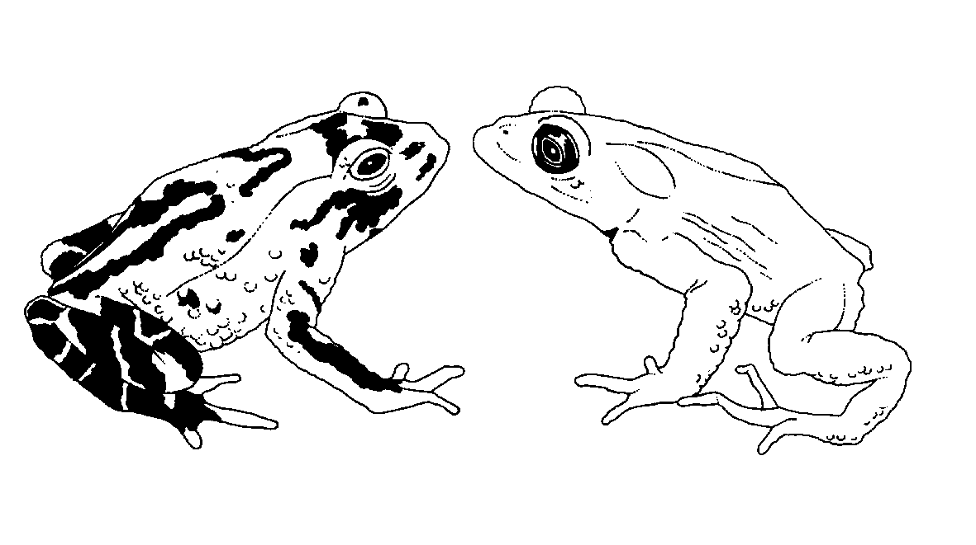

Eighteenth meeting of the Animals Committee
San José (Costa Rica), 8-12 April 2002

Regional reports

Europe
This document, covering the period from June 2001 to January 2002, has been prepared by Dr Marinus Hoogmoed and Dr Katalin Rodics in their capacity as Regional Representatives for Europe.
General information
1. Members: Dr Marinus S. Hoogmoed (The Netherlands) and Dr Katalin Rodics (Hungary). For logistical reasons, Dr Hoogmoed keeps regular contacts with the Scientific Authorities (SAs) of the members of the European Union (EU) through meetings of the EU Scientific Review Group, which during the reporting period met on 18 July 2001 and on 29 November 2001. Dr Rodics keeps contacts with the non-EU Parties in Europe.
2. The 17th meeting of the Animals Committee (AC17) took place in Hanoi, Viet Nam, from 30 July to 3 August 2001. Both regional members and the alternate Dr Vin Fleming attended the meeting. Alternate member Dr Thomas Althaus could not attend because just prior to the 18th meeting of the Animals Committee (AC18), he had to participate in a meeting of the International Whaling Commission, of which he is a commissioner.
3. Dr Hoogmoed is Chairman of the Animals Committee and has devoted most of his working time to the running of the Committee, which mainly involved:
a) contacts with the Secretariat about a plethora of subjects concerning Animals Committee business;
b) preparation of AC18;
c) preparation and checking of the Proceedings of AC17;
d) preparation of workshops on trade in freshwater turtles and tortoises (Decisions 11.93 and 11.150) and seahorses and other Syngnathids (Decisions 11.97 and 11.153);
e) maintaining contact with members of the Animals Committee;
f) maintaining contact with the Chairmen of Animal Committee working groups;
g) participation in discussions on many issues related to AC business;
h) participation in the work of the Criteria Working Group (CWG) [meeting held in Siguënza, Spain, 21-23 May 2001(see below)];
i) participation in preparing the final draft of the report of the Chairmen of the Animals Committee, Plants Committee and CWG on the work of the CWG [16-20 November 2001 (see below)];
j) maintaining liaison with the Standing Committee (SC);
k) maintaining contact with FAO concerning the International Plan Of Action for the conservation and management of sharks (IPOA –sharks); and
l) correspondence on various topics with Governments and NGOs.
4. More details on the work that the Chairman undertook up until 12 January 2002 is provided in his report to SC46 (SC46 Doc. 21), which has also been distributed as an AC18 document.
5. During all of 2001, Dr Rodics was very involved in organizing the regional meeting for SAs in Bonn, Germany. This involved writing documents, soliciting documents, maintaining liaison with the different countries and participants, etc.
6. The alternate members were Dr Vincent Fleming (United Kingdom) for Dr Hoogmoed and Dr Thomas Althaus (Switzerland) for Dr Rodics.
7. The number of Parties in Europe increased to 37 (Ireland became a new Party on 8 January 2002).
8. Parties responded to communications (Austria, Azerbaijan, Bulgaria, Czech Republic, Denmark, Estonia, Georgia, Germany, Italy, Latvia, Lithuania, Monaco, Norway, Poland, Russian Federation, Slovakia, Spain, Switzerland).
9. No NGOs or other institutions were contacted during the reporting period.
Follow up on agenda items identified at AC17
10. The review of Resolution Conf. 9.24 regarding the criteria for amendments of Appendices I and II continued. A second meeting of the Criteria Review Group (CRG) was held in Siguënza, Spain, 21-23 May 2000, to specifically discuss Annex 5 of Resolution Conf. 9.24. The report of this discussion was added to the report that the Chairmen prepared in April 2001, and forwarded to the Parties and interested NGOs with Notification to the Parties No. 2001/037 of 31 May 2001. Comments could be sent to the Secretariat before 15 October 2001.
11. During a meeting of the Chairmen of CWG and AC (the Chair of PC could not attend because of health problems) in Geneva on 17-20 November 2001, the final draft of the revision of Resolution Conf. 9.24 was produced as a document for the Standing Committee.
12. Dr Rodics was a member of the Transport Working Group (chaired by Dr Irina Sprotte from Germany).
13. Dr Fleming, alternate member for Europe, is Chairman of the working group on trade in hard corals. The SA (Fauna) of the United Kingdom commissioned a study to distinguish fossilized from non-fossilized coral rock in trade as a contribution to the work of this group. The report has been published.
14. Dr Hoogmoed and several other members of the AC (Mr Tonny Soehartono, Mr Sixto Inchaustegui) and Mr Tom De Meulenaer of the Secretariat made a very instructive trip to reptile and monkey breeding facilities in southern Viet Nam after AC17 (3-7 August 2001). It became clear that Python molurus bivittatus is bred in large numbers, even under very simple conditions. Crocodylus siamensis is also bred in several facilities. Efforts to register these establishments with the CITES Secretariat are underway. Also several non-CITES-listed species (e.g. Physignathus cocincinus) are bred in large numbers. Techniques are well developed. Macaca fascicularis was bred in large numbers in a big, well organized complex just outside Ho Chi Minh City. Most specimens were exported to Europe and the United States of America for laboratory research.
Duties of members of the AC and their alternates
15. The following summarizes the activities that the members of the AC and their alternates in Europe undertook to fulfil their duties as outlined in Decision 11.90.
a) Where necessary and feasible the alternates were contacted.
b) Concerning communication with Parties in the region, Dr Hoogmoed met representatives of SAs of Member States of the EU on 18 July and 29 November 2001. An update about AC matters was provided on these occasions. Dr Rodics had regular contacts with Eastern European countries. These contacts were intensive, especially in the second half of the year, in preparation of the Bonn meeting. Dr Rodics gave a presentation on the work of AC during the “End of the One-Year Meeting of CITES Implementation Project” in Cesis, Latvia, 24-25 September 2001, and presented “News from the Meetings of the AC and SC and preparation of the First European Regional AC Meeting”
c) It has been decided that Dr Rodics will represent the non-EU countries of Europe (Eastern European countries, Iceland, Norway, Switzerland) and Dr Hoogmoed the EU countries. The persons mentioned as contacts of the SAs in the list provided by the Secretariat are considered contact persons. Communications are also sent to MAs of the countries concerned. At the time of writing of this report, the following European States were not party to CITES: Albania, Andorra, Armenia, Bosnia-Herzegovina, Holy Sea, Lithuania (will effectively join on 9 March 2002), San Marino and Yugoslavia.
d) Where appropriate, the role and importance of the AC has been emphasized.
e) As indicated under b), the Parties in the region were informed about the agenda of AC meetings, and input has been sought.
f) Annual reports on the AC members’ activities were produced.
g) The Proceedings of AC16 and AC17 were distributed on 10 August and 19 December 2001 respectively in English, French and Spanish.
h) The members could attend all meetings, and the provision was thus not applicable.
i) At the generous invitation of Germany, a European regional Meeting was organized in Bonn, Germany, on 14-16 November 2001. During this meeting a number of matters of common interest to European countries and items on the Agenda of AC were discussed: trade in brown bear, Ursus arctos; trade in birds of prey; Black Sea bottlenose dolphins, Tursiops truncatus ponticus; sturgeons in the Black Sea basin and in the Caspian Sea; transport of wild animals; regular review of the Appendices; CITES species bred in captivity in large numbers; the trade in colour mutants; trade in reptile watch straps; the procedure about registering scientific institutions; transborder movement of exhibitions/circus animals; trade in oriental medicines.
j) During the meeting, each country gave a presentation of how CITES within each country was organized, how the Convention was implemented and also about penalties concerning infringements.
k) The meeting was perceived by all present as a good means to learn about each other’s organization and problems encountered. It also served to strengthen personal relations. Thanks to the generous financial support of the German authorities East European countries could attend the meeting with MA and SA representatives. We want to take this opportunity to thank Mrs Elizabeth Munzert and Mr Erik Schmidt-Wergifosse for the good organization of this meeting.
l) The German authorities provided simultaneous translation into English, German and Russian, which proved to be very useful for this specific meeting. They also provided for taking minutes.
m) The meeting was attended by Dr. G. van Vliet of the Secretariat as an observer.
n) There was one sub-regional meeting in Eastern Europe (Latvia) and two in the EU (Belgium), as mentioned under point b).
o) This duty is not yet applicable.
Capacity-building activities
16. The CITES Secretariat organized a training seminar for European SAs in Bonn, Germany, on 12 and 13 November, 2001, just before the regional meeting described in 15 i) above. Eastern European countries in particular (many of them relatively new Parties to CITES) perceived this seminar as useful, and this opinion was shared by EU and other countries that have a longer history in CITES.
Difficulties in implementation encountered in the region
17. From the reports given by each country at the regional meeting in November 2001, it was clear that the problems encountered were numerous and varied, and extended beyond CITES. Eastern European countries in particular, where nature is still relatively undisturbed compared to western Europe, suffer from the attention of western collectors and hunters through, for instance, the fact that they take large amounts of birds from the wild and attempt to export them. This especially concerns individuals from Austria (who seek birds of prey for falconry), Germany and Italy (hunters). Policing these activities takes a a large share of the resources of the eastern European authorities.
18. Most Eastern European MAs are understaffed and most SAs do not have paid staff for CITES work. The help of the CITES Secretariat in addressing problems was appreciated.
Other topics
19. There were no other topics related to CITES and animals species that need to be reported on.
Work to be done by the next meeting of the Conference of the Parties
20. During AC18 many Agenda items will have to be finalized, in order to present the CoP with advice, draft recommendations and reports. Some items will end at CoP12, others will continue beyond CoP12. The Chairmen of the various working groups are well aware of this and are pushing members of their working groups in order to be able to present members of the AC with advice on which the AC can base its decisions, either at, or shortly after AC18.
Report written by M.S. Hoogmoed and K. Rodics.
Leiden, 21 January 2002

