AC18 Doc. 5.1 (Rev. 1)

CONVENTION ON INTERNATIONAL TRADE IN ENDANGERED SPECIES
OF WILD FAUNA AND FLORA

___________________
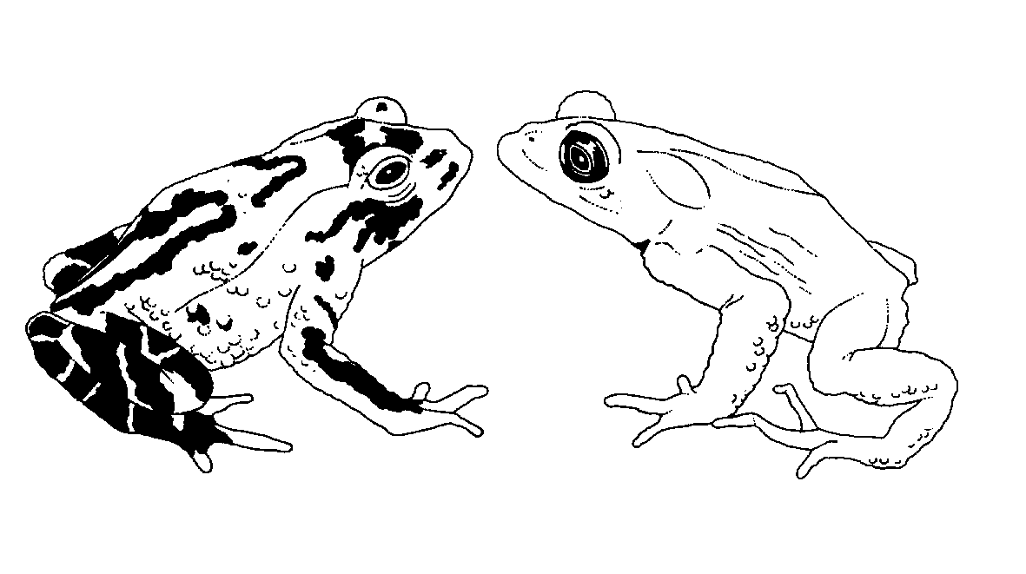

Eighteenth meeting of the Animals Committee
San José (Costa Rica), 8-12 April 2002

Regional reports

Africa
This document has been prepared by Professor Kim Howell and Michael Griffin in their capacity as Regional Representatives for Africa.
Introduction
1. Sāo Tome and Principe has recently joined CITES. They are an island nation, off the coast of Ghana in the Bay of Guinea. We are not yet aware of the array of CITES-related issues, which they deal with, but they have shown themselves to be an active centre of research into conservation and sustainable utilization of several species of marine turtles – all of which are CITES-listed. This brings the total to 49 countries in the African region, representing nearly a third of total CITES membership.
2. Communication within the region continues to be a problem: all regional members (Scientific as well as Management Authorities) were contacted (all combinations of postal, e-mail, and fax/telephone). We requested national information for the regional report, and specific issues to be raised at the 18th meeting of the Animals Committee on their behalf. We received responses back from 8 members. Therefore, this is not a comprehensive report and draws primarily on eastern and southern African sources.
3. During the period under review (August 2001-January 2002), the African Region witnessed a number of positive examples of conservation measures relating to CITES-listed species. These species ranged in size from large mammals to a tiny toad.
Captive breeding and other approaches to conservation of Nectophrynoides asperginis, the Kihansi spray toad
4. Captive-breeding efforts in the United States of America aimed at the Appendix-I Kihansi spray toad, Nectophrynoides asperginis, appear to be having very limited success owing to parasitic infections and most recent reports indicate that very few F2 individuals have resulted from this programme. To our knowledge, this is the only Appendix-I species of African amphibian, which is being bred in captivity. The toad is restricted to a tiny area of spray associated with a waterfall, which has had its flow greatly decreased by the construction and operation of a hydropower dam. The long-term effectiveness and practicality of in situ conservation efforts, which rely largely on a system of artificial sprinklers, has not yet been adequately assessed. In the mean time, efforts continue to locate suitable habitats in the region for reintroduction.
Environmental impact assessment and CITES
5. An example of a regional initiative which may assist in raising awareness of CITES issues and in taking these into account as part of the development process is the founding of the East African Association of Impact Assessment. K. Howell attended the meeting of founders in Nairobi. Once this association has become fully registered, it will provide a useful forum for sensitizing all stakeholders in the Environmental Impact Assessment to CITES issues.

Meetings
6. A number of meetings, which discussed CITES-related issues, were held in the region. Of particular note were a number of informal regional strategy workshops designed to gain consensus and support on proposals (some controversial) for the CoP in November. Another example is an FAO–sponsored conference on Sharks in the southern African region in October – where the commercial fishing industry and government regulating bodies were sensitized to shark-conservation issues.
Coelacanth discovered in Kenya
7. Relevant news from the eastern region was the discovery of a coelacanth, Latimeria spp., in Kenyan marine waters. This raises the likelihood that this Appendix-I species, previously known only from southern African waters and the Comoros and vicinity, may also be found along the eastern African coast as well – suggesting this taxon may have a much more robust population than previously thought.

New order of insect
8. A new order of Insecta is being described from Namibia. The last new order of insect was described in 1957. Although this is a joyous occasion for the CBD, the practical ramifications have Namibian conservationists worried; due to uncontrolled over-collecting, new species are sometimes collected to extinction even before the primary literature is published. Insect market-collecting is already a problem in the region, so the infrastructure is already in place to exploit this new form. Although the new animal is not charismatic (resembles a cricket), the demand for specimens of a new order are expected to be unusually high. Current national legislation is weak in this regard.
9. Unfortunately, a number of problems continue to persist in the region which make management and conservation efforts extremely difficult.
Continuing civil unrest and military activity
10. Continuing unrest and military activity in the Democratic Republic of the Congo (DRC) has affected key species such as the gorilla, Gorilla gorilla, the African elephant, Loxodonta africana, and a rhinoceros, Ceratotherium simum cottoni. A United Nations report called for the need for an assessment to be made of the effects of military activity on wildlife in the DRC. Such disturbances are also ongoing in other countries in Africa, and until these cease, the socio-economic conditions and stability necessary for law enforcement and governance, and thus adherence to regional and international legal instruments such as CITES, will not be met.
11. Civil unrest in Nigeria has led to the cancellation (twice) of a CMS-organized follow-up workshop on African-Atlantic marine turtles. This workshop is now scheduled for Nairobi, later this year.
12. Reduced hostilities in Angola should improve the prospect of enlisting this country as a CITES member; this would be a beneficial move for the region as the current unstable situation there fosters an uncontrolled wildlife trade, including trade in CITES–listed species, and not all of Angolan origin.
Issues relating to elephants and ivory
13. ETIS, the Elephant Trade Information System, continues to operate, although only three African countries – Cameroon, Egypt and Namibia – have submitted official data. Overall, the region is failing to respond adequately to both the reporting of seizures and feedback from ETIS country reports. This is especially worrying for countries with significant elephant populations, ongoing ivory seizures and accumulating stockpiles, which may themselves serve as sources of illegal ivory.
Some recent examples of incidences of illegal ivory trade involving the Africa region
Month | Location of seizure | Agency responsible | Description | Origin | Destination | Arrests
April 2001 | Gatwick Airport, United Kingdom | Customs CITES Team | 445 kg raw ivory | Kenya | China | One Chinese national
April 2001 | Los Angeles International Airport and Hollywood, United States of America | Customs | 480 pieces of ivory (117 kg) including 38 tusks | Nigeria | United States of America | Two men charged
June 2001 | Zaventem Airport, Belgium | Customs Anti-Drugs Team | 45 unworked and 29 worked tusks and 405 ivory items (total 150 kg) | Mali | China | Fifteen Chinese nationals
June 2001 | Djibouti-ville, Djibouti | MHUEAT and police | 16 elephant ivory pieces, | Neighbouring countries | Mostly sold to non-Djiboutians
August 2001 | JF Kennedy Airport, United States of America |  | 57 ivory carvings | Abidjan, Ivory Coast | United States of America | One Ivory Coast national
October 2001 | Schiphol Airport, The Netherlands | Dutch Customs | Ivory necklace, bracelet and two worked tusks
January 2002 | Dar es Salaam, United Republic of Tanzania | Police | 1,255 tusks weighing some 3,000kg |  |  | Two Tanzanians

14. MIKE (Monitoring the Illegal Killing of Elephants) is operational at differing levels of efficiency and commitment within the region. Although there has been a series of (successful) regional training workshops, national implementation of MIKE still ranges from total non-compliance to serious commitment. In the southern region for instance, Botswana is functioning very well; however, a specific complaint raised by Botswana is extremely valid; although they have been particularly diligent in submitting reports, they have had no feedback from the regional coordinator. This is an important point, as these programmes will only function when participants are kept fully informed, updated and encouraged on a continuous basis.

Rhinoceros conservation
15. Four black rhinoceroses, Diceros bicornis, were sent from South Africa to a highly protected site within Mkomazi Game Reserve in the United Republic of Tanzania as part of a long-term breeding project. This took place with financial aid from outside nature conservation groups. White rhinoceroses, Ceratotherium simum, were also moved to Uganda to repopulate areas in which they had been poached.
16. In November 2001, four black rhinoceros carcasses were discovered in Kenya, the first known rhino poaching inside a National Park in Kenya in eight years. Three rhino horns were seized from two suspects by Kenyan authorities, and the rhino horns are undergoing DNA testing in attempts to determine their origin.
17. Under the correct conditions, rhino reproduce well and there is now a regular supply of “excess” animals available for restocking previously poached-out areas. Namibian conservation areas, for instance are producing a regular supply and they are being distributed to other wildlife agencies in the subregion, as well as to private game reserves under a custodianship programme. These reintroduction schemes generally work well, but often seem to ignore principles of genetic integrity, especially in regards to cross-border transfers – a subject of greater interest to the CBD.
Live reptile and amphibian trade
18. There are indications that legal and illegal trade in reptiles and amphibians is on the increase in the region, including Angola (a non-Party), the Comoros, DRC, Madagascar, Mali, Mozambique, South Africa, Togo and Uganda,. This is something that needs to be looked at more closely and for many countries in the region, it is closely related to the general issue of quota setting. For countries which do not yet have such systems in place, a range of criteria including survey data and more intuitive-type assessments (such as local knowledge) need to be used within an agreed quota-setting framework that includes regular monitoring, annual reviews, and stakeholders’ participation and input. It is important that quotas are based on biology and are not simply bureaucratic decisions. The United Republic of Tanzania is one example where trade applications go through a stringent matrix of authorities, and where quotas are set by consensus.

Madagascar is a special case
19. This nation has been identified for the test case for the Country-Based Significant Trade Review Process. Although this is universally acknowledged as a positive step, and choice, it would appear that current trade for the exotic pet market is entirely out of control. Regional observers request a fast-track approach as it is felt that delays may result in a very impoverished fauna within the very near future. Madagascan authorities are currently considering a moratorium on all CITES exports until the situation is assessed and brought under control and this initiative is to be congratulated. A report addressed to the Animals Committee by John Behler in early 2002 raised concern over ongoing problems with the trade in endangered tortoises in Madagascar. He also reported that the liver of tortoises was used to produce a pâté for export to East Asia.
20. Within the same area, the Republic of Seychelles is concerned about a local trade in Hawksbill turtle, and a market in Asia has been identified.
21. 113 angulated tortoises, Chersina angulata (CITES Appendix II), were seized by Cape Nature Conservation Authorities (Capetown, South Africa), and two Slovak nationals were charged and heavily fined. The animals were to be shipped to eastern Europe, where they allegedly obtain CITES certificates and then enter the European trade. South Africa in increasingly associated with both regional and global legal and illegal wildlife trade.
22. Tunisia appears to have been the destination for a shipment of Horsfield’s tortoises, Testudo horsfieldii (CITES Appendix II), found in the suitcase of a passenger from the Russian Federation at Heathrow Airport, United Kingdom, in March 2000.
Issues relating to the handling of confiscated specimens
23. An incident highlighting the need for CITES signatories to be aware of the many complex issues relating to the handling of confiscated animals involved the reported killing by drowning in a chemical vat of a chimpanzee, Pan troglodytes, and a baby gorilla, Gorilla gorilla, by Egyptian authorities. These animals were seized in Cairo after being imported by a Nigerian. It is not clear whether the smuggler was prosecuted, nor how the animals were allowed on the aircraft, which transported them without, valid CITES documentation. This is a clear case where local authorities in both countries mishandled the issue, but CITES received bad publicity in the subsequent outcry.
General unsustainable harvest of species which might be candidates for CITES listing
24. There are indications that the illegal harvesting and export of abalone, Haliotis midae, from South Africa are increasing. Despite the fact that there have been numerous seizures of large quantities of abalone over the last year (350,000 specimens were confiscated in 2001), and many associated arrests, poaching of abalone does not seem to be decreasing. Discussions among South African stakeholders as to a possible CITES listing are ongoing.
Bushmeat and CITES
25. In last year’s report, this issue was mentioned as an area of concern, and a recent TRAFFIC study in eastern and southern Africa has provided more information on this topic. In addition to local and regional use, international trade is increasing; as ethnic African populations outside the continent increase, so does the demand for home-supplied bushmeat. Two Nigerian nationals were convicted in the United Kingdom in 2001 for smuggling of specimens of CITES-listed species, some in the form of wild meat. Bushmeat shipments to the United Kingdom from Cameroon have included monkeys, pangolins, tortoises, and antelopes, as well as many non-CITES-listed species. Although local trade in bushmeat is a traditional activity and integral in many local economies, there is clearly a need for more data on the bushmeat trade (regionally and internationally) and its effects on populations of CITES-listed species within the region.

