AC18 Doc. 4 (Rev. 1)
(English only/ Seulement en anglais/ Únicamente en inglés)

CONVENTION ON INTERNATIONAL TRADE IN ENDANGERED SPECIES
OF WILD FAUNA AND FLORA

___________________
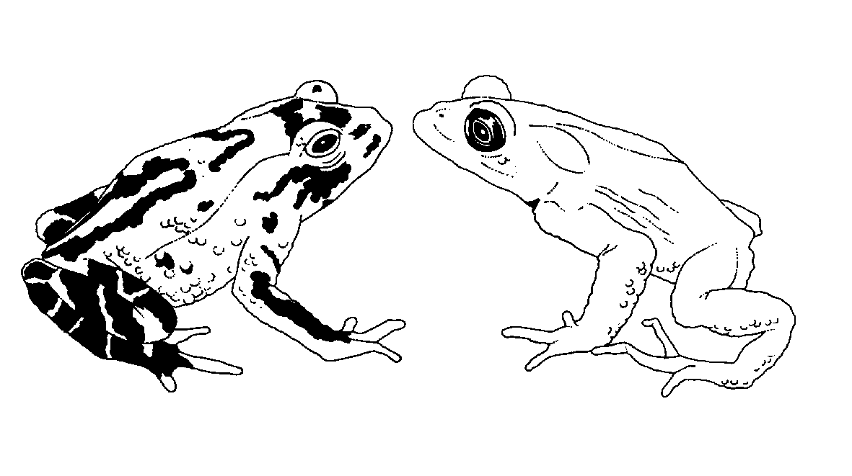

Eighteenth meeting of the Animals Committee
San José (Costa Rica), 8-12 April 2002

admission of observers
1. The present document lists all organizations that had informed the Chairman of their desire to be represented at the 18th meeting of the Animals Committee by observers. This list is submitted to the Animals Committee for the purpose of considering the admission of observers.
2. Intergovernmental organizations
European Commission
IUCN–The World Conservation Union
UNEP-WCMC
3. Non-governmental organizations
American Federation of Aviculture, Inc.
American Zoo and Aquarium Association
Animal Welfare Institute
Caribbean Conservation Corporation
Conservation Force
David Shepherd Conservation Foundation
Earth Negotiation Bulletin
Humane Society International
Humane Society of Canada
Humane Society of the United States
International Association of Fish and Wildlife Agencies
International Caviar Importers Association
Indonesian Coral, Shell and Ornamental Fish Association
International Elephant Foundation
International Foundation for the Conservation of Natural Resources
International Fund for Animal Welfare
International Wildlife Coalition
IWMC–CH
Midwest Association of Fish and Wildlife Agencies
Ornamental Aquatic Trade Association Ltd.
Peat Institute
Pro Wildlife
Project Seahorse
Ringling Bros - Center for Elephant Conservation
Royal Society for the Prevention of Cruelty to Animals
Safari Club International
Species Survival Network
SWAN International
The Fund for Animals, Inc.
TRAFFIC Network
Western Association of Fish and Wildlife Agencies
Whale and Dolphin Conservation Society
Wildlife Conservation Society
World Association of Zoos and Aquaria
World Society for the Protection of Animals

