AC18 Doc. 3.2

CONVENTION ON INTERNATIONAL TRADE IN ENDANGERED SPECIES
OF WILD FAUNA AND FLORA

___________________
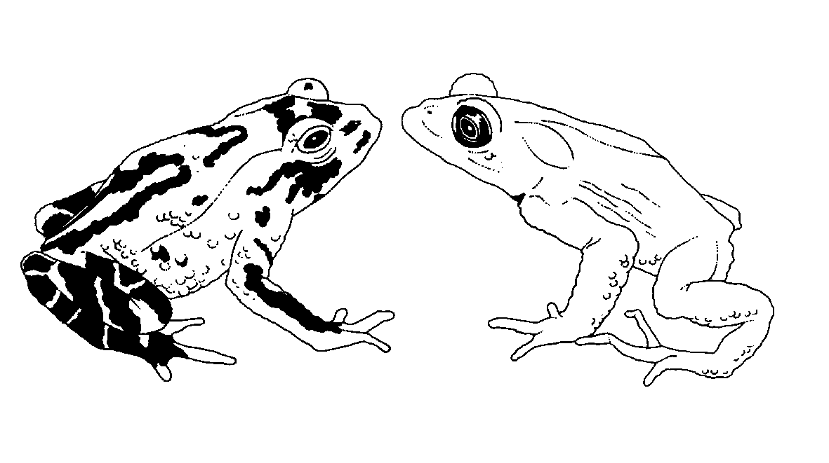

Eighteenth meeting of the Animals Committee
San José (Costa Rica), 8-12 April 2002

Adoption of the Agenda and Working Programme

WORKING PROGRAMME (Provisional)
Monday, 8 April 2002
09h30-10h00 1. Opening of the meeting
10h00-10h30 Morning tea/coffee
10h30-10h40 2. Adoption of the Rules of Procedure
10h40-10h50 3. Adoption of the Agenda and Working Programme
10h50-10h55 4. Admission of observers
10h55-11h45 5. Regional Reports
11h45-12h15 6. Report from Chairman
12h15-12h30 7. Implementation of Resolution Conf. 8.9 (Rev.) (Decision 11.106)
7.5 Significant trade field projects for animals (Notification to the Parties No. 763)
12h30-14h00 Lunch
14h00-15h30 7. Implementation of Resolution Conf. 8.9 (Rev.) (Decision 11.106) (continued)
7.1 Progress on the implementation of the Review of Significant Trade (Phases IV and V)
15h30-16h00 Afternoon tea/coffee
16h00-17h30 7. Implementation of Resolution Conf. 8.9 (Rev.) (Decision 11.106) (continued)
7.1 Progress on the implementation of the Review of Significant Trade (Phases IV and V) (continued)
7.2 Review of the implementation of recommendations
(Part 2: Review of the outcome of Phase 1)
7.3 Revision of Resolution Conf. 8.9 (Rev.) and Decisions 11.106-11.108
7.4 Progress on the first country-based Significant Trade Review
Tuesday, 9 April 2002
08h30-09h15 8. Periodic review of animal taxa in the Appendices (Resolution Conf. 11.1)
09h15-10h30 9. Registration and monitoring of operations breeding Appendix-I animal species for commercial purposes
(Resolution Conf. 11.14 and Decision 11.101)

10h30-11h00 Morning tea/coffee
11h00-12h00 10. Relationship between ex situ production and in situ conservation
(Decision 11.102)
12h00-12h30 13. Implementation of Decision 11.165 on trade in traditional medicines
12h30-14h00 Lunch
14h00-14h45 11. Implementation of Resolution Conf. 10.21 on transport of live animals
14h45-15h30 12. Trade in hard corals
12.1 Implementation of Decision 11.99
12.2 Mariculture and propagation of coral – response to Notification to the Parties No. 2001/010
15h30-16h00 Afternoon tea/coffee
16h00-16h45 12. Trade in hard corals (continued)
12.3 Implementation of Decision 11.98
16h45-17h15 15. Universal labelling of caviar
17h15-17h30 16. Trade in Tursiops truncatus ponticus (Decision 11.91)
Wednesday, 10 April 2002
08h30-09h30 14. Control of captive breeding, ranching and wild harvest production systems for Appendix-II species
09h30-10h00 17. Trade in freshwater turtles and tortoises in Southeast Asia
10h00-10h30 18. Conservation of seahorses and other members of the family Syngnathidae (Decision 11.97)
10h30-11h00 Morning tea/coffee
11h30-12h15 19. Implementation of Decision 11.94 regarding the biological and trade status of sharks
12h15-12h30 20. Implementation of Decision 11.100 regarding trade in alien species
12h20-14h00 Lunch
14h00-15h00 21. Conservation of Acipenseriformes (Decisions 11.59 and 11.152)
15h00-15h10 Establishment of working groups/drafting groups
15h10-15h30 Working groups/drafting groups
15h30-16h00 Afternoon tea/coffee
16h00-17h30 Working groups/drafting groups (continued)
Thursday, 11 April 2002
08h30-10h30 Working groups/drafting groups (continued)
10h30-11h00 Morning tea/coffee
11h00-12h30 Working groups/drafting groups (continued)
12h30-14h00 Lunch
14h00--15h30 Working groups/drafting groups (continued)
15h30-16h00 Afternoon tea/coffee
16h00-17h30 Reports of working groups
Friday, 12 April 2002
08h30-10h30 Reports of working groups (continued)
10h30-11h00 Morning tea/coffee
11h00-11h45 Reports of working groups (continued)
11h45-12h15 23. Any other business
Finalization of documentation
12h15-12h30 24. Closing Remarks

