AC18 Doc. 3.1 (Rev. 2)

CONVENTION ON INTERNATIONAL TRADE IN ENDANGERED SPECIES
OF WILD FAUNA AND FLORA

___________________
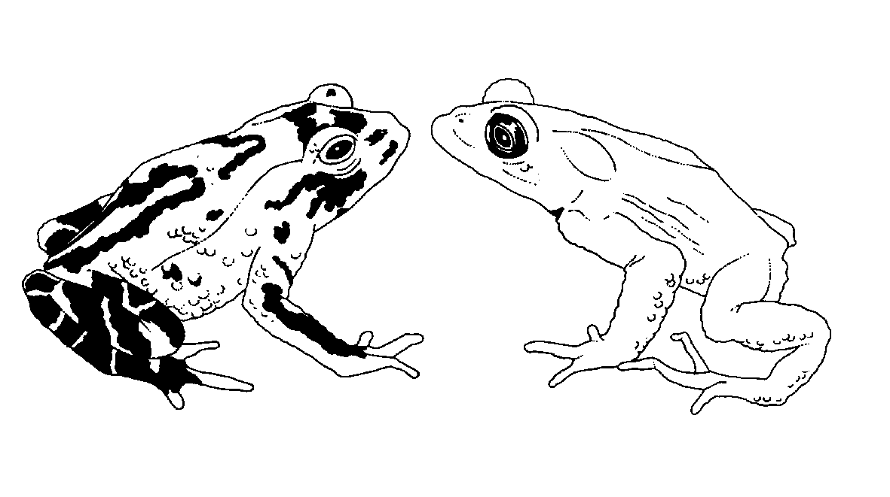

Eighteenth meeting of the Animals Committee
San José (Costa Rica), 8-12 April 2002

Adoption of the Agenda and Working Programme

AgendatE>
Agenda item | Document No. | Language
1. Opening of the meeting | No document
2. Adoption of the Rules of Procedure | AC18 Doc. 2 | E, F, S
3. Adoption of the Agenda and Working Programme
3.1 Agenda | AC18 Doc. 3.1 | E, F, S
3.2 Working Programme | AC18 Doc. 3.2 | E, F, S
4. Admission of observers | AC18 Doc. 4 | E
5. Regional reports
5.1 Africa | AC18 Doc. 5.1 | E (Rev.)
5.2 Asia | AC18 Doc. 5.2
5.3 Central and South America and the Caribbean | AC18 Doc. 5.3 | S
5.4 Europe | AC18 Doc. 5.4 | E, F, S
5.5 North America | AC18 Doc. 5.5 | E, F, S
5.6 Oceania | AC18 Doc. 5.6 | E, F, S
6. Report from Chairman
6.1 Liaison with the Standing Committee | AC18 Doc. 6.1 | E, F, S
7. Implementation of Resolution Conf. 8.9 (Rev.)
(Decision 11.106)
7.1 Progress on the implementation of the Review of Significant Trade (Phases IV and V) | AC18 Doc. 7.1 | E, F, S
7.2 Review of the implementation of recommendations  (Part 2: Review of the outcome of Phase 1) | No document
7.3 Revision of Resolution Conf. 8.9 (Rev.) and  Decisions 11.106-11.108 | AC18 Doc. 7.3 | E, F, S
7.4 Progress on the first country-based Significant Trade Review | No document
7.5 Significant trade field projects for animals  (Notification to the Parties No. 763) | AC18 Doc. 7.5 | E, F, S
8. Periodic review of animal taxa in the Appendices
(Resolution Conf. 11.1)
8.1 Report of the working group | AC18 Doc. 8.1 | E, F, S
9. Registration and monitoring of operations breeding Appendix-I species for commercial purposes (Resolution Conf. 11.14 and Decision 11.101) | AC18 Doc. 9 | E, F, S
10. Relationship between ex situ production and in situ conservation (Decision 11.102) | AC18 Doc. 10 | E, F, S
11. Implementation of Resolution Conf. 10.21 on transport of live animals
11.1 Report of the working group | AC18 Doc. 11.1 | E, F, S
12. Trade in hard corals
12.1 Implementation of Decision 11.99 | AC18 Doc. 12.1 | E, F, S
12.2 Mariculture and propagation of coral – response to  Notification No. 2001/010 | No document
12.3 Implementation of Decision 11.98 | No document
13. Implementation of Decision 11.165 on trade in traditional medicines
13.1 List of species traded for medicinal purposes | AC18 Doc. 13.1 | E, F, S
13.2 Inventory of operations where captive breeding of CITES species is conducted for medicinal purposes | AC18 Doc. 13.2 | E, F, S
14. Control of captive breeding, ranching and wild harvest production systems for Appendix-II species
14.1 Report of the working group | No document
15. Universal labelling system for the identification of caviar (Resolution Conf. 11.13)
15.1 Report of the working group | AC18 Doc. 15.1 | E, F, S
15.2 Proposed amendment to Resolution Conf. 11.13 | AC18 Doc. 15.2 | E, F, S
16. Trade in Tursiops truncatus ponticus (Decision11.91)
16.1 Progress on the implementation of Decisions 11.91 and 11.139 | AC18 Doc. 16.1 | E, F, S
17. Trade in freshwater turtles and tortoises in Southeast Asia | No document
18. Conservation of seahorses and other members of the family Syngnathidae (Decisions 11.97 and 11.153)
18.1 Report of the working group | AC18 Doc. 18.1 | E, F, S
19. Implementation of Decision 11.94 regarding the
biological and trade status of sharks
19.1 Report of the Chairman | No document
19.2 Report on Implementation of the International Plan of Action for Sharks | AC18 Doc. 19.2 | E, F, S
20. Implementation of Decision 11.100 regarding trade in alien species
20.1 Report of the working group | AC18 Doc. 20.1 | E, F, S
21. Conservation of Acipenseriformes (Decisions 11.59 and 11.152) | AC18 Doc. 21 | E, F, S
22. Any other business | No document
23. Closing remarks | No document

INFORMATION DOCUMENTS
Agenda item | Document No. | Language
Report by the Management Authority of Australia on progress regarding the conservation of sharks | AC18 Inf. 1 | E
Report by ACCOBAMS on the current status of bottlenose dolphins (Tursiops truncatus) in the Black Sea | AC18 Inf. 2 | E
Response from the Management Authority of the United States of America to Notification to the Parties No. 2001/85 on sturgeon conservation | AC18 Inf. 3 | E
Trade in animal species listed in AC18 Doc. 13.1 | AC18 Inf. 4 | E
Response from the Management Authority of the Russian Federation to Notification to the Parties No. 2001/85 on sturgeon conservation | AC18 Inf. 5 | E
Review of Significant Trade | AC18 Inf. 6 | E, F, S
Letter from FAO concerning the International Plan of Action for the Management and Preservation of Sharks | AC18 Inf. 7 | E
Trade in products, possibly used as medicinals, of the species listed in document AC18 Doc. 13.1 (see document AC18 Inf. 4) | AC18 Inf. 8 | E (website only)
Identification Manual Progress Report | AC18 Inf. 9 | E, F, S
Update - Report on Implementation of the International Plan of Action for Sharks (IPOA-Sharks): AC18 Doc. 19.2 | AC18 Inf. 10 | E
The potential to breed appendix-I reptiles in captivity -  a preliminary assessment | AC18 Inf. 11 | E
Draft report of the working group on conservation and trade in freshwater turtles and tortoises | AC18 Inf. 12 | E
UNEP-WCMC report on the development of a rapid assessment technique for the review of animal taxa | AC18 Inf. 13 | E
Statement by the First Deputy Chairman of the State Committee for Fisheries of the Russian Federation | AC18 Inf. 14 | E
WWF report on biological and trade status of sharks (agenda item 19) | AC18 Inf. 15 | E
Statement by the Japanese delegation on the implementation of Decision 11.94 regarding the biological and trade status of sharks | AC18 Inf. 16 | E

