AC17 Doc. 18.1

CONVENTION ON INTERNATIONAL TRADE IN ENDANGERED SPECIES
OF WILD FAUNA AND FLORA

____________
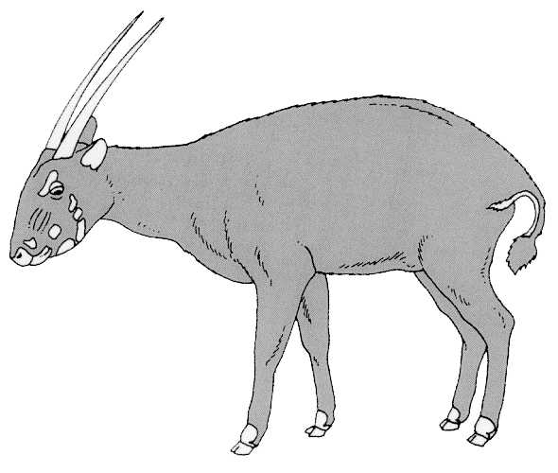
Seventeenth meeting of the Animals Committee
Hanoi (Viet Nam), 30 July-3 August 2001

Conservation of seahorses and other members of the family Syngnathidae (Decision 11.97)
REPORT OF THE WORKING GROUP
1. This document and the translations into French and Spanish have been prepared by the Chairman of the working group on syngnathids.
2. This report provides a brief overview of progress made by the Secretariat, the Animals Committee and the working group on syngnathids towards implementation of Decisions 11.153 and 11.97.
Role of the Secretariat
3. At its 11th meeting (Gigiri, 2000), the Conference of the Parties adopted Decision 11.153, which directs the Secretariat to:
"a) assist in obtaining funds from interested Parties, intergovernmental and non-governmental organisations, exporters, importers and other stakeholders, to support a technical workshop of relevant experts on the conservation of seahorses and other syngnathids; and
b) contingent on the availability of external funding, cooperate with other relevant bodies, including the fisheries sector, to convene a technical workshop to consider and review biological and trade information that would assist in establishing conservation priorities and actions to secure the conservation status of seahorses and other syngnathids;
c) request Parties to provide, for discussion at the technical workshop, all relevant available information concerning the status, catches and bycatches of, and trade in, seahorses and other syngnathids and on any domestic measures for their conservation and protection, and to review the adequacy of such measures;
d) encourage scientific research to promote the long-term conservation and sustainable use of seahorses and other syngnathids; and
e) explore ways to enhance the participation of fishermen, traders and consumers in the conservation and sustainable use of seahorses and other syngnathids."
4. Regarding paragraph 2a) the Secretariat has received two generous offers of funding for this technical workshop, from Australia (AUD 20,000, equivalent to about USD 10,000) and the United States of America (USD 23,000). The workshop is expected to cost approximately USD 65,000-70,000, so that perhaps half of the total has now been raised. The working group invites any other interested Parties or non-governmental organisations to contact the Secretariat with offers of funding, to ensure the success of this meeting.
5. Regarding paragraph 2b) the Philippines has kindly offered to host the technical workshop, subject to funding and support from the Secretariat. The Secretariat is considering the possibility of holding this meeting in January or February 2002. Participation will be by invitation only, to a specific individual (and non-transferrable), and all participants would have expertise relating to syngnathids; this should include a good mix of stakeholders. The workshop will probably last 3-4 days, with a tight adherence to the role mandated by this Decision.
6. Regarding paragraphs 2c)-e), the Secretariat has issued two Notifications to meet these responsibilities. The first of these (Notification No. 2001/23 of 16 March 2001) requested Parties “to provide information on seahorses and other members of the family Syngnathidae for discussion at a technical workshop on the conservation of this family, as directed in Decision 11.153” and also informed Parties that the Secretariat was seeking funding for the workshop.
7. The Secretariat had received six responses to the Notification 2001/23 by 30 June 2001, from Ecuador, Germany, Israel, New Zealand, South Africa, Sweden, the Ukraine and the European Commission. All responses have contained valuable information that has added to understanding of these animals and their trade. The working group accordingly hopes to receive similar input from more Parties.
8. The second Notification (Notification No. 2001/034 of 18 May 2001):
a) requested Parties to contact the Secretariat if they could help fund the technical workshop,
b) repeated the request for Parties to provide information on syngnathids and their relatives, for discussion at the technical workshop, by 31 October,
c) indicated interest in the results of scientific research on seahorses and other syngnathids and encouraged such research, and,
d) invited all Parties and organisations to provide information on community involvement in the conservation and sustainable use of syngnathid species.
Role of the Animals Committee
9. At its 11th meeting (Gigiri, 2000), the Conference of the Parties adopted Decision 11.97, which directs the Animals Committee to:
"a) review, with the assistance of experts as may be needed, the outcomes of the technical workshop convened by the Secretariat and other available information concerning the biology, catch and bycatch of and trade in seahorses and other syngnathids and develop appropriate recommendations; and
b) prepare, for consideration at the 12th meeting of the Conference of the Parties, a discussion paper on the biological and trade status of seahorses and other syngnathids to provide scientific guidance on the actions needed to secure their conservation status."
10. The Secretariat, through its Notifications, has called on the Parties to provide available information on syngnathids. In addition, Project Seahorse has indicated a willingness to make the following available to a technical workshop:
a) new life history tables for all seahorses and seadragons;
b) its 1996 monograph with TRAFFIC on the International Trade in Seahorses;
c) its pending 2001 monograph with TRAFFIC on the international trade in seahorses and pipefishes; and
d) its suggested fisheries management guidelines for some seahorse species, arising from a small consultative workshop in June 2001.
11. The Chairman of the Animals Committee has asked that the technical workshop be held with no preconceived opinion that any syngnathid should be listed on CITES, and that other solutions should also be considered. The working group and participants in the technical workshop will use all available information to produce a discussion paper for the Animals Committee to consider at its 18th meeting in early 2002.

