AC17 Doc. 13.1

CONVENTION ON INTERNATIONAL TRADE IN ENDANGERED SPECIES
OF WILD FAUNA AND FLORA

____________
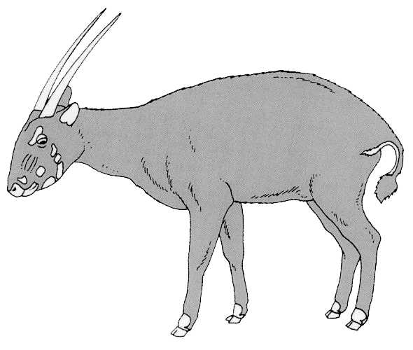
Seventeenth meeting of the Animals Committee
Hanoi (Viet Nam), 30 July-3 August 2001

Implementation of Decision 11.165 on trade in traditional medicines

List of species traded for medicinal purposes
1. The Annex to this document has been prepared by the Secretariat on the basis of a list of species used in traditional medicine, with accompanying information about the medicinal use and conservation status of the species concerned, that was compiled by the International Fund for Animal Welfare (IFAW) as agreed by the Animals Committee at its 16th meeting. This contribution, presented as document AC17 Inf. 5, is gratefully acknowledged.
2. The Annex contains a provisional list of animal species known to be used for medicinal purposes (primarily in traditional medicine) that has been compiled from the information provided by IFAW in document AC17 Inf.5. The Annex currently includes CITES-listed and non-listed species. The list of species is probably incomplete (and does not include any plants) as the information does not seem to reflect the use of traditional medicines in all regions adequately. Input for further development of the list will be requested from the Plants Committee as well.
3. The Secretariat notes that the existence of records of the use of a species for medicinal purposes does not necessarily imply that specimens of those species are traded internationally. In order to compile the list called for in Decision 11.165 paragraph c) of species of plants and animals and their parts traded for medicinal properties, the Secretariat will request UNEP-WCMC to determine the level of trade in the species in the Annex as recorded in the CITES database of statistics from annual reports.

