AC17 Doc. 12.2

CONVENTION ON INTERNATIONAL TRADE IN ENDANGERED SPECIES
OF WILD FAUNA AND FLORA

____________
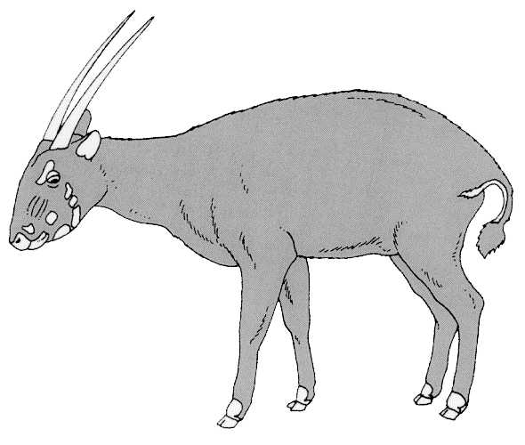

Seventeenth meeting of the Animals Committee
Hanoi (Viet Nam), 30 July-3 August 2001

Trade in hard corals

Mariculture and propagation of coral –
response to notification no. 2001/010
This document has been prepared by the chairman of the working group on trade in hard corals.

1. Tasks related to coral mariculture were directed to the working group on trade in hard corals at the 16th meeting of the Animals Committee and included: reviewing the extent of, and methods for, the artificial culturing of corals; the species to which these methods have been applied; the potential impact of such actions on wild populations; the scope to expand these methods to produce corals for international trade; defining what constituted a cultured coral, the source code that should be applied and whether cultured corals can be distinguished in trade.
2. Notification No. 2001/010 requested Parties to inform the Secretariat of any coral mariculture operations within their jurisdiction so that the coral working group could contact them to develop an inventory of practices and species being cultivated. The representative from the United States of America offered to compile the results of responses to the notification for the working group to consider at the 17th meeting of the Animals Committee (AC17).
3. To date, three formal responses have been received. However, the working group is aware of operations underway in at least eight other countries including both exporting and importing States. A report will be compiled from information received in time for consideration by the working group at AC17. Following this first step, the group will move on to consider the other tasks assigned to it.

