AC17 Doc. 7.5

CONVENTION ON INTERNATIONAL TRADE IN ENDANGERED SPECIES
OF WILD FAUNA AND FLORA

____________
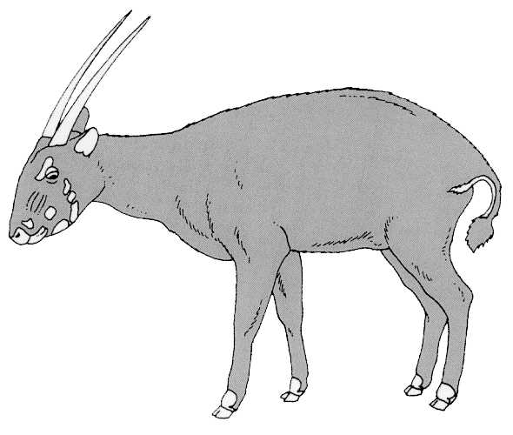

Seventeenth meeting of the Animals Committee
Hanoi (Viet Nam), 30 July-3 August 2001

Implementation of the Review of Significant Trade

PROPOSAL FOR THE FIRST COUNTRY-BASED significant trade review
This document has been prepared by the Secretariat.
1. As explained at the 16th meeting of the Animals Committee, it has become apparent that some Parties have either not been able to respond effectively to recommendations made by the Committee pursuant to Resolution Conf. 8.9 (Rev.) or not been able to apply corrective measures for a species subject to such recommendations to other species warranting similar attention. The result is that the review of the Committee has identified one species after the other as being subject to potentially problematic levels of trade in the same country, and this is likely to continue. The Secretariat believes that a country-specific approach to solving problems of implementing Article IV would be more appropriate and cost effective in such instances.
2. Resolution Conf. 8.9 (Rev.) in paragraph c) under DIRECTS, makes provision for country-specific status assessments for species under review by the Committee for which sufficient information on trade and biological status of the species is not available. The Committee is also able to make primary and secondary recommendations on a wide range of issues related to trade, administration and conservation management, concerning species for which sufficient information is available to determine possible problems with the implementation of Article IV [see DIRECTS paragraph b)]. Species previously reviewed and placed in Category 1 or 2 may be reconsidered by the Committee at any stage.
3. The Committee may also decide to include in this review other Appendix-II species that have not previously been reviewed, on the basis of its consideration of the level of trade in such species over the previous five years, or alternatively, on the basis of immediate concern over such species [see Decision 11.106 paragraphs c) and d) respectively]. It is thus possible to include in a Review of Significant Trade of a particular country both species that have previously been reviewed and placed in Category 1 or 2, and species exported from that country that have not previously been reviewed.
4. The Secretariat therefore suggests that the Committee, could conduct a country-based Review of Significant Trade, as a test case, for a Party that has a significant overall level of trade in specimens of Appendix-II species and has:
a) been subject to the recommendations in relation to several species for which there continues to be a justifiable concern over the implementation of Article IV concerning exports;
b) experienced problems in establishing and implementing export quotas and in addressing recommendations made by the Committee in accordance with Resolution Conf. 8.9 (Rev.);
c) experienced problems in the monitoring of trade and meeting CITES reporting requirements;
d) not adopted adequate legislation to implement CITES and/or experienced problems with the enforcement of legislation (e.g. persistent illegal trade); and
e) remained subject to trade suspensions recommended by the Standing Committee.
5. If the Committee agrees with this approach and the proposed objectives for the review presented in the Annex, the Secretariat will inform the Party concerned and request its cooperation, develop terms of reference for the review in consultation with the Animals Committee and endeavour to engage appropriate consultant(s) to initiate the review in 2001. The Secretariat will also consult with the Plants Committee as appropriate, depending on the country selected and the relevance of this approach to plant trade issues for that country.
AC17 Doc. 7.5
Annex
Country-based Review of Significant Trade
Objectives
- To undertake a country-based Review of Significant Trade on the basis of an overview of trends in trade in species listed in CITES Appendix II from the Party concerned, previous actions by the CITES authorities of the Party concerned, recommendations of the Animals and Standing Committees, current concerns about compliance with the provisions of Article IV paragraphs 2a) and 3, institutional and administrative arrangements related to implementation of Article IV for exports of Appendix-II species, and the effectiveness of relevant national legislation and its implementation;
- To use the findings of the country-based Review of Significant Trade to develop (in close cooperation with the Secretariat) a functional and generic model for effective implementation of Article IV for the export of Appendix-II species that the Animals Committee can recommend to the Party concerned, and that consists of an implementation plan and guideline outlining the appropriate sequence of events and the respective responsibilities of the CITES Management and Scientific Authorities of the Party concerned;
- To ensure that the implementation model covers all key aspects of managing exports of Appendix-II species, i.e. the assessment of population status, the identification of gaps in information, sources of information to underpin non-detriment findings, the process of making non-detriment findings, quota setting, the supervision of different production systems (e.g. wild harvesting, ranching, and captive breeding), the issuance of export documents, monitoring of trade, compilation of trade data, and the production of annual and other CITES reports, as required from CITES Management and Scientific Authorities;
- To develop an implementation model that is as far as possible appropriate to and compatible with the current institutional and legal framework of the Party concerned, but that where necessary provides options that may include as part of the implementation plan a requirement for improved management capacity, institutional strengthening and/or legislative improvements; and
- To use this review to identify the resources required by the Party concerned to implement CITES and to obtain donor support as required.

