AC17 Doc. 5.2

CONVENTION ON INTERNATIONAL TRADE IN ENDANGERED SPECIES
OF WILD FAUNA AND FLORA

____________
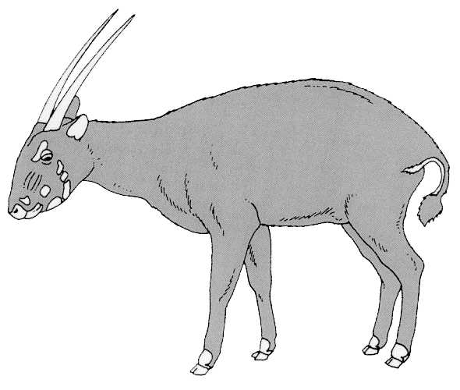
Seventeenth meeting of the Animals Committee
Hanoi (Viet Nam), 30 July-3 August 2001

Regional Reports

asia
This report (for the period December 2000 – May 2001) has been prepared by Dr Tonny Soehartono in his capacity as Regional Representative for Asia.

Parties to CITES in Asia

- Based on communications with the CITES Secretariat in April 2001, the number of Parties in Asia that have acceded to CITES is 29.

Consultation process

- In preparation for the seventeenth meeting of the Animals Committee in Hanoi (Viet Nam), which will be held from 29 July to 3 August 2001, 15 Parties were contacted through their CITES Management Authorities via electronic mail (e-mail) on 30 April 2001, and the others were contacted via facsimile. Three Parties responded via e-mail [China (including Hong Kong), Indonesia and Korea] before 15 May 2001.

- To avoid communication problems, a second letter was issued to all the Parties on 12 May 2001 with the information on the deadline (25 May 2001) for written comments and contributions for the final report to the Secretariat. However, by 25 May 2001, none of the Parties had responded to the second letter.

CITES activities

- The recorded CITES activities between December 2000 and May 2001 in the Asia region are the following:

a) The Chinese CITES Scientific Commission (ESSC) conducted a market survey on musk trade in China. The ESSC also organized a symposium on resource and sustainable use of musk on 10-12 April 2001. The report is available from the ESSC.
b) During an International Workshop on the Trade in Stony Corals in Jakarta, Indonesia on 9-12 April 2001, some members of the Coral Working Group held informal discussion on issues the Group is dealing with. The workshop was attended by representatives of the Scientific Authority and Management Authority of Indonesia, a Scientific Authority from the European Union (United Kingdom), the Indonesian Coral Trade Society, the US Fish and Wildlife Service, fisheries agencies from Tonga and the Solomon Islands, Oceanography of Vietnam, TRAFFIC Europe, WWF UK and local NGOs. The report and the recommendations will be submitted in due course by the group.

