AC17 Doc. 3.2

CONVENTION ON INTERNATIONAL TRADE IN ENDANGERED SPECIES
OF WILD FAUNA AND FLORA

____________
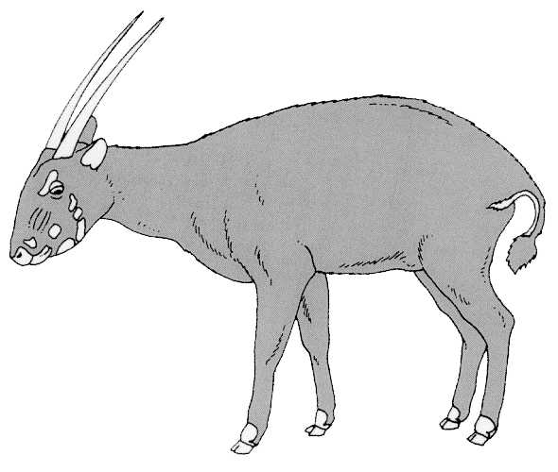
Seventeenth meeting of the Animals Committee
Hanoi (Viet Nam), 30 July-3 August 2001

Provisional Agenda

Provisional WORKING PROGRAMME
Monday, 30 July 2001

09h30-10h00 1. Opening of the meeting (30’)

10h00-10h30 Morning tea/coffee

10h30-11h00 2. Adoption of the Rules of Procedure (30’)

11h00-11h15 3. Adoption of Provisional Agenda and Working Programme (15’)

11h15-11h25 4. Admission of observers (10’)

11h25-12h00 5. Regional Reports (6X5’)

12h00-12h45 6. Report from Chairman (45’)

12h45-14h00 Lunch

14h00-15h30 7. Implementation of Resolution Conf. 8.9 (Rev.) (Decision 11.106) (180’)

15h30-16h00 Afternoon tea/coffee

16h00-17h30 7. Implementation of Resolution Conf. 8.9 (Rev.) (Decision 11.106) (continued)

Tuesday, 31 July 2001

09h00-10h30 8. Periodic review of animal taxa in the Appendices [Resolution Conf. 9.1 (Rev.)] (90’)

10h30-11h00 Morning tea/coffee

11h00-12h30 9. Registration and monitoring of animal species bred in captivity
(Resolution Conf. 11.14 and Decision 11.101) (180’)

12h30-14h00 Lunch

14h00-15h30 9. Registration and monitoring of animal species bred in captivity
(Resolution Conf. 11.14 and Decision 11.101) (Continued)

15h30-16h00 Afternoon tea/coffee

16h00-16h30 10. Implementation of Resolution Conf. 10.21 on transport of live animals (30’)

16h30-17h15 11. Implementation of Resolution Conf. 11.16 regarding ranching operations (45’)

17h15-17h30 19. Implementation of Decision 11.94 on the status of international trade in shark Species (15’)

Wednesday, 1 August 2001

09h00-09h30 12. Trade in hard corals (30’)

09h30-10h00. 13. Implementation of Decision 11.165 on trade in traditional medicines (30’)

10h00-10h30 15. Universal labelling of caviar (30’)

10h30-11h00 Morning tea/coffee

11h00-12.00 14. Control of captive breeding, ranching and wild harvest production systems for Appendix-II species (60’)

12h00-12h20 16. Trade in Tursiops truncatus ponticus (Decision 11.91) (20’)

12h20-14h00 Lunch

14h00-14h45 17. Trade in freshwater turtles and tortoises in Southeast Asia (45’)

14h45-15h00 18. Conservation of seahorses and other members of the family Syngnathidae (Decision 11.97) (15’)

15h00-15.30 20. Implementation of Decision 11.100 regarding trade in alien species (30’)

15h30-16h00 Afternoon tea/coffee

16h00-17h30 Parallel working groups/drafting groups

Thursday, 2 August 2001

09h00-10h30 Parallel working groups/drafting groups (continued)

10h30-11h00 Morning tea/coffee

11h00-12h30 Parallel working groups/drafting groups (continued)

12h30-14h00 Lunch

14h00--15h30 Parallel working groups/drafting groups (continued)

15h30-16h00 Afternoon tea/coffee

16h00-17h30 Parallel working groups/drafting groups

Friday, 3 August 2001

09h00-10h30 Reports of working groups

10h30-11h00 Morning tea/coffee

11h00-12h30 Reports of working groups (continued)

12h30-14h00 Lunch

14h00-15h00 Reports of working groups (continued)

15h00-15h30 Afternoon tea/coffee

15h30-16h00 21. Any other business

Finalization of documentation

16h00 Closing Remarks

