AC17 Doc. 3.1 (Rev. 1)

CONVENTION ON INTERNATIONAL TRADE IN ENDANGERED SPECIES
OF WILD FAUNA AND FLORA

____________
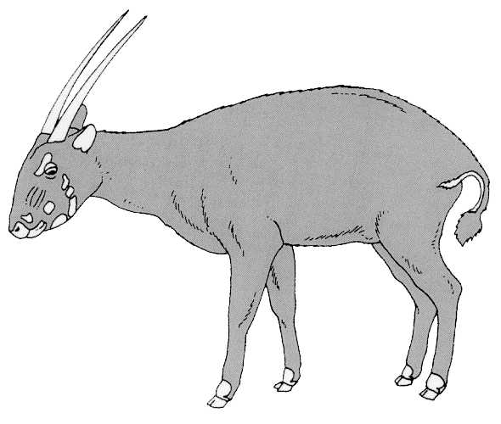
Seventeenth meeting of the Animals Committee
Hanoi (Viet Nam), 30 July-3 August 2001

Adoption of the Agenda and Working Programme

Agenda (provisional)tE>
Agenda item | Document No. | Language
1. Opening of the meeting | No document
2. Adoption of the Rules of Procedure | AC17 Doc. 2 (Rev. 1) | E, F, S
3. Adoption of the Agenda and Working Programme | No document
3.1 Agenda | AC17 Doc. 3.1 | E, F, S
3.2 Working Programme | AC17 Doc. 3.2 | E, F, S
4. Admission of observers | AC17 Doc. 4 | E, F, S
5. Regional Reports | No document
5.1 Africa | AC17 Doc. 5.1 | E, F, S
5.2 Asia | AC17 Doc. 5.2 | E, F, S
5.3 Central and South America and the Caribbean
5.4 Europe | AC17 Doc. 5.4 | E, F, S
5.5 North America | AC17 Doc. 5.5 | E, F, S
5.6 Oceania | AC17 Doc. 5.6 | E, F, S
6. Report from Chairman | No document
6.1 Liaison with the Standing Committee | AC17 Doc. 6.1 | E, F, S
6.2 Review of Resolution Conf. 9.24 | No document
7. Implementation of Resolution Conf. 8.9 (Rev.) (Decision 11.106) | No document (see AC17 Inf. 1, Inf. 2)
7.1 Progress on the implementation of Phase IV of the Review of Significant Trade | AC17 Doc. 7.1 | E, F, S
7.2 Review of the implementation of recommendations  (Part I: List of species previously reviewed) | AC17 Doc. 7.2 | E, F, S
7.3 Progress on the review of species selected at AC16. | No document
7.4 Revision of Resolution Conf. 8.9 (Rev.) and  Decisions 11.106-11.108 | AC17 Doc. 7.4 | E, F, S
7.5 Proposal for the first country-based Significant Trade Review | AC17 Doc. 7.5 | E, F, S
8. Periodic review of animal taxa in the Appendices (Resolution Conf. 11.1) | No document
8.1 Evaluation of species selected at AC15 and AC16 | AC17 Doc. 8.1 | E, F, S
9. Registration and monitoring of animal species bred in captivity (Resolution Conf. 11.14 and Decision 11.101) | No document
10. Implementation of Resolution Conf. 10.21 on transport of live animals | No document
10.1 Report of the working group | AC17 Doc. 10.1 | E, F, S
11. Implementation of Resolution Conf. 11.16 regarding ranching operations | No document
11.1 Annual reporting on crocodile ranching operations | AC17 Doc. 11.1 (Rev. 1) | E, F, S
12. Trade in hard corals | No document
12.1 Report of the working group | AC17 Doc. 12.1 | E, F, S
12.2 Mariculture and propagation of coral – response to  Notification No. 2001/010 | AC17 Doc. 12.2 | E, F, S
13. Implementation of Decision 11.165 on trade in traditional medicines | No document
13.1 List of species traded for medicinal purposes | AC17 Doc. 13.1 | E, F, S
14. Control of captive breeding, ranching and wild harvest production systems for Appendix-II species | AC17 Doc. 14 (Rev. 1) | E, F, S
15. Universal labelling of caviar | No document
15.1 Report of the working group | AC17 Doc. 15.1 | E, F, S
16. Trade in Tursiops truncatus ponticus (Decision 11.91) | No document
17. Trade in freshwater turtles and tortoises in Southeast Asia | No document
17.1 Report of the working group | AC17 Doc. 17.1 | E, F, S
18. Conservation of seahorses and other members of the family Syngnathidae (Decision 11.97) | No document
18.1 Report of the working group | AC17 Doc. 18.1 | E, F, S
19. Implementation of Decision 11.94 regarding the biological and trade status of sharks | No document
19.1 Report of the Chairman | No document
20. Implementation of Decision 11.100 regarding trade in alien species | No document
20.1 Report of the working group | AC17 Doc. 20.1 | E, F, S
21. Any other business | No document
xx. Closing remarks | No document

INFORMATION DOCUMENTS
Document title | Document No. | Language
The Significant Trade Review process | AC17 Inf. 1 | E, F, S
A Guide to the Review of Significant Trade | AC17 Inf. 2 | E, F, S
History of species reviewed under Resolution Conf. 8.9 (Rev.) | AC17 Inf. 3 | E
Notification to the Parties No. 2001/043 | AC17 Inf. 4 | E, F, S
List of animal species used in traditional medicine | AC17 Inf. 5 | E
Review of Totoaba macdonaldi | AC17 Inf. 6 | E, S
An overview of the trade in live South-east Asian freshwater turtles | AC17 Inf. 7 | E
International trade in live Testudinidae: Review of trade levels and trends over two decades | AC17 Inf. 8 | E
Universal labelling system for the identification of caviar | AC17 Inf. 9 | E
Intellectual property and genetic resources, traditional knowledge and folklore | AC17 Inf. 10 | E
Interpretation and implementation of the Convention  Significant trade in specimens of Appendix-II species (SC45 Doc. 12.1) | AC17 Inf. 11 | E, F, S

