PC13 Inf. 12
(English only/Únicamente en inglés/Seulement en anglais)
CONVENTION ON INTERNATIONAL TRADE IN ENDANGERED SPECIES
OF WILD FAUNA AND FLORA
____________
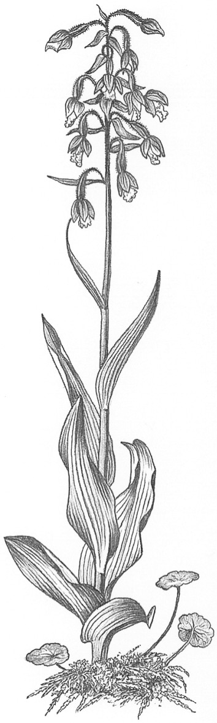
Thirteenth meeting of the Plants Committee
Geneva (Switzerland), 12-15 August 2003
Correspondence FROM THE Executive Secretary OF CBD
to the Chairman of the Plants Committee

Ref.: SCBD/STTM/JM/36250

Dear Margarita,

Many thanks for your email message of 7 July 2003 and for the invitation to participate in the 13th Session of the CITES Plants Committee. I would like to congratulate you on your important efforts to promote the CBD and CITES through your directorship of the Masters Course.
We very much welcome the decision of CITES COP to consider the targets of the Global Strategy for Plant Conservation. I would also like to acknowledge your important role in developing the Strategy, and express my appreciation to your efforts in this regard. I know that your guidance in drafting Target 11 in particular was crucial in elaborating a target that could be useful to the CITES community.
It is very positive that the Plant Committee will be discussing the Global Strategy for Plant Conservation and analyzing the links between CITES and the CBD. As you know, Target 11 was elaborated to be consistent with the CITES Strategic Plan, and we would welcome any further elaboration from the CITES community of how the Target can be successfully attained.
Unfortunately, due to a number of other commitments coinciding with the summer period, it is not possible for the CBD Secretariat to send a representative to the Committee. I would be grateful however, if you would convey the attached message to the session of the Committee.
We look forward to continuing close collaboration between our Conventions to address this common objective.
With my very best wishes for a successful session.

Hamdallah Zedan


CBD

Convention on International Trade in Endangered Species of Wild Fauna and Flora (CITES)
Committee on Plants - 13th Session, 11- 15 August, 2003, Geneva, Switzerland
Item 22 of the Provisional Agenda

Statement by the Executive Secretary of the Convention on Biological Diversity
At its sixth meeting in The Hague, April 2003, the Conference of the Parties to the Convention on Biological Diversity adopted the Global Strategy for Plant Conservation. The ultimate aim of the Strategy is to halt the current and continuing loss of plant diversity. The Strategy features 16 outcome-oriented targets, aimed at achieving a set of measurable goals by 2010. It is hoped that such targets, adopted by the international community, will provide a focus for concerted action by all actors, whether Governments, international organizations, civil society or the private sector.
The Strategy and its targets was developed in a two-year period through a unique partnership of international and national organizations, which continue to work together to facilitate and promote implementation of the Strategy. CITES has been a key player in this partnership and has provided inspiration, in particular, for Target 11: By 2010 “No species of wild flora endangered by international trade”. I would like to pay tribute to the important role played by your Secretary, Professor Margarita Clemente, in contributing to the development of the Strategy in general, and of target 11 in particular.
We very much welcome the decision of the last meeting of the CITES Conference of the Parties to consider the targets of the Global Strategy for Plant Conservation and it is very positive that the Plant Committee is discussing the Strategy and analyzing the links between CITES and the CBD, at this meeting.
Target 11 was elaborated to be consistent with the CITES Strategic Plan, and we would welcome any further elaboration from the CITES community of how the Target can be successfully attained. A liaison group will meet in October 2003 to review progress on each of the targets in preparation for the ninth meeting of the Subsidiary Body on Scientific, Technical and Technological Advice (SBSTTA-9).
I see this as a very positive example of cooperation between biodiversity-related conventions on very tangible matters. I look forward to continuing close collaboration between our Conventions to address our common objectives and wish you all success in your important work.
Thank you.

