PC13 Inf. 9
(English only/Únicamente en inglés/Seulement en anglais)
CONVENTION ON INTERNATIONAL TRADE IN ENDANGERED SPECIES
OF WILD FAUNA AND FLORA
____________
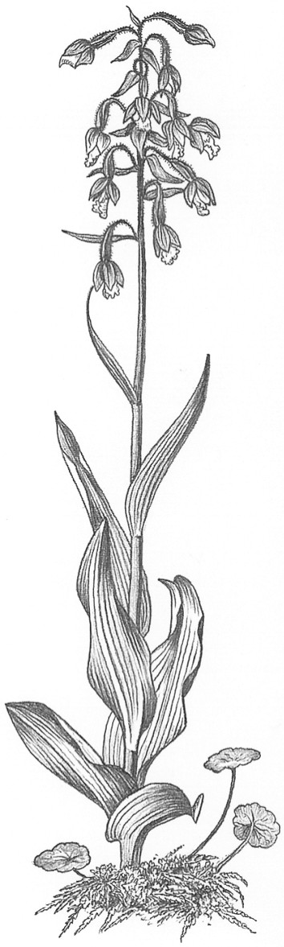
Thirteenth meeting of the Plants Committee
Geneva (Switzerland), 12-15 August 2003

Document prepared by the Scientific Authority of Austria for PC13 (Agenda item 15.4)
Preparation of CITES checklist for Bulbophyllum (Orchidaceae)
Austria welcomes the report of the Nomenclature Committee (document CoP12 Doc. 10.3) and congratulates the committee for the work. This shows the excellent work of the technical committees.
Austria also notes that, with Resolution Conf. 12.11, the Conference of the Parties has adopted the Checklist for CITES plants, compiled by the UNEP WCMC, and its updates, as the standard reference for species included in the Appendices.
Austria agrees with document PC13 Doc. 15.1 §3 in highly estimating this list as an extremely useful and important tool. However, the need for taxon-specific checklists is emphasized (in agreement with the reasons outlined in document PC13 Doc. 15.1 §3). Such taxon-specific checklists are especially needed for groups of plants with large distribution areas, numerous species and difficult taxonomy.
Therefore, and with reference to the "orchid checklist", (document CoP12 Doc. 10.3, point 63), Austria expresses its continuing support for the planned checklist on the genus Bulbophyllum and its allies. Within orchids, this group is a real nightmare as regards botanical names. This is obvious when considering the more than 3.000 names already documented in the pilot project for species in this group, funded by Austria. A report of this pilot project is attached.
Because of the request for additional funding for this project, as expressed in documents CoP12 Doc. 10.3 and PC13 Doc. 15.1 §7, and in light of the fact that the budget lines for the Nomenclature studies were deleted for 2003-2005 (and budget included in “Support to Scientific Authorities”) by decision of the CoP12, requiring external funding for Nomenclature projects, Austria will continue to support the Bulbophyllum- checklist project with an additional amount of c. 4.000 Euro. This money is hoped to be “seed money” stimulating additional support to ensure the continuation of this work.
The now envisaged project is aimed to result in a “checklist for Bulbophyllum”-draft manuscript for CoP 13. This draft will be prepared in consideration of the proposals of the Plants Committee regarding document PC13 Doc. 15.1 and in consultation with the Vice-Chairman of the Nomenclature Committee.
First steps towards the preparation of a CITES checklist for Bulbophyllum (Orchidaceae)
Report of a project financed by the Austrian CITES-MA
Michael Kiehn & Anton Sieder
Aims of the project:
- Collection of all literature dealing with the genus Bulbophyllum - descriptions, floras, keys etc.
- Extraction of information needed for a CITES checklist for Bulbophyllum
- Establishment of a electronic data-base for this information
- Starting with the input of data of CITES relevance into this data base
- Establishing contacts with experts of the genus on a worldwide basis (as precondition for a consensus about accepted names for the checklist)
Results:
- The literature collected and consulted relates to c. 3.000 names of Bulbophyllum and relatives.
- Species at one time referred to as members of Bulbophyllum were originally described as or are currently attributed to one of the following 55 genera:
Acrochaene, Adelopetalum, Anisopetalum, Bolbophyllaria, Bulbophyllopsis, Bulbophyllum, Canacorchis, Chaseella, Cirrhopetalum, Cochlia, Codonosiphon, Dactylorhynchos, Didactyle, Diphyes, Drymoda, Ephippium, Epicranthes, Ferruminaria, Genyorchis, Gerinia, Hapalochilus, Henosis, Hippoglossum, Hyalosema, Ionea, Jejosephia, Lyraea, Macrolepis, Malachadenia, Mastigion, Megaclinum, Monomeria, Monosepalum, Odontostyles, Osyricera, Oxysepalum, Pedilochilus, Pelma, Phyllorchis, Phyllorkis, Porpax, Rhytionanthos, Saccoglossum, Sarcopodium, Sestochilus, Synarmosepalum, Stolzia, Sunipia, Tapeinoglossum, Taurostalix, Thelynchiton, Trias, Tribrachia, Vesicisepalum, Xiphizusa, Zygoglossum
The checklist will have to deal with all these genera.
- Additional 120 names of sections and subgenera in Bulbophyllum have been documented.
- An electronic data-base for the preparation of the checklist was created in collaboration with Noel McGough (RBG Kew). Using access as background program, this data base includes (amongst others) the following fields: genus, species, author, occurance, first description (year), section, type, synonyms, is synonym to, first publication in genus xx. It is designed to specially accomodate the complicated and manyfold synonymies.
- Data for c. 300 species are already taxonomically checked and included in the data base. Inclusion of data for another 1.000 taxa is prepared and depends on further financial support for the project.
- Contacts with experts of the genus on a worldwide basis are established - this process is open ended and still ongoing.
Proposed next steps (subject to additional funding):
- Continuation with the taxonomic work on valid and accepted names.
- Increasing the communication with the Bulbophyllum-specialists (e.g., by visits of the coordinator for the project in Paris and Kew).
- Continuation of inclusion of data in the database.

Austrian Federal Ministery of Agriculture, Forestry, Environment and Water Management, Abt. II/5 U (DI Günter Liebel), Stubenbastei 5, A-1010 Vienna
Institute of Botany, University of Vienna, Rennweg 14, A-1030 Vienna

