PC13 Doc. 6.6.1
(English only/Únicamente en inglés/Seulement en anglais)
CONVENTION ON INTERNATIONAL TRADE IN ENDANGERED SPECIES
OF WILD FAUNA AND FLORA
____________
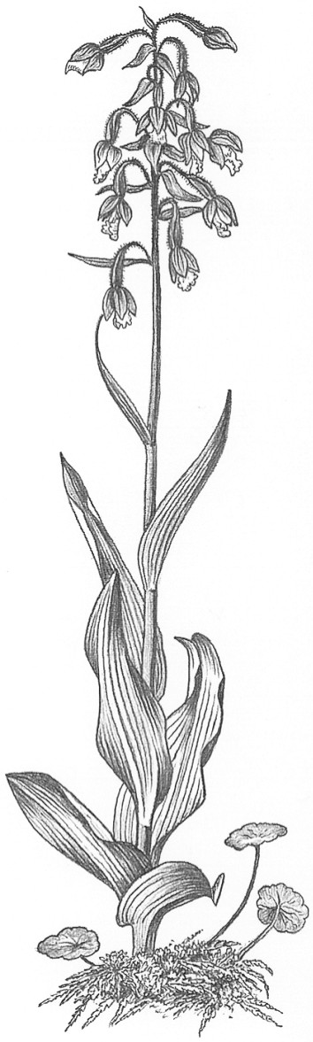
Thirteenth meeting of the Plants Committee
Geneva (Switzerland), 12-15 August 2003
Regional reports and updated regional directories [Decisions 12.14 and 12.15]
Oceania
Regional report

General Information
a) Regional Member (author of report): Greg Leach (Australia)
b) Alternate Member: Osia Gideon (Papua New Guinea)
c) Parties in the Region: Australia, Fiji, New Zealand, Papua New Guinea, Vanuatu
Regional Directory
The Oceania Regional Directory of plant specialists has been maintained and a revised edition dated July 2003 has been provided to CITES Secretariat. The Australian Management Authority has also produced a Regional directory of contacts for all CITES issues.

Communication with Parties in the region
A report of the 12th PC meeting was distributed to all Oceania parties and plant specialists in July 2002. In addition to providing a summary of the meeting, detailed comments on implications for CoP12 were also provided. These comments highlighted flora issues of concern or relevance to the Oceania region.
To facilitate the Tree Species Evaluation exercise, all species that occur in Oceania were extracted from the report and provided to Parties in a Table showing distribution by Range State. Range States were urged to check the information, particularly given that species could be selected for further evaluation. No response was received.
All Oceania Parties and specialists were contacted in May 2003 to follow up on requests for information for the Cycad Significant Trade Study. A further request for comment on the Tree Species Evaluation exercise was also made.
The Regional representative had communications with:
a) The Australian Management Authority to facilitate a response to the Cycad Significant trade review
b) TRAFFIC SEA concerning on-going activities with studies on the trade in Agarwood
c) The New Zealand Scientific Authority on import of Cycad seeds
d) The Australian Management Authority on enforcement issues relating to Cycad trade
e) The Vanuatu Management Authority on trade interest in wild harvested Cycads
Regional meetings at any CoP are an important communication opportunity for a region such as Oceania where there are few other opportunities for all Parties to discuss CITES issues. CoP12 was no exception but it was very disappointing that Papua New Guinea and Vanuatu were not represented at CoP12. There has been no other regional meeting since PC12 and Oceania will need to continue to look for other regional fora/meetings to maintain communications.

Capacity building activities

Oceania Capacity Building Workshop
CITES Parties and Non-Parties in the Oceania region attended a Regional Workshop for Small Island Developing States in Fiji from 29 April to 1 May 2002. Participants agreed on the need to improve communication on management, scientific and enforcement matters. It was agreed that a further workshop should be held and 2 decisions taken at CoP12 are directly relevant to progressing this objective: 12.94 Capacity building in the Oceania region and 12.95 Capacity building in Small Island Developing States. The region looks forward to progressing discussions with the Secretariat and work continues between Fiji, Australia, TRAFFIC and the Secretariat in advancing the organisation of such a workshop.

Australia

Species Management Workshop - Indonesia
Australia funded and facilitated a Species management workshop in Bogor, Indonesia from 15 to 17 April 2002. The workshop was attended by Indonesian CITES authority officials, researchers, local environmental NGO’s and the timber industry. The workshop provided training in species population assessment, population assessment methods and the preparation of species management programs that meet CITES requirements.
Papua New Guinea
Two workshops have been developed to assist with enforcement and species identification. The enforcement workshop was developed collaboratively with the PNG Customs and the Public Prosecutors Office. The species identification workshop is targeted towards insects with experts from the PNG Dept of Agriculture. Both workshops have been run this year.
All additional samples of Agarwood collected thus far in PNG are Gyrinops ledermannii so the Agarwood trade from PNG continues to be outside the CITES listing of Aquilaria malaccensis. A proposal for funding of future work has been submitted to the FAO Technical Co-operation programme.
WWF South Pacific Programme has continued its work with harvesting communities and has also begun a database effort for Agarwood information. TAFFIC/WWF has report on regulation of Agarwood exports from PNG in a draft review stage.
Effort continues in PNG to improve the organisation and controls of the Agarwood trade but there is acknowledgment that the processes within the minor forest product sector have inadequacies. Activities in response to Decisions 12.66-12.71 are outlined in PC13 Doc. 9.3 and Papua New Guinea hopes that these will contribute to resolution of the trade issues in PNG.

New Zealand
Two new community-based initiatives aimed at education and voluntary compliance with CITES have produced encouraging results. The first was the CITES Chinese Community project which developed after the recognition that traditional Chinese medicines were a major component of seizures. Another major component of seizures was marine products such as clam, coral and turtle from Pacific countries. In both programs there were awareness campaigns and education programs but of greatest significance to the success of the programs was the involvement of the Chinese and Pacific Island communities.

Vanuatu
Capacity building has concentrated on skills in the identification of corals and a national workshop was held on this topic.

Difficulties of implementation encountered in the region
Non-compliance in the areas of annual reporting, financial contributions and legislation continue to be problems experienced by some Parties in the region. These problems highlight the need for capacity building activities.

Enforcement
Australia

Wildlife law enforcement conference in Australia
In November 2001 Australia hosted the second conference on Combating Wildlife Crime in the 21st Century. Australia hopes to run another Regional Wildlife Law Enforcement Officers Conference during 2003. The Conference will be held in Australia and will either follow the Interpol Wildlife Subgroup meeting in New Zealand in October or later during November.
New Zealand

Wildlife Enforcement Group
The Wildlife Enforcement Group occupies the seat of the Oceania representative to the Interpol Working Group on wildlife crime. New Zealand anticipates hosting a meeting of this group in October which would be the first such meeting in the Oceania region. Such a meeting would be an excellent opportunity for enforcement capacity building for Parties and non-Parties in the region.
Prosecutions during the period relate to fauna offences.

