PC13 Doc. 6.2.1 (Rev. 1)
(English only/Únicamente en inglés/Seulement en anglais)
CONVENTION ON INTERNATIONAL TRADE IN ENDANGERED SPECIES
OF WILD FAUNA AND FLORA
____________
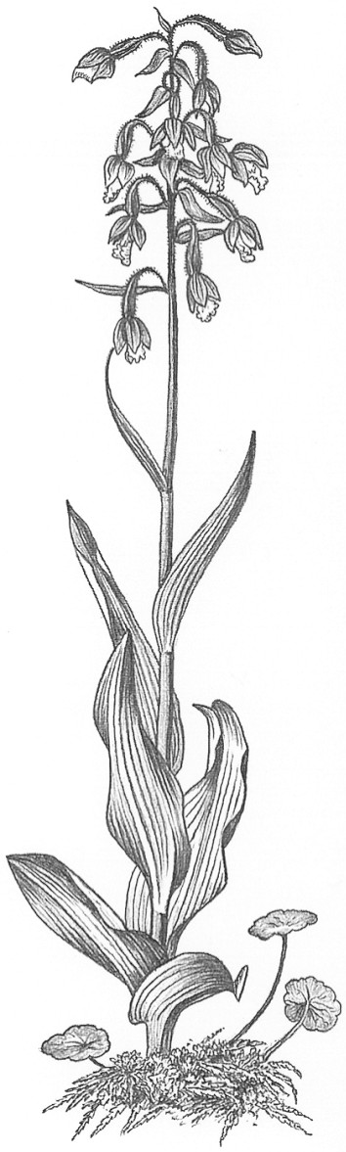
Thirteenth meeting of the Plants Committee
Geneva (Switzerland), 12-15 August 2003
Regional reports and updated regional directories [Decisions 12.14 and 12.15]
Asia
Regional report

Western Asia
1. General information
a) Name of the representative (author of the report): N.P. Singh (India)
b) Name of alternate representative: Jian Sheng Jia (China)
c) Number of Parties in the region: 16 in western Asia (Afghanistan, Bangladesh, China, India, Iran, Israel, Jordan, Nepal, Pakistan, Qatar, Saudi Arabia, Sri Lanka, the United Arab Emirates and Yemen; Bhutan and Kuwait became Parties after CoP12). Asia has 31 Parties.
d) Number of Parties/Scientific Authorities responding to communications: none.
e) Names of other institutions or NGOs contacted for CITES work during the period: Royal Botanic Gardens, Kew (United Kingdom), particularly for information on the genus Taxus and on Fungi.
2. List of items
a) Introduction
The report covers the period from the 12th meeting of the Plants Committee to this date.
b) Regional Directory
Efforts were made to update this directory.
3. Communication with Parties in the region
Difficulties have been consistently encountered in communicating with the Parties. However, efforts were made to contact all 14, the then existing Parties before CoP12, both by email (whenever addresses were available) and by a letter sent out on 27 September 2002, to exchange ideas and send suggestions for the meeting. However not a single response was received. This is one area which needs attention of the Plants Committee.
4. Miscellaneous
Correspondence and exchange of ideas were continuously maintained by email with the Chairman, members of the Plants Committee and the Secretariat, whenever needed.

Eastern Asia
5. General information
a) Name of the representative: Irawati (Indonesia)
b) Name of alternate representative: Zul Mukshar Md. Shaari (Malaysia)
c) Number of Parties in the region: 13 in eastern Asia (Brunei Darussalam, Cambodia, Indonesia, Japan, Kazakhstan, Malaysia, Mongolia, Myanmar, the Philippines, the Republic of Korea, Singapore, Thailand, Uzbekistan and Viet Nam).
d) Number of Parties responding to communication: none.
6. List of items
a) This report covers the period from 12th meeting of the Plants Committee to this date.
b) As with what happened in western Asia, not a single response were received in response to correspondence sent.
c) A CITES capacity-building workshop was organized by the CITES Secretariat, TRAFFIC South East Asia and the Sabah Forestry Department in Kota Kinabalu, Sabah, Malaysia. Scientific and Management Authorities from Brunei Darussalam, Indonesia, Malaysia, the Philippines and Thailand, as well as other participants from this region attending this workshop on 5-9 May 2003.
d) This year, the Management and Scientific Authorities of Indonesia are conducting a CITES awareness programme in six cities representing five main islands in Indonesia: Borneo, Celebes, Java, Papua and Sumatra.
e) A CITES public awareness campaign for the western Indonesian region has been conducted in Jakarta and in Bali by the Management Authority and WWF Indonesia programme, especially for officers of the forestry department, quarantine, Customs and the police.
f) Communication among parties in this region also needs to be improved.

