PC13 Doc. 6.1.1
(English only/Únicamente en inglés/Seulement en anglais)
CONVENTION ON INTERNATIONAL TRADE IN ENDANGERED SPECIES
OF WILD FAUNA AND FLORA
____________
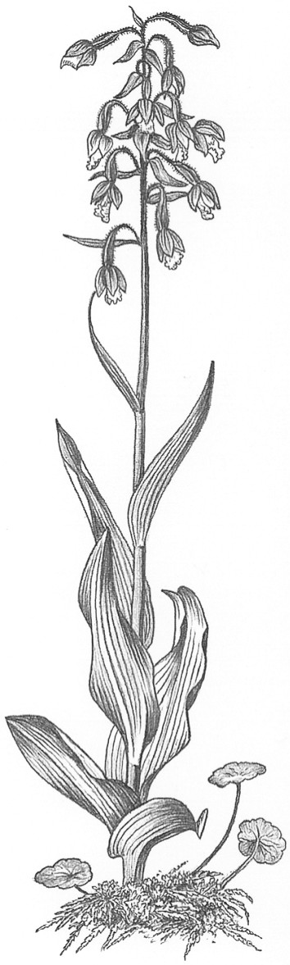
Thirteenth meeting of the Plants Committee
Geneva (Switzerland), 12-15 August 2003
Regional reports and updated regional directories [Decisions 12.14 and 12.15]
Africa
Regional report
1. General information
1.1 Name of the Representatives (authors of the Report): Dr John Donaldson and Mr Quentin Luke
1.2 Number of Parties in the Region: 53
1.3 Number of Parties responding to communications: 6
1.4 Names of the other institutions, NGOs contacted for CITES work during the period: TRAFFIC (East/Southern Africa), IUCN, UNEP-WCMC, FFI, Resource Africa.
2. Follow-up on agenda items since last Plants Committee
2.1 Significant Trade
a) MADAGASCAR: As part of the significant trade review process, a survey of trade data, mainly from the UNEP-WCMC database was undertaken by Royal Botanic Gardens, Kew, and a workshop was held in Madagascar.
b) DEMOCRATIC REPUBLIC OF CONGO, GHANA, KENYA, MOZAMBIQUE, NIGERIA, SOUTH AFRICA, SWAZILAND, TANZANIA, UGANDA, ZAMBIA, ZIMBABWE: Management Authorities were requested to supply information on trade and conservation of cycad species as part of the significant trade review process.
c) KENYA: The management authority was contacted with regard to the Aloe extract trade and FFI was contracted to undertake the study.
2.2 Review of the Appendices
Nothing to report.
2.3 CITES-Projects
a) NAMIBIA: In terms of Resolution Conf. 12.63, range states of Harpagophytum are requested to provide an update on the implementation of policies and management programmes mentioned in earlier reports. A report on ongoing work in Namibia has been submitted to PC13 (document Pc13 Doc. 9.1.1).
b) SOUTH AFRICA: To comply with Resolution Conf. 12.63. regarding Devil’s Claw, an assessment of the status of Devil’s Claw in South Africa has been carried out by a combined team of NGOs and government agencies with funding from the Whitley Laing Foundation in the United Kingdom. The report will be submitted to PC 14.
c) SOUTH AFRICA: funding has been obtained from NORAD and the Critical Ecosystem Partnership fund for work on threatened plants including an assessment of risk due to domestic and international trade.
2.4 Nursery Registration
Nothing to report.
2.5 Other
Nothing to report.
3. Communication with Parties in the African region
3.1 Several range states were contacted to obtain the latest information on Management and Scientific Authorities in the African Region.
3.2 BOTSWANA requested information on the correct way to deal with plant issues, especially the structure of a Scientific Authority.
3.3 The Draft Agenda of the 13th Plant Committee meeting was circulated asking for suggestions.
3.4 SOUTH AFRICA and BOTSWANA were alerted to their need to respond to Resolution Conf. 12.63.
3.5 LESOTHO (not a Party) requested information on trade in Aloe species and was referred to the CITES Secretariat.
4. Capacity building activities
4.1 Training seminars
None.
4.2 Education
a) Representatives from BOTSWANA, NIGERIA, SOUTH AFRICA, TANZANIA, and UGANDA attended the 4th Masters degree programme in Management, access, and conservation of species in trade at the International University of Andalucía in Spain.
b) TRAFFIC (East/Southern Africa) has obtained funding for a capacity building programme in southern Africa.
4.3 Meetings
a) SOUTH AFRICA: a task team has been established to deal with CITES issues and prepare for the next CoP and a meeting was held on 6 June 2003 in Pretoria.
4.4 Contacts with specialists and/or NGOs
a) TRAFFIC (East/Southern Africa), Fauna and Flora International, Resource Africa, IUCN/SSC Red List officer, Cycad Specialist Group, and southern African Plants Specialist Group.
4.5 Financial support for the Africa representative as PC Vice-Chairman
a) Meetings held in Nairobi with UNEP to follow-up on offers of support made in Santiago were unsuccessful. The African representative (QL) is thus unable to carry out the duties as Vice-Chairman and tenders his resignation to make way for a member of the PC who can give the necessary support to the Chairman.
5. Difficulties of implementation encountered in the region
5.1 A press report appeared in Kenya regarding the succulent plant trade from Somalia via Kenya to nurseries in Europe and North America. Investigations showed that, although of local conservation concern, none of the species mentioned were CITES listed.
5.2 Communication remains a major stumbling block. Despite letters and emails to Parties, there is generally a poor response. For example, not one African country responded to requests for information on cycad trade. The capacity of African countries to deal with CITES relating to plants needs to be strengthened.
6. Other topics (medicinal plants, timber)
6.1 A research paper on the heavily utilised carving- wood species Dalbergia melanoxylon in Tanzania was reviewed. The species had been proposed for listing in 1995 and has been the subject of research ever since.
6.2 Plant Red Data lists were published for BOTSWANA, MALAWI, MOZAMBIQUE, NAMIBIA, SWAZILAND, ZAMBIA, and ZIMBABWE, making it easier to identify plants that may be under threat as a result of trade.
7. Work to be done until next Plants Committee
7.1 Report back from PC 13 to Parties.
7.2 Get final responses from African range States for significant trade reviews that are in progress.

