PC13 Inf. 1
(English only/Únicamente en inglés/Seulement en anglais)
CONVENTION ON INTERNATIONAL TRADE IN ENDANGERED SPECIES
OF WILD FAUNA AND FLORA
____________
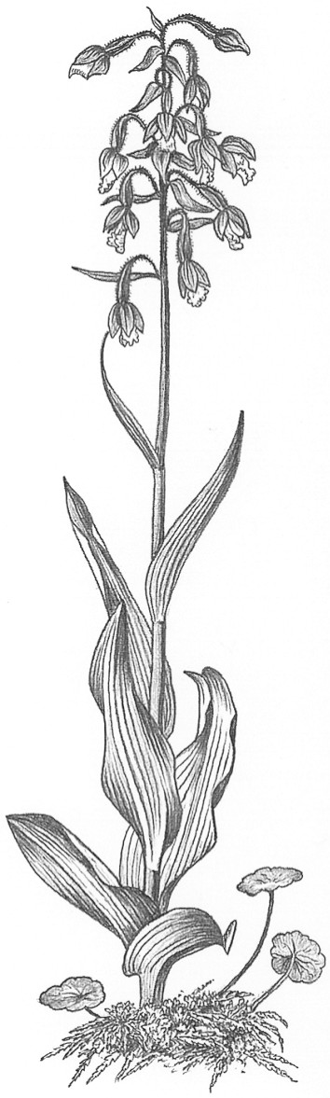
Thirteenth meeting of the Plants Committee
Geneva (Switzerland), 12-15 August 2003
response from Association Technique Internationale des
Bois Tropicaux (ATIBT) to document PC13 Doc. 10.14
ATIBT’s Response to the USA CITES Management Authorities proposed draft document on the determination of the definition of Swietenia macrophylla plywood and the unit of measure for Swietenia macrophylla plywood
1. Proposed interim determination of the definition of Swietenia macrophylla plywood
The United States CITES Management Authority proposes to use the following interim definition for the listing of Swietenia macrophylla plywood for Appendix II listing purposes.
“Consisting of three or more sheets of wood glued and pressed one on the other and generally disposed so that the grains of successive layers are at right angles”
This definition is taken from HS-commodity code 44.12 of the US Customs Harmonized Schedule. As the commodity codes of the US Customs Harmonized Schedule are taken from the World Customs Organisations Harmonized Schedule, and the CITES recommends that the parties apply the commodity codes of the latter, then the ATIBT agree with the United States CITES Management Authorities interim definition of plywood.
Furthermore, this definition rejoins that of the CEN (European Committee for Standardisation) and ISO (International Standardisation Organisation) namely that:
“Plywood is a wood-based panel consisting of an assembly of layers glued together with the direction of the grain in adjacent layers usually at right angles”
However, despite agreeing with the United States CITES Management Authorities definition, the ATIBT feel that it could be further improved by making reference to Sub-code 44.12.13 of the World Customs Organisations Harmonized Tariff Schedule namely:
“Plywood consisting solely of sheets of wood, each ply not exceeding 6mm in thickness with at least one outer ply of tropical wood specified in subheading note 1 (list of tropical woods).
And in particular the phrase “not exceeding 6mm in thickness”, therefore giving the following new definition:
“consisting of three or more sheets of wood glued and pressed one on the other, the thickness of each individual ply not exceeding 6 mm and generally disposed so that the grains of successive layers are at right angles”.
2. Proposed measurement unit for Swietenia macrophylla (SM) plywood
As for the proposition made by the US CITES Management Authority to record plywood containing SM in m², in order to determine the degree of SM present in individual plywood panels, the ATIBT would like to point out the following:
- It appears that there is no uniform International norm in force attaining to the method of plywood measurement neither at the moment of reception nor invoicing. Indeed, the marketing of plywood is undertaken both in m² or in m³, and it is perfectly common for the two methods to appear on individual contracts.
- If a m² measurement is to be applied with any accuracy, the “exact” SM content of individual plywood panels needs to be known.
Although SM is very rarely used for the inner plies of plywood panels, therefore rendering possible an accurate measurement in m², it can on occasion be the case however, for example, in the manufacturing of marine ply which is often made up partly or entirely of SM.
- As the thickness of individual plies would not be taken into account in a m² measurement, it would be impossible to determine with any accuracy the true amount of SM present in individual plywood panels.
In conclusion, the only sure way to have an accurate notion of the “exact” quantity of SM present in individual plywood panels would be to know the exact percentage of SM that has gone into the fabrication of the panel, and then work out the volume of SM present in the panel in m³ as a percentage of the total volume of the panel.

