PC13 Inf. 4
CONVENTION ON INTERNATIONAL TRADE IN ENDANGERED SPECIES
OF WILD FAUNA AND FLORA
____________
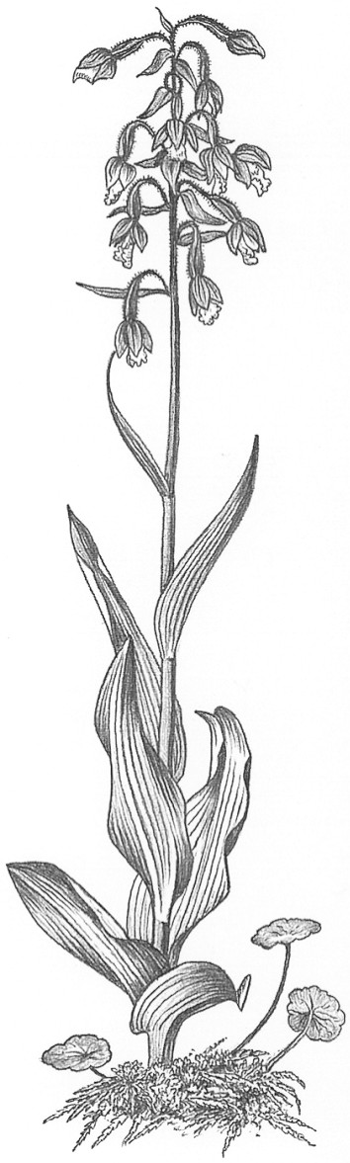
Thirteenth meeting of the Plants Committee
Geneva (Switzerland), 12-15 August 2003
PROPOSAL TO INCLUDE CAESALPINIA ECHINATA IN THE APPENDICES
PRESENTATION OF THE INTERNATIONAL PERNAMBUCO CONSERVATION INITIATIVE
1. This document has been prepared by the Confederation of Craftsmen and Users of Natural Resources (Comurnat), the International Pernambuco Conservation Initiative Deutschland e.V. (IPCI-Germany) and the International Pernambuco Conservation Initiative - United States (IPCI-USA) on behalf of their bow and violin maker members.
2. Point 11.3 of the provisional agenda of the 13th session of the Plants Committee is titled “Proposal to include Caesalpinia echinata in the Appendices”.
3. The purpose of this document is to present an initiative from the users of the species aimed at implementing a sustainable use strategy for Pernambuco (C. echinata).
4. Historically, the exploitation of Pernambuco, a tree species occurring in the Mata Atlantica, started in 1502 following the discovery of Brazil. At this time the species was exported to European countries where it was used as a dye. Called Pau Brasil by the Portuguese, it became Brazil’s first export commodity and gave the country its name. The use of the species as a dye gradually came to an end in the mid-19th century. In the early 1870s the Brazilian authorities closed the trade records of Pau Brazil because its exportation was no longer significant from an economic point of view. In Brazil itself the species, as with other hardwoods, has been used for fence posts, railway ties, telephone posts, home construction, furniture making and other domestic uses.
5. In the mid-1700’s Pernambuco was first introduced to the bowmaking community and gained wide acceptance by the end of the 18th century. Within a short time it supplanted all other species previously used because its combination of resilience, density, strength and ability to hold a fixed curve make this wood a unique material for crafting cambered bows. Since then, bowmakers have developed a close association with this wood, which they consider irreplaceable.
6. A significant number of bowmakers who started their craft since the 1980’s had gradually become sensitive to the issue of pressures on the Mata Atlantica due to urban development, mass sugar cane and cellulose production, pasture, etc. While they were genuinely concerned, they felt that a solution to the problem was beyond their control.
7. In 2000, Comurnat made bowmakers further aware of the possible implications regarding the long-term availability of supplies. It also made clear that it was possible for them to become involved in the conservation and sustainable use of the species.
8. A group of bowmakers strongly in favour of such involvement then decided in May 2000 to create the International Pernambuco Conservation Initiative (IPCI), a program co-ordinated by Comurnat. This program serves as a catalyst for professional bowmakers to address these specific issues and to fund action taken by the Initiative. In September 2001 and August 2002, national delegations of the IPCI were created in Germany and in the United States. As of July 2003, the IPCI, also known as the Pernambuco Initiative, has 220 individual members (i.e. approximately 70% of the world bowmaking community) established in 22 countries and 10 professional organisations.
9. Since it was created, the IPCI made possible:
a) The organisation and funding of a workshop held in Domingos Martins, ES, Brazil, in March 2001. The main result of this conference was to initiate dialogue between representatives of IPCI-Comurnat, members of the Brazilian scientific community and Funbrasil, a Brazilian foundation involved in Pernambuco conservation since 1970.
b) Also during this meeting and following information on the lack of a continuous water supply to Funbrasil, bowmakers decided to fund the drilling of an artesian well to irrigate the seedlings produced in the foundation nursery. This well has been in operation since June 2001.
c) In May 2002, in the context of the Pau Brazil week, the IPCI financed the purchase of 5 000 seedlings which were planted in ten townships in Pernambuco State. A similar action is planned for May 2004 and the purchase of 10 000 seedlings and care of them has already been financed in April of this year.
d) At the initiative of an Austrian member of the IPCI, a concert by members of the Vienna Philarmonic Orchestra was organised in November 2002 to raise awareness and funds needed to finance the actions of the Pernambuco Initiative.
10. These actions are small scale but they have been critically important in demonstrating to bowmakers and the string playing community that it is possible for them to be involved in the conservation of the species. This brought together a significant percentage of the profession to support the objectives of the Pernambuco Initiative.
11. However, there is no doubt that one of the most important aspects of this initial phase is that it allowed an ambitious partnership between professional bowmakers and the Brazilian authorities to be developed.
12. Contacts have been established with different Brazilian institutions during the period April-September 2001. Following these contacts a comprehensive five-year plan named Programa Pau Brasil has been drawn up and will begin to be implemented in the coming weeks. This action plan comprises 52 complimentary projects covering all aspects necessary for implementing a sustainable use strategy. Projects include inventories of Pernambuco populations in five Brazilian States, DNA studies of these different populations, research relating to the propagation of Pernambuco, creating an organisation of Pau Brazil producers, increasing public awareness within local communities of the need for the preservation of Pernambuco, instigating public policies favourable to the sustainable use of Pau Brazil, planting of 500,000 trees. These few examples are all part of the Programa Pau Brasil.
13. The involvement of professional bowmakers in this partnership is demonstrated by their commitment to fund this five year plan and also by the active support they will provide to all action taken within this framework. We really are in the situation where a profession is gradually and concretely integrating the sustainable use of the resource it uses.
14. Conservation of tropical timber species is a complex issue where all the parameters under consideration need to be addressed carefully. One of the most important factors is to have the support and involvement of the users of the species.
15. With that in mind, the IPCI appreciates the move forward suggested in documents PC13 Doc 14.1 and PC13 Doc 14.2 (Rev. 1). In particular, and as outlined in paragraphs 5.a) and 5.b) of the latter, both an integrated approach and the participation of stakeholders in the evaluation process are requisites of primary importance.
16. This would allow the review process to consider all possible options so that the best solution for the conservation of the species can be determined.
17. Needless to say, the Pernambuco Initiative wishes to participate in the process and will help in any possible way.

