PC13 Inf. 2
(English and Spanish only/Únicamente en inglés y español/Seulement en anglais et espagnol)
CONVENTION ON INTERNATIONAL TRADE IN ENDANGERED SPECIES
OF WILD FAUNA AND FLORA
____________
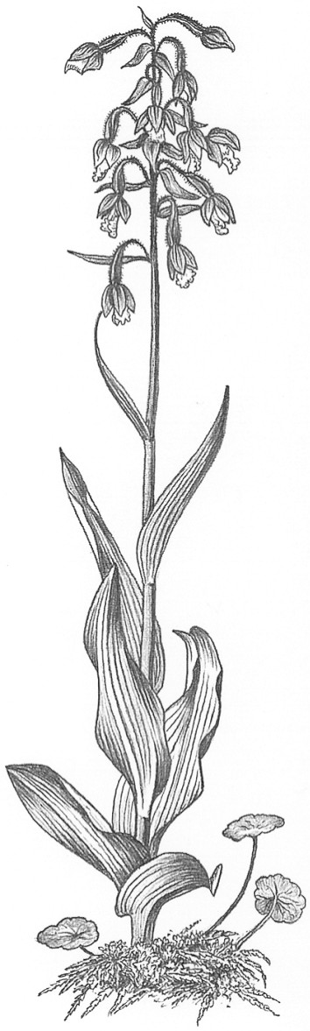
Thirteenth meeting of the Plants Committee
Geneva (Switzerland), 12-15 August 2003
Guaiacum sanctum in MEXICO: PROGRESS IN THE STUDY OF population status,
recent management and ENFORCEMENT ACTIONS, and other related issues
This document has been prepared by the CITES Scientific Authority of Mexico.
Following the Decision 11.114 (Rev. CoP12), related to Guaiacum spp. and previous discussions during the11th and 12th meetings of the Plants Committee, Mexico developed a project to evaluate the status of wild populations of G. sanctum (and sympatric G. coulteri) in Mexico. An overview of the project, as well as the progress, funding sources, and actions taken through a collaborative effort among scientific, administrative and law enforcement authorities in Mexico, are presented below:
1. Progress in the Study of Population Status of Guaiacum sanctum L. in Mexico:
Title: Abundance, distribution, and conservation status of Guaiacum sanctum L. in Mexico
Target group: Guaiacum sanctum (and sympatric G. coulteri) populations in Mexico.
Objectives: Examine the current distribution, abundance, and population dynamics of Guaiacum sanctum (and sympatric populations of G. coulteri if identified) in Mexico to determine its conservation status and availability. The study will provide the basis to determine the viability to exploit wild populations on a sustainable way, considering the alteration degree of the habitat. It will also generate the information needed to evaluate the feasibility to continue the commercial exportation from Mexico and to improve management practices. The identification of priority conservation areas is an important part of the project as well. In addition to the evaluation of some aspects of the natural history of the species and habitat condition (well preserved, fragmented, degraded), the project considers population genetics and reproductive biology studies to complement the demographic section. All this information will be used to develop proper indicators to evaluate the conservation (or deterioration) status and population viability analysis of remnant populations in Mexico.
Research team: The study will be developed by a group of scientists from the Centro de Investigaciones en Ecosistemas (CIECO), UNAM Campus Morelia (www.oikos.unam.mx), leaded by Dr. Miguel Martinez Ramos, and with the support of Conabio (Mexico’s Scientific Authority under CITES). Conabio is responsible for the coordination and administration of the project. For these reasons, it will maintain constant communication with the researchers and make periodic revisions of reports, assisting them with all the available resources (e.g. information systems: species localities database). Once the project is finished, Conabio, as the CITES Scientific Authority in Mexico, will provide proper recommendations according to the results. It will also submit an information report with the results to the Plants Committee.
The research team that will be working on specific tasks of the project is:
GARP & SIG: Dr. Gerardo Bocco and Dr. Alfredo Cuarón.
1. Plant communities: Dr. Guillermo Ibarra and Dr. Diego Pérez.
2. Population genetics: Dr. Ken Oyama.
3. Reproductive Biology: Dr. Mauricio Quesada.
Study area: Based on the potential distribution maps, some sampling areas with a high probability to find Guaiacum sanctum populations have been located: Istmo de Tehuantepec (Oaxaca), La Angostura (Chiapas), Reserva de la Biosfera de Calakmul, Bosque Modelo, Cobá and localities close to Escárcega (Campeche), Puerto Morelos region and Dzibilchaltum Natural Reserve (Yucatán) and Reserva de la Biósfera de Sian Ka´an (Quintana Roo).
Duration and expected results: The whole project will take from two to three years to be completed in two stages, with the following expected results:
First Stage (2003-2004):
a) Potential and current distribution of the species in Mexico.
b) Assessment of the species abundance in its current distribution range.
c) Population structure characterization (relative frequencies for individuals in different life stages: seedlings, juveniles, reproductive and non-reproductive adults; heights and trunk diameters).
d) Survey results regarding the conservation status and use of Guaiacum in the study area.
e) Characterization of the environment within the current distribution range of the species: vegetation types and their attributes (vegetation cover, basal area, plant species diversity), abiotic environment (soil, climate, and geomorphology), fragmentation degree (e.g. size of the remnant forest fragments that contain the species), degradation (e.g. percentage of the area with relict presence of the species that has been converted into agro-systems).
f) Population viability analysis based on theoretical demographic arguments (extinction risk).
g) Location of the areas which hold healthy populations of the species (from a demographic point of view), and based on this information propose priority conservation areas.
Second Stage (2004-2005):
a) Demographic rates characterization (relative to size groups); this is necessary to evaluate the natural renovation rates and population dynamics; if possible for areas with different conservation degree.
b) Genetic diversity estimates, crossing-over rates, inbreeding, and gene flow between populations; if possible for areas with different conservation degree.
c) Reproductive biology: polinization mechanisms, seed dispersal and germination, and establishment of seedlings, under different habitat conservation conditions (well preserved vs. altered).
Funding: The total cost of the ecological population project is approximately $37,500.00 USD, and will be co-financed by different national and foreign institutions, as follows:
a) Conabio: $10,000.00 USD.
b) Instituto Nacional de Ecología (INE): $10,000.00 USD (in progress).
c) Dirección General de Gestión Forestal y de Suelos (DGGFS, Semarnat): $ 3,000.00 USD (in progress).
d) U.S. Forest Service: $15,000.00 USD.
e) The German Government has made available $10,000 Euro for the CITES Secretariat to support the population study of Guaiacum (answer from CITES Secretariat pending).
f) Also, Conabio requested financial support to the European Commission, who in turn suggested to submit a co-financing proposal for the project via the annual “Call for proposals in the field of environmental protection 2003”. Conabio submitted all the required information and is waiting for the Commission’s decision.
Advances: The first step of the project, consisting in the determination of the field sampling sites, was made. The selection was based on potential distribution maps (see annex) for both species that were elaborated using Desktop GARP. The model was supplied with herbarium specimens records, provided by Conabio’s Scientific Collections’ Database. The probable niches distribution maps resulted from 30 iterations of the algorithm and it was refined by using distribution probabilities, eco-regions, bio-geographic provinces and recent vegetation type maps.
2. Management Actions:
Conabio recommended the Management Authority under CITES (Dirección General de Vida Silvestre, Semarnat) not to authorize more extraction permits of Guaiacum sanctum, until it has the results of the study (above). Consequently, the Management Authority decided not to issue any new extraction permit and will consult with Conabio any future extraction submission.
3. Enforcement Actions:
In March 2003, the Law Enforcement Authority (PROFEPA) made five inspections to three authorized forest extraction areas and two timber storage and transformation centres, in the State of Campeche. The results of these inspections showed the legal provenance of the timber found in the storage and transformation centres. Nevertheless, one of the authorized forest extraction areas got 30% more than the authorized volume and, another one took the wood from a near non-authorized area. Both infractions will be penalized according to Mexican laws. The sampling of these inspections represents almost 50% of the area under authorized management in the State.
4. Further studies needed for the distinguish of Guaiacum wood
Considering the lack of precise Genus wood anatomy, information on the basis of an accurate methodology, we will undertake an anatomical and structural study of all Guaiacum species that might enable their identification and the improvement of control measures. In consequence, Mexico will elaborate Terms of Reference for the elaboration of a Protocol, and an estimation of the cost.
PC13 Inf. 2
Annex

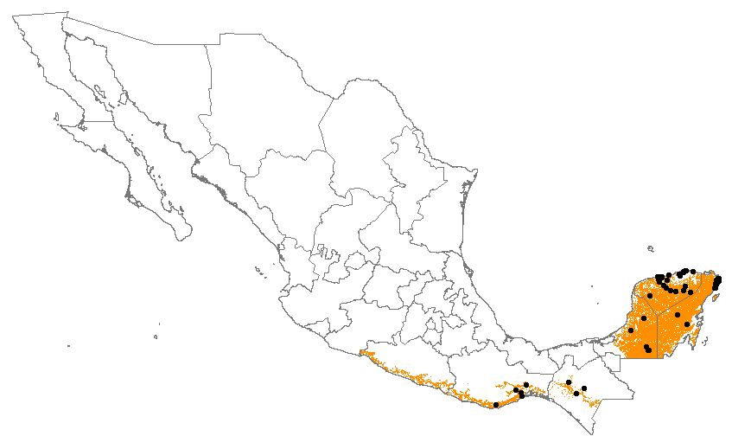

Guaiacum sanctum herbarium specimens records and potential distribution map using GARP.

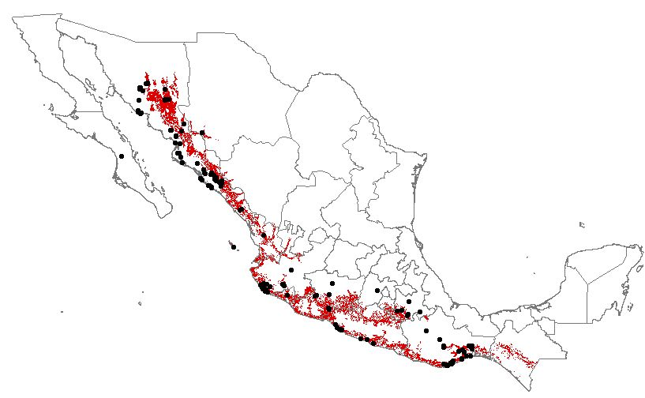

Guaiacum coulteri herbarium specimens records and potential distribution map using GARP.

