PC12 Doc. 16.2
English only/Solamente en inglés/Seulement en anglais
CONVENTION ON INTERNATIONAL TRADE IN ENDANGERED SPECIES
OF WILD FAUNA AND FLORA
____________
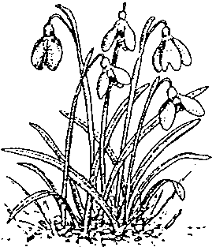
Twelfth meeting of the Plants Committee
Leiden (The Netherlands), 13-17 May 2002

ID Manual

Identification of Appendix I cacti
1. This document has been prepared by the Management Authority of Switzerland.

Background
2. In 1999, the Secretariat and the Management Authority of Switzerland agreed to produce a contribution to the ID Manual, treating all Cactaceae that are included in Appendix I.

Progress
3. Subsequently, 105 identification sheets have been prepared by the Management Authority of Switzerland, covering all cacti of CITES Appendix I to the level of subspecies and varieties. This involved broad international co-operation with experts and nurseries.
4. Additionally, an extensive set of indices has been compiled, including
a) an alphabetic index of 648 names and synonyms with references to ID sheets;
b) an index by countries of origin;
c) a historical index of Appendix I-listings;
d) an index of the CITES-registered nurseries for propagation of Appendix I-cacti; and
e) an illustrated index of growth forms and collectors groups.
5. In 2001, it was agreed that the Management Authority of Switzerland would produce a book, containing the indices and the 105 ID sheets. This book was to be published in English and submitted to the Secretariat for distribution to the Parties and subsequent translation into the other languages of the convention. The Swiss Management Authority further decided to make the book available also on CD-ROM.
6. In February 2002, the book and CD-ROM was shipped to the Secretariat for distribution to the Parties.
7. The book and CD-ROM was further made available to the general public through non-CITES channels of distribution.

