PC12 Doc. 10.2
English only/Solamente en inglés/Seulement en anglais
CONVENTION ON INTERNATIONAL TRADE IN ENDANGERED SPECIES
OF WILD FAUNA AND FLORA
____________
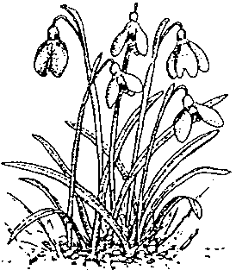
Twelfth meeting of the Plants Committee
Leiden (The Netherlands), 13-17 May 2002
Species proposals for the 12th meeting of the Conference of the Parties
Delisting of leaf-bearing cacti (Pereskioid and Opuntioid Cactaceae)
Delisting from Appendix II of Cactaceae, subfamily Opuntioideae (all species)
and
Delisting from Appendix II of leaf-bearing cacti (Cactaceae): subfamily Pereskioideae (all species) and the genus Pereskiopsis (all species) and the genus Quiabentia (all species)
1. This document has been prepared by the Management Authority of Switzerland.
Background
2. At the 11th meeting of the Plants Committee, in Langkawi, Malaysia, Switzerland submitted two proposals on Cactaceae with the above titles for consideration (Agenda Item and PC 11 Doc. 10.1.1).
Consultation with Parties
3. At the same time and upon recommendation of the Secretariat, Switzerland submitted the two proposals to the Secretariat for the agenda of the 12th meeting of the Conference of the Parties and for prior notification to all Parties (according to Resolution Conf. 8.21).
4. The reason for this proceeding is, that a great number of Parties are considered range States of the taxa concerned and that the consultation with range States is considerably facilitated by a notification to all Parties.
5. With notification No. 2002/009, dated 6 March 2002, the two proposals have been forwarded to all Parties.
6. Interested Parties (range States as well as non-range States) are invited to send their comments to the Management Authority of Switzerland in order to allow submission of revised proposals at least 150 days before the 12th meeting of the Conference of the Parties (i.e. by 6 June 2002).
7. Following notification No. 2002/009, the Management Authority of Switzerland has up to date received a single response from a non-range State. Ukraine informed, that it agrees with both proposals.

