AC17 Inf. 9
(English only / Seulement en anglais / Solamente en inglés)

CONVENTION ON INTERNATIONAL TRADE IN ENDANGERED SPECIES
OF WILD FAUNA AND FLORA

____________
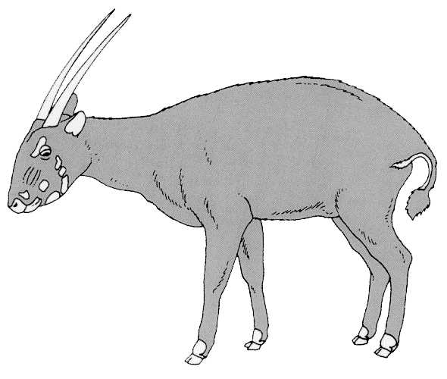
Seventeenth meeting of the Animals Committee
Hanoi (Viet Nam), 30 July-3 August 2001

Universal labelling system for the identification of caviar
1. This document has been prepared by the Secretariat.
2. Resolution Conf. 11.13 (Universal labelling system for the identification of caviar) recommends that the labelling system outlined in the Resolution should take effect as soon as possible for the export quotas for the year 2001.
3. To date (24 July 2001), the Secretariat is aware that Kazakhstan and the Russian Federation appear to be the only Parties that have introduced such a labelling system. Examples of the labels in use are attached. The Secretariat has been unable to discuss with its Management Authority the system used by Kazakhstan but it appears to be similar to that of the Russian Federation. It notes, however, that Kazakhstan has used a three letter country code and not the two letter ISO code. Its labels also appear to have only one reference number, instead of a processing plant number and a lot identification number.
4. The Secretariat has, however, received information about the system being used by the Russian Federation and it is described as follows.
5. The Russian Federation labels are printed on adhesive paper and are non-reusable. They are suitable for use on primary and secondary containers. Any attempt to remove the label or open the container will result in damage to the label. One company is being used to prepare the labels and only does so on the instructions of the CITES Sturgeon Management Authority of the Russian Federation. Labels bearing the grade of caviar, Acipenseriformes species code, ISO code of the country of origin and year of harvest are pre-printed. On application for an export of caviar, the Management Authority (having satisfied itself regarding non-detriment and legal origin findings) instructs the printer to add the producer number and a consignment number. Each label also bears a holographic design to deter counterfeiting. The printer will be instructed to only prepare a number of labels consistent with the quantity of caviar to be exported. The exporter will be responsible for affixing the labels and any not used must be returned to the Management Authority for destruction.
6. The Russian Federation has used the terms ‘producer’ and consignment’ in relation to the final two sets of numbers recommended in the Resolution. It is not yet clear to the Secretariat whether the term ‘producer’ means the company that prepared the caviar or if it could also refer to an exporting company that was not involved in the actual preparation of the caviar. The term ‘consignment’ appears to refer primarily to the caviar that is intended for export, although it is expected to be from the same method of processing, the same kind of packing and relate to the same producer, exporter and consignee.
7. Whilst the Secretariat is of the opinion that the labels and system used by the Russian Federation offer a good example to other Parties, it has some concerns that the system may not altogether follow the recommendations of the Resolution. The Resolution uses the terms ‘processing plant’ and ‘lot identification number’ and not ‘producer’ and ‘consignment’. Consequently, the Secretariat is of the opinion that the Conference of the Parties intended that the labels should clearly relate to where the caviar itself was processed, whereas it appears that the Russian Federation may allocate producer numbers to exporting companies. Similarly, the Secretariat believes that the final number referred to in the Resolution was also intended to relate to the processing or production process, whereas it appears that the Russian Federation relates this number to a quantity submitted for export.
8. In a previous submission to the Animals Committee, the Secretariat expressed the opinion that the term ‘lot’ is relatively commonly used in production industries and would relate to a series/batch of materials or a separate production-run of goods. This might, for example, be equivalent to all the goods of an identical type processed in one working shift, an entire working day, week, or other period of manufacture. It sees no reason why such an interpretation could not also apply in the processing and production of caviar.
9. The Secretariat is advised that existing regulations in the Russian Federation require primary containers to indicate: the name of the producer; the name of the product; the conditions of storage; the trade mark of the producer; and the date of production, with indications of the month, year and master number. It would appear, therefore, that the Sturgeon Management Authority of the Russian Federation could relate the information from its labelling system to the production process but not in a manner envisaged by the Resolution.
10. The Secretariat believes that the labels introduced by the Russian Federation appear to be of a high quality and are of a format that other Parties may wish to also adopt. However, it recommends that other Parties consider carefully how to allocate the processing plant and lot identification numbers in a manner that is consistent with the Resolution, so as to take account of the production process and not simply the identification of caviar submitted for export and international trade. The Secretariat believes that the Conference of the Parties intended that the information on the labels should help confirm that the caviar is of legal origin.
11. The Secretariat intends in the near future to distribute, via a Notification to the Parties, information relating to the system adopted by the Russian Federation. This appears to also be an opportunity to offer advice to other exporting countries and the Secretariat would welcome comments from the Animals Committee that can be incorporated into such a Notification.

